Trading & Exchanges
Summary of classes by Prof. Dr. Gunther Wuyts, winter semester 2024

1.1 Financial Market Structure: Key Concepts

Efficient Markets
- True / fair value definition: fundamental value $\tilde{V}$ of an asset is the value at which the asset can be liquidated in a frictionless and efficient market after trading has ended
    - Value will realise at some point and you do not know it for sure today
    - Tilde above $\tilde{V}$ indicates a random variable
    - Friction refers to difficulties market participants are faced with
    - Divide time in discrete periods (t = 0, 1, 2…)
- Efficient market hypothesis (EMH)
    - Price is the expectation of the $\tilde{V}$ of the asset, based on all information available
    - If markets are efficient & no frictions exist, then prices reflect all available information
    - Price $p_{t}$ at which asset trades, should be equal to best possible assessment about its $\tilde{V}$, given all information available at t
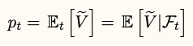

      - $Ε_{t}$ is expectations operator conditional on all information at time t
      - $F_{t}$ is the expectation set used in $Ε_{t}$
    - Depending on the information set, EMH has three forms
      - Weak-form efficiency: information set contains history of prices
      - Semi-strong-form efficiency: information set contains all publicly available information
      - Strong-form efficiency= information contains all information available to any single market participant (all private information)
    - No discounting to account for time value: time intervals used are very short
- EMH implications
    - Price changes only occur due to arrival of new information
    - Define news as innovation in the value of the asset
      - Use random variable $\tilde{ε}$
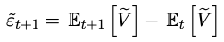
      - Define ${\tilde{ε}}_{t+1}$as an update of expectation of investors due to news arriving in the interval t and t+1
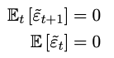
      - The following must hold, otherwise you already expected part of the innovation (so it was not in fact, news)
      - Past innovation should not allow you to forecast (part of the) news

    - This means best estimator for future value is the current price
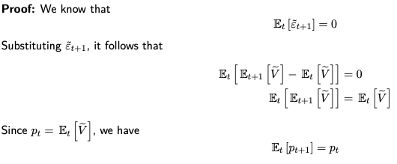
      - Theorem 1: under EMH transactions follow a martingale

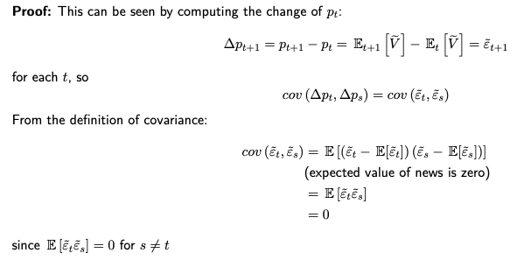
    - Consequence of T1: price changes over an interval are serially uncorrelated

Friction
- Friction: measure of how difficult/costly it is to trade an asset
- Distinction between real and informational frictions
    - Real friction
      - Order processing costs (personnel, equipment…)
      - Imperfect competition between dealers (market power)
      - Inventory risk (dealer wants compensation for this risk)
    - Informational sources of friction
      - Market participants having more information than others
      - Dealer having less information than a trader (ex. hedge fund)
      - Dealer will want compensation for expected losses due to information asymmetry

Market Liquidity
- Definitions:
    - Market liquidity: the degree to which orders can be executed within a short time frame at a price close to the consensus value
    - Transaction price: prices at which you can actually buy or sell
    - In illiquid markets, due to frictions, transaction prices can deviate substantially from the asset’s fundamental value
- Trader definitions
    - Bid: price at which the trader can sell immediately
    - Ask: price at which the trader can buy immediately
    - Midquote: average of ask and bid
    - Bid-ask spread (in short, spread): ask – bid, can be looked at in two ways
      - Cost for the trader
      - Profit/compensation for the dealer
    - Depth: number of shares that are available at ask or bid quote
    - Tick size: minimum price variation
- In terms of liquidity
    - Spread is an inverse measure: higher spread = lower liquidity
    - Depth is a measure of liquidity: higher depth = higher liquidity
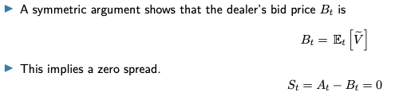
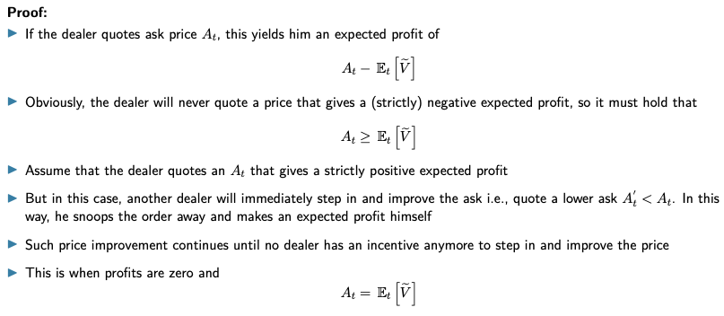
In frictionless, efficient markets the bid-ask spread is zero: the market is perfectly liquid

Price Impact (PI)
- d_{t} is the direction of a trade: 1 for a buy and -1 for a sell transaction
- Impact of a trade at time t on the price of time t + s is defined as the difference between
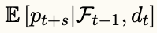
    - The expected transaction price at time t + s, conditional on all information available before the trade

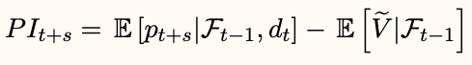
    - The expectation about the fundamental value of the asset just before the transaction at time t
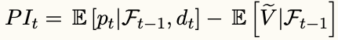
- The immediate (short term) price impact of the trade at t is then
- Proposition: in efficient markets, prices do not change in response to order flow
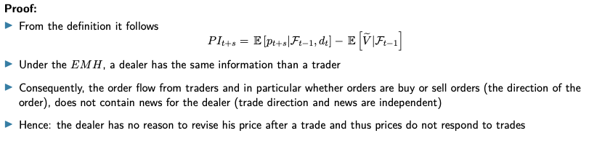
Price impact of a trade is 0
- Price discovery
    - The speed & accuracy with which transaction prices incorporate information available to market participants
    - In efficient markets, price discovery is instantaneous & complete

2.1 Order Processing Costs

Introduction
- Assume the following for this chapter
    - Designated group oof agents supplies liquidity: dealers/market makers
    - One group of market participants demands liquidity: traders
    - Transactions go through an intermediary: the dealer who takes the opposite side of the trade
    - Dealer markets are also called quote-driven markets
- Under EMH, markets are perfectly liquid and trades have no price impact (≠ real world)
- Order processing costs: cost dealer incurs when executing an order, received from a trader, includes trading fees, clearing & settlement fees, costs of back office…

Organisation of Dealer Markets
- Variation in organisation of dealer markets based on
    - Information available
    - Binding quotes
    - Bargaining
    - Preferencing
    - Dealer obligations
- May be more than one dealer per asset
    - If all quotes are shown, easy to find cheapest dealer
    - If no real-time info: search is needed
    - No enforcement of price priority: when trade occurs, no guarantee that other dealers don’t quote a better price
- Traders can bargain over prices
    - Trades could occur within the spread
    - Can happen for large orders
    - Dealers can have a preferencing agreement with brokers
Broker sends all orders to dealer, who then executes at best price
    - Payment for order flow: broker agrees to send specific categories of orders (ex. small orders, retail orders…) to that dealer, who then offers a rebate to the broker
- Dealer market has 2 tier structure (2 segments in the market)
    - Retail segment: serves final investors (traders)
    - Wholesale segment (interdealer market): dealers trade with each other to share inventory risk
    - Interdealer market volume is much larger

Model Setup
- Assumptions
    - Financial asset is traded, with fundamental value of random variable $\tilde{V}$
    - Time divided in discrete periods t = 0, 1, 2…
    - Each time t, trader arrives in the market who is a buyer or seller with equal probability 50%
    - Trader submits only market orders
    - Each order is for one unit of the asset
- Remark 1: Arrival process of traders is a collection of random variables that are i.i.d.
    - i.i.d.: independent & identically distributed
    - Direction of current trade has no implication on direction of future trades
- Remark 2: we do not model explicitly the motives for trading
    - Assume that traders trade for exogenous motives (reasons outside model and not related to information)
    - Call such traders liquidity (or noise) traders
- Liquidity is provided by the dealer
    - Takes the counterpart of every trade
    - Behaves competitive and is risk-neutral
- This dealer has a fixed order processing cost c per transaction
    - Each transaction is for one unit, so is same as c dollar per share of the asset
    - Model can easily be adjusted if c would be per dollar traded

Prices & Market Liquidity
- Assuming dealer behaves competitive and is risk-neutral
    - Quoted ask is such that it covers the order processing cost
    - Then he breaks even, profit is 0
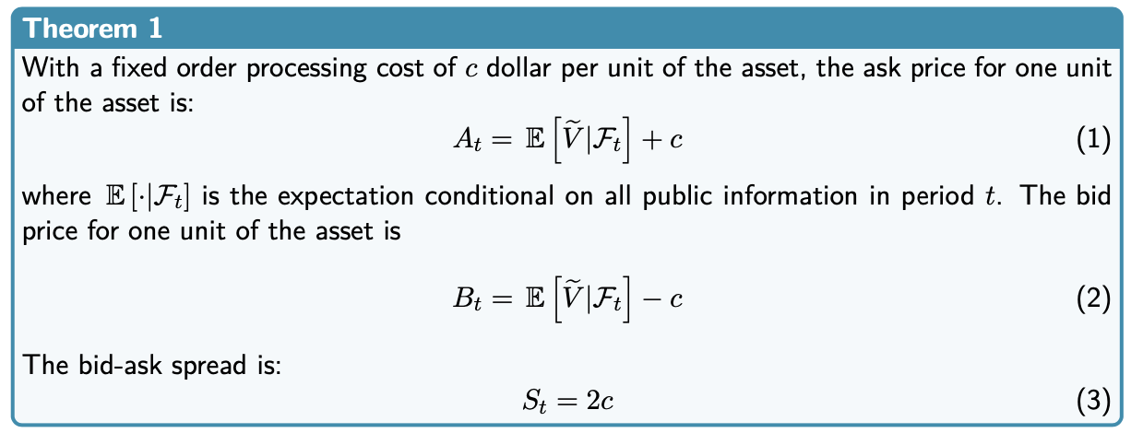
- Theorem for bid ask prices quoted by the dealer and the spread

    - Interpretation: relative to efficient markets, small change in model in form of a cost c for the dealer, implies that the market now has 2 prices
      - B_{t} at which the traders sell
      - A_{t} at which the traders buy
    - Market no longer perfectly liquid but has a positive bid-ask spread

Price Impact of Trades
- Price impact a trade at t has with order processing costs
    - Immediate PI_{t} of a buy trade at time t is +c
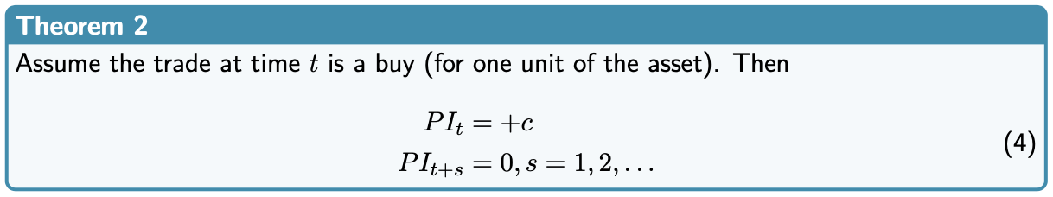
    - Price impact in later periods is 0

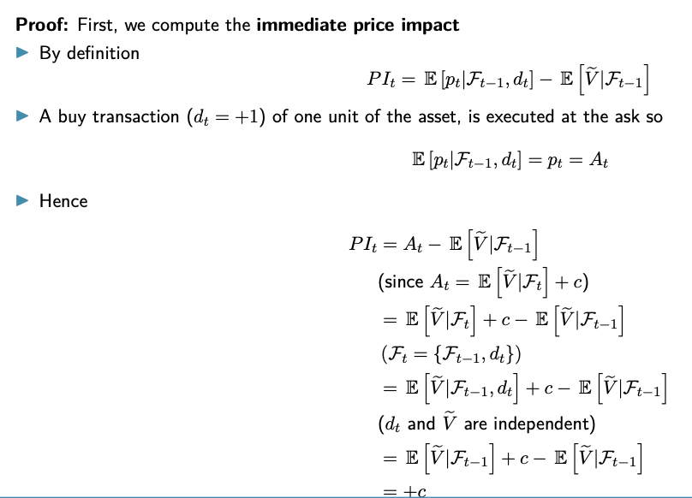
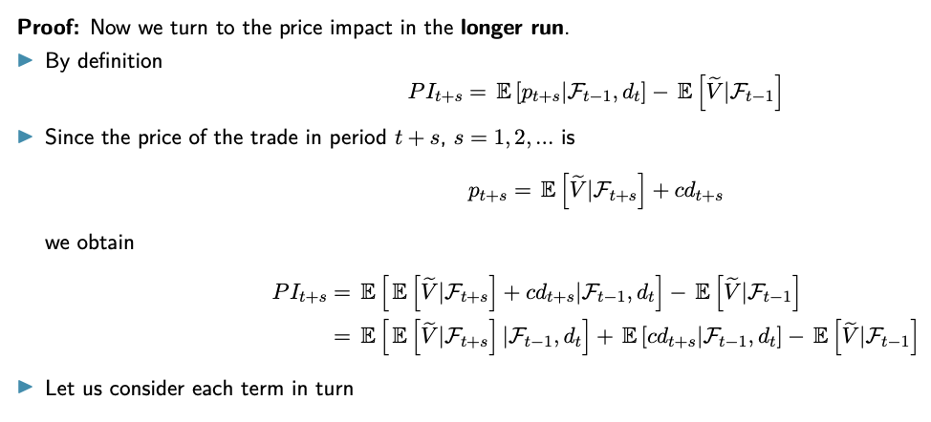
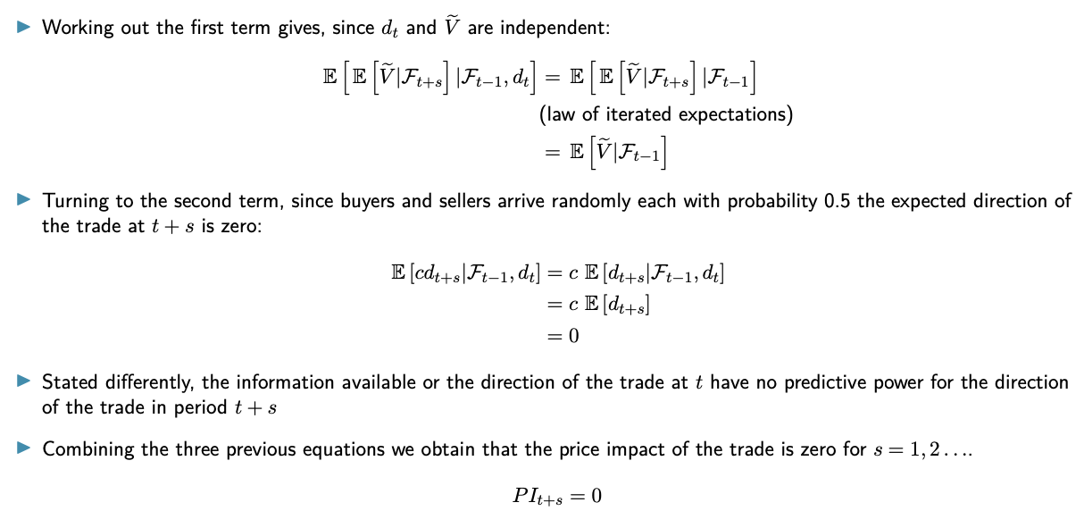
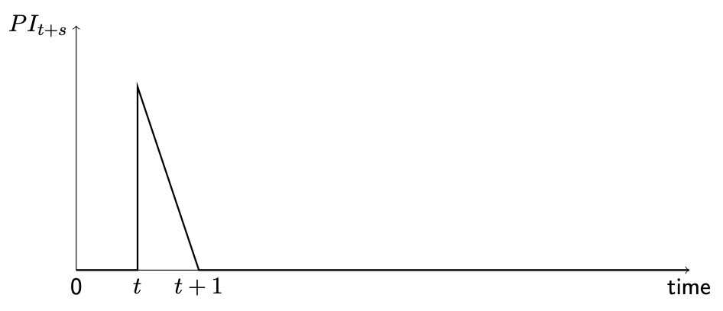
- Path of price impact PI after a buy transaction of 1 unit, plot follows from theorem above

Imperfect Competition
- Retain previous assumptions, but assume dealer does not behave perfectly competitive
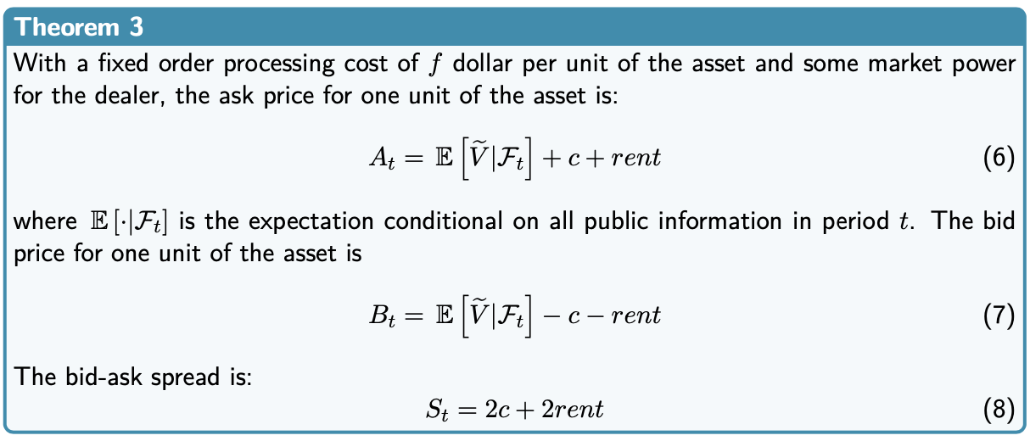
Has some market power, allowing him to extract rent from trader by adjusting spread

2.2 Inventory Models

Introduction
- Why the need of a dealer
    - Buyers & sellers don’t arrive at same time in the market
    - Dealer can serve as intermediary, is exposed to inventory risk
    - Inventory risk: change in value of position due to change in asset’s fundamental value (news)
- Ways to model inventory
    - Risk averse dealer: our approach
    - Risk neutral dealer who can fail
- Inventory example
    - See dealer as any other type of investor
    - Wants to hold (and currently holds) optimal portfolio
    - Trader buys 1 share from dealer
    - Dealer does not hold optimal portfolio anymore
    - Difference between actual portfolio & optimal portfolio is the inventory (-1)
- Inventory causes portfolio risk & return to deviate from optimal risk & return
If dealer is risk averse: wants compensation for extra risk (the spread)
- Dealer will actively manage portfolio, otherwise has to wait for a buyer & seller to cover risk
    - Increase ask after trade, making buying less attractive for future traders
    - Increase bid after trade, making selling more attractive for future traders
Dealer makes covering its risk more likely
    - Can also offload inventory position in interdealer market (not in our model)

Link with Portfolio Theory
- Dealer has preferred optimal portfolio like any other investor
- Assume
    - N risky assets: feasible set is area within ABC
    - Efficient frontier is curve AB
    - If risk free asset (cash) is included: line R_{f}E is efficient frontier
    - Efficient frontier
      - All possible combinations of efficient portfolio of risky assets
      - Point E: tangency point of the line to the curve AB
      - Point R_{f}: cash
      - Curve U: indifference curve of the dealer
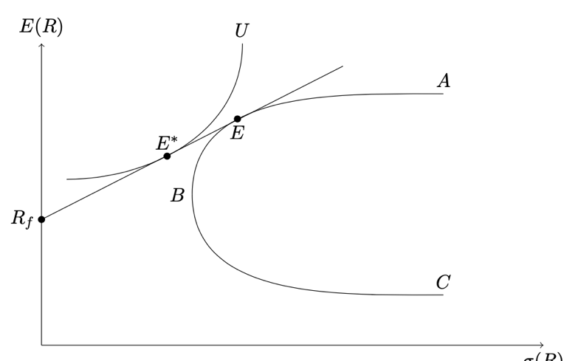
    - Optimal portfolio of dealer is E*, call this investment account of the dealer
- Dealer
    - Intermediates between traders, offering them immediacy
    - Absorbs imbalances in order flow when buyers & sellers don’t arrive at the same point in time
    - Dealer acquires position in asset when intermediating (inventory)
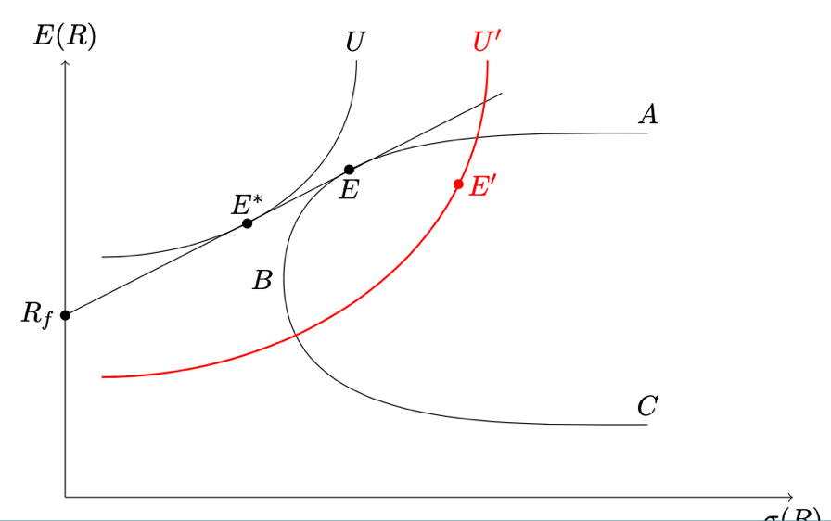
Pushed off efficient frontier and to lower indifference curve U’

- Compensation
    - Risk averse dealer requires compensation
    - Costs associated with deviation of optimal portfolio: inventory holding costs
    - Compensation received from the spread
- Return to the optimal portfolio
    - Aim to attract order flow to bring inventory back to zero
    - Make the trade needed to return to zero very attractive (change bid/ask)
    - Ex. increase bid & ask to make selling more & buying less attractive

Model of Inventory Risk
- Assumptions
    - Two period model, periods are t = 0, 1 (no discounting)
    - N risky assets, indexed by i = 1, 2… N, that can be traded
      - Focus is on the dealer
      - Do not model trading motives of traders (exogenous)
    - Dealer is counterparty of each trade: risk averse & competitive
    - Dealer enters t = 0 holding optimal portfolio
      - $q_{i, 0}^{*}$ units of asset i (> 0 if long position, < 0 if short)
      - An amount of c₀ cash (to buy & sell assets)
    - Return on cash is risk-free rate R_{f}, set to zero for simplicity
- Model setup
    - Observed fundamental value in t = 0 of risky asset i is V_{i,0}
    - Dealer enters period 0 with wealth equal to value of initial portfolio
    - Value in t = 0 of portfolio is equal to $W_{0}=\sum_{i=1}^{N}{V_{i,0}q_{i,0}^{*}+c_{0}}$
- Possibility of two cases
  - Dealer does not trade in t = 0
    - Dealer keeps optimal portfolio until t = 1
    - Assume at t = 1, payoff of each asset i is ${\tilde{V}}_{i}$
      - Tilde: random variable
      - Is not the fundamental value (see later)
      - Beliefs of dealer on distribution don’t change over time (contrast with information-based models where dealer updates beliefs after a buy or sell trade)
    - Terminal wealth at t = 1 is then
      - ${{\tilde{W}}_{1}}^{NoTrade}=\sum_{i=1}^{N}{{\tilde{V}}_{i}q_{i,0}^{*}+c_{0}}$
      - Since payoff is random variable, terminal wealth is too
      - Is determined by optimal portfolio
  - Dealer executes order from trader
    - Assume that dealer makes only one transaction per trading interval
      - After trade, we move to period t = 1
      - Traders only submit market orders
    - Size of trader’s order is x_{i,0} units of asset i
      - x_{i,0} > 0 means dealer receives a buy order (= dealer sells)
      - x_{i,0} < 0 means dealer receives a sell order (= dealer buys)
      - Determine sign of trade using person who initiates the trade (trader)
    - Decision variable is p_{i,0} (price), quoted by dealer for transaction of size x_{i,0}
    - Dealer’s terminal wealth ${{\tilde{W}}_{1}}^{Trade}=\sum_{i=1}^{N}{{\tilde{V}}_{i}q_{i,0}^{*}+c_{0}-}{\tilde{V}}_{i}x_{i,0}+p_{i,0}x_{i,0}$
      - Is determined by investment account and inventory
      - ${\tilde{V}}_{i}x_{i,0}$ gives impact of trade on value of position in asset i
      - $p_{i,0}x_{i,0}$ is impact on cash position of the dealer
- Dealer cares about expected utility of terminal wealth at t = 1
    - Assume he is perfectly competitive when quoting $p_{i,0}$
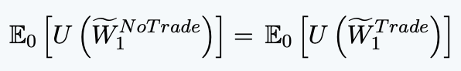
    - He will execute order if expected utility of terminal wealth when executing the order, is the same as expected utility without trading
With U(.) dealer’s utility function
- Assume dealer has mean-variance preference (and is risk averse)
    - Implies dealer has utility function on wealth where expected utility is linear function of mean and variance of wealth
    - Dealer has utility function which is increasing in expected value of terminal wealth and decreasing in its variance, equation becomes:
Where A is coefficient of absolute risk aversion
    - Dealer will set $p_{i,0}$ at which he wants to trade such that equality is achieved
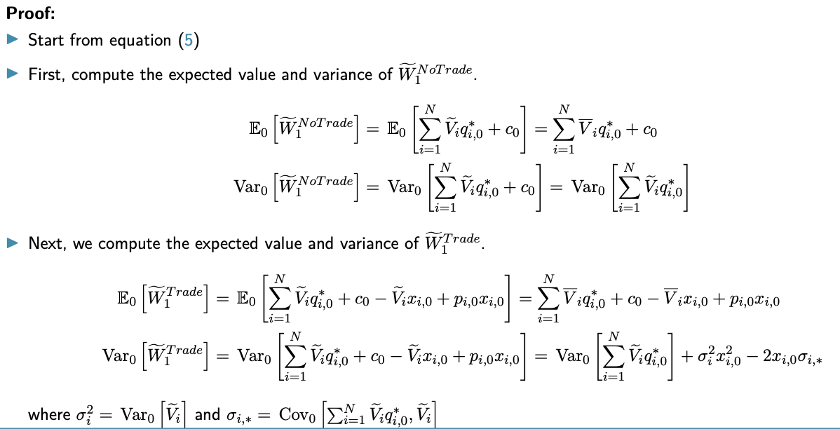
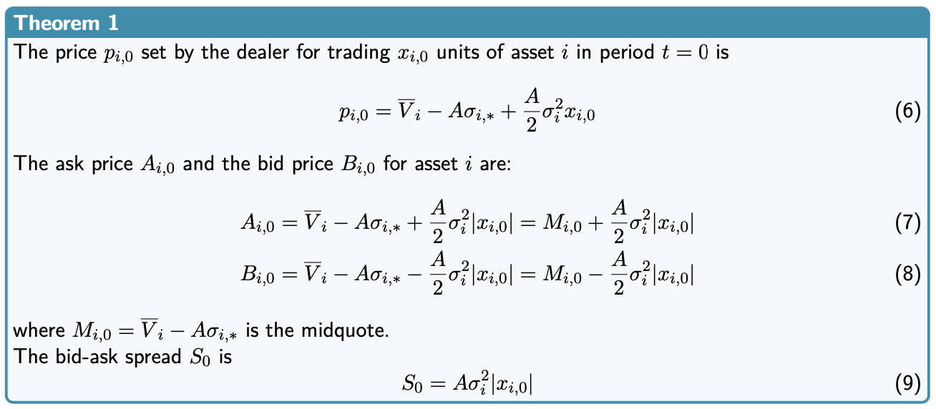
- Notation
    - $\overline{V_{i}}$ is expected payoff (expected value of $\tilde{V_{i}}$)
    - $σ_{i}^{2}$is variance of $\tilde{V_{i}}$
    - $σ_{i,*}$ covariance between asset i and optimal portfolio of risky assets on efficient frontier, at time t = 0

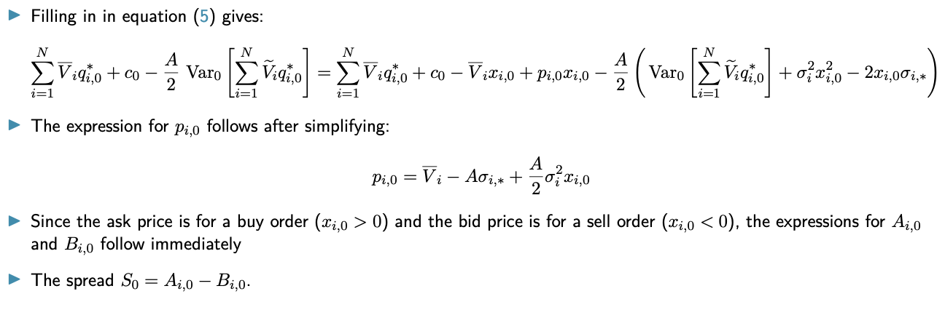
Quotes & Market Liquidity
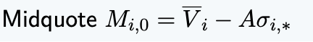
- Determine position of optimal ask and bid prices, is driven by number of factors
    - Dealer characteristics: higher risk aversion 1 lower midquote
    - Asset characteristics
      - Higher expected payoff of asset $i \overline{V_{i}}$
higher midquote
      - Higher assets covariance with efficient frontier portfolio of $σ_{i,*}$
lower midquote
- Can be interpreted as fundamental value of the asset
    - Value at which asset can be liquidated without inventory friction after trading has ended
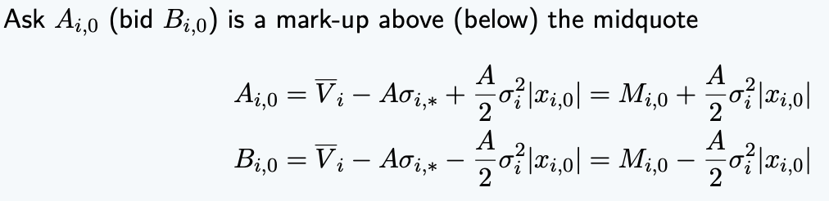
    - Interpretation: M_{i,0} is expected payoff minus discount for asset’s systematic risk (covariance with efficient frontier portfolio)
    - Difference with midquote represents compensation for dealer of executing buy (sell) order of the trader and as a consequence taking a non-optimal position (and thus inventory risk)
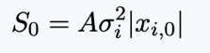
- Spread is an increasing function of
    - Dealer’s risk aversion A
    - Riskiness of the asset $σ^{2}$
    - Trade size x_{i,0}
    - Size of spread does not depend on covariance, but position does

Initial Inventory
- Look at case where initial inventory in t = 0 deviates from optimal portfolio
- Initial inventory of dealer equals I_{i,0}
    - I_{i,0} > 0: larger holdings of asset i than optimal
    - I_{i,0} < 0: less holdings of asset i than optimal
- Value of initial portfolio W₀ is equal to $W_{0}=\sum_{i=1}^{N}{V_{i,0}q_{i,0}^{*}+c_{0}}+V_{i,0}I_{i,0}$
- Terminal wealth becomes
    - Without trading is ${{\tilde{W}}_{1}}^{NoTrade}=\sum_{i=1}^{N}{{\tilde{V}}_{i}q_{i,0}^{*}+c_{0}+{\tilde{V}}_{i,0}I_{i,0}}$
    - With trading is ${{\tilde{W}}_{1}}^{Trade}=\sum_{i=1}^{N}{{\tilde{V}}_{i}q_{i,0}^{*}+c_{0}+{\tilde{V}}_{i,0}I_{i,0}-}{\tilde{V}}_{i}x_{i,0}+p_{i,0}x_{i,0}$
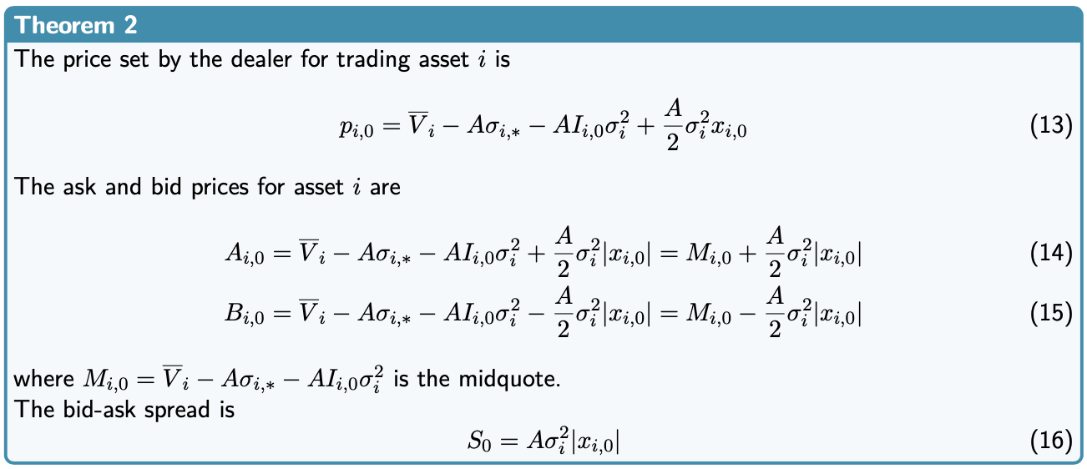
    - Initial inventory determines midquote and thus position of bid & ask prices
    - Unwind position
      - If initial inventory is higher, quote lower prices than equilibrium
    - Replenish position
      - If initial inventory is lower, quote higher prices than equilibrium
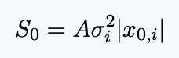
- Magnitude of the spread is independent of initial inventory, but the position of the spread does depend on it

Implications of the Theory
- Price impact of trades: what is the impact of an order on the path of transaction prices after the order, according to inventory models
- PI_{t+s} of a trade at time t with direction d_{t}, is the difference between the expected transaction price at time t + s, conditional on
    - All information available before the trade
    - The direction of the trade
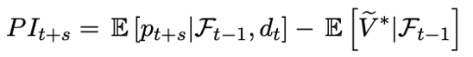
    - The expectation about the fundamental value of the asset before transaction at time t, conditional on all public information available then F_{t-1}
      - We denote the fundamental value exceptionally by ${{\tilde{V}}_{i}}^{*}$ (${\tilde{V}}_{i}$ was used for payoff)
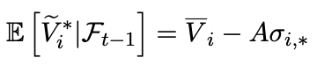
      - Fundamental value of the asset is so
      - Difference between ${\tilde{V}}_{i}$ and ${{\tilde{V}}_{i}}^{*}$ is due to the inclusion risk aversion in our inventory model
- To analyse PI, stretch 2 period model with initial inventory
    - Set price for one period, then again for one, without thinking about future
Do not consider multi-period optimisation for optimal inventory control
- Assumptions
    - Current period is t (time 0) in which one buy order arrives
    - Initial inventory at this time is 0
    - Without inventory friction, arriving trader is seller or buyer with 50% chance

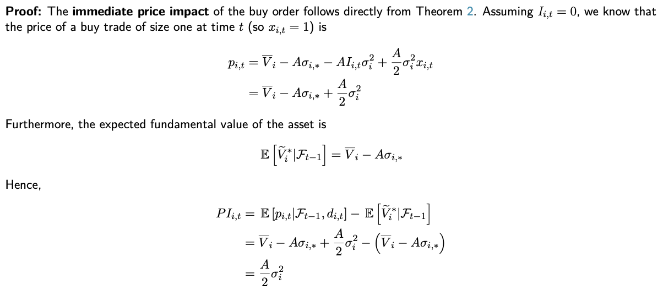
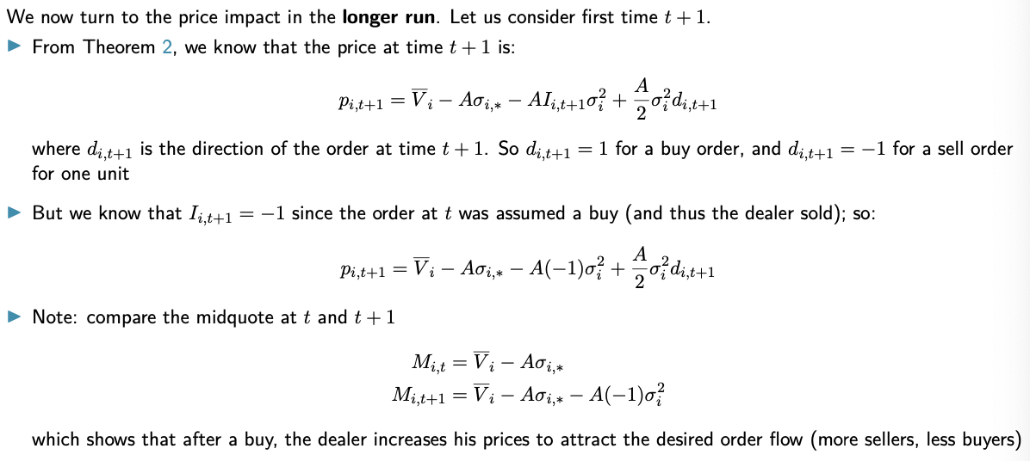
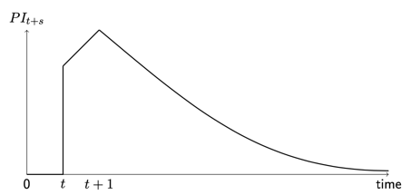
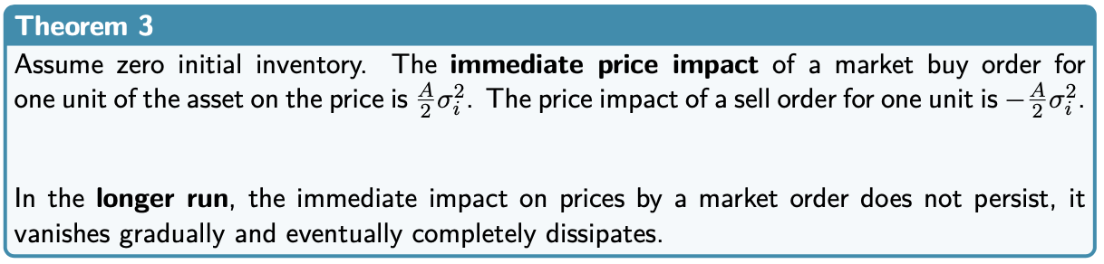
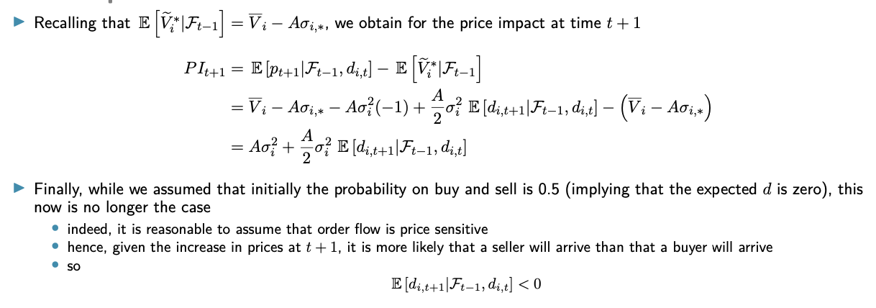

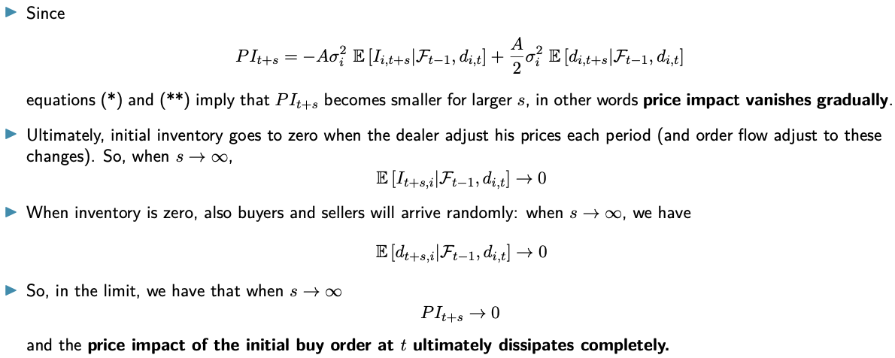
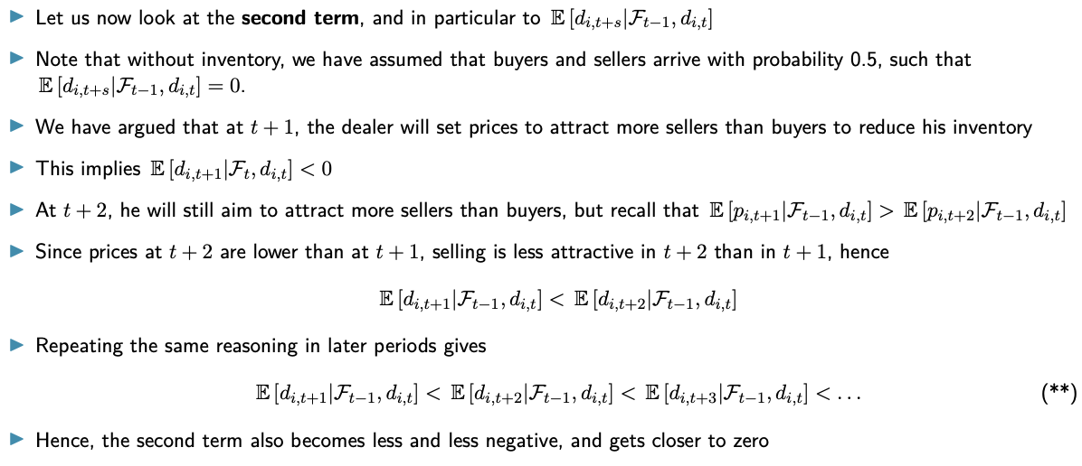
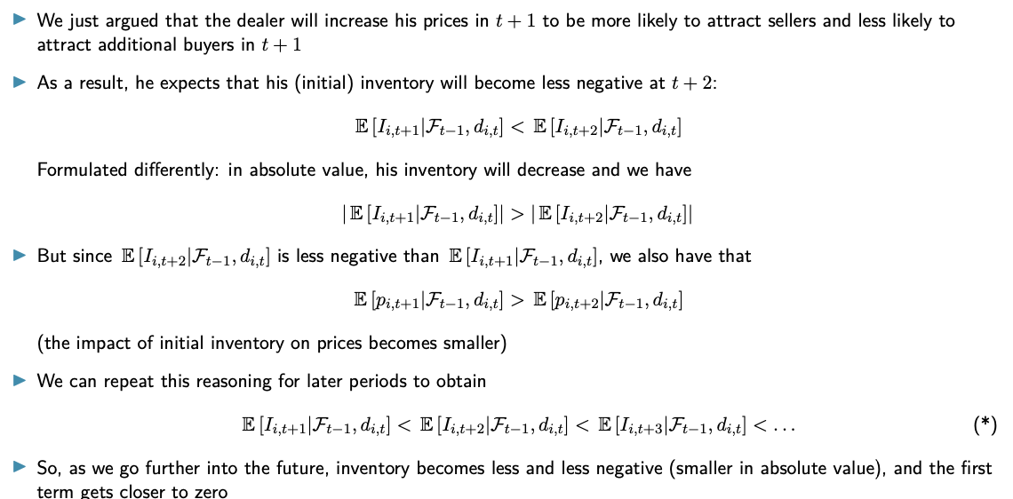
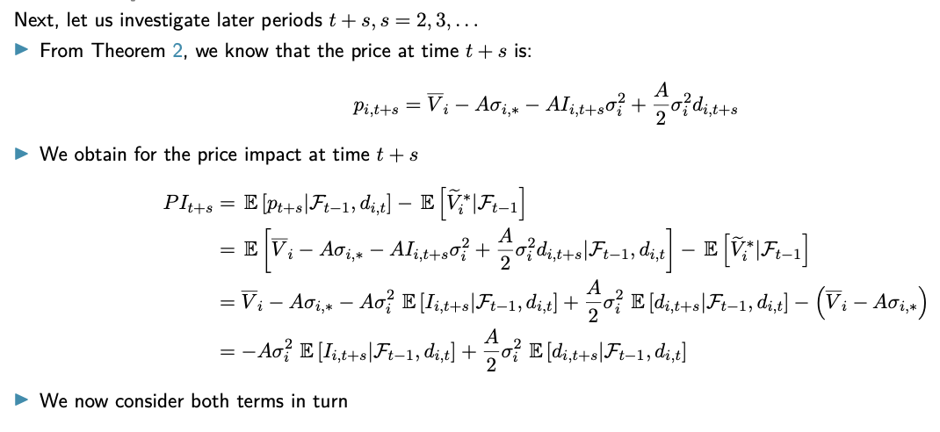
- Corollary 1: inventory is mean-reverting
- Corollary 2: inventory risk implies positive short-term correlation between the change in the midquote (position of the dealer’s quotes) and the order flow. The longer run correlation between both is negative
- Corollary 3: Under inventory models, there is negative serial correlation in changes (first differences) in prices, as well as in trades
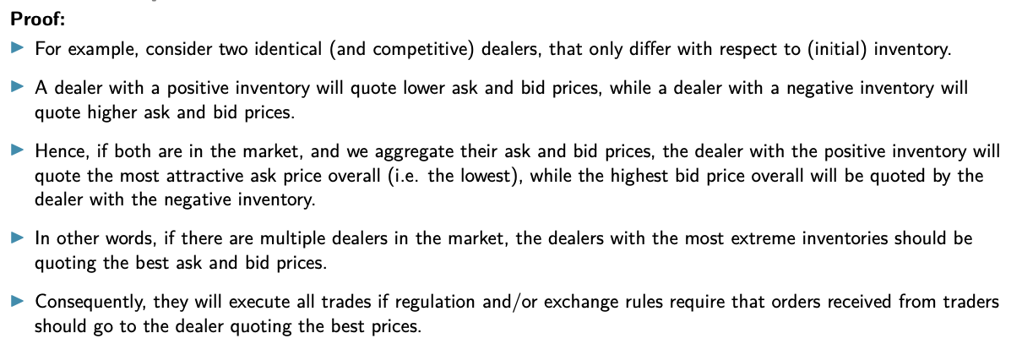
- Corollary 4: Dealers with more extreme inventory positions will quote more aggressively and will execute the orders received from traders

Empirical Evidence of Inventory Management
- Empirical evidence that test predictions of inventory models is mixed
    - Some are in line with predictions from theory
      - Evidence of preferred inventory positions
      - Evidence from dealers engaging in inventory management
    - Some are not in line
      - Dealers deviating from preferred positions for long periods
      - Little empirical evidence on price reversion found
- Conflicting results from
    - Differences in market structures & data sources
    - Difficulty of specifying empirical tests given simplicity of current models
    - If inventory can be correlated with factors related to future stock price movements, then testing for inventory effects can be extremely complex
- Paper Hansch et al. (1998): inventory model of a competitive dealership
    - Data
      - Quotes from transactions on London Stock Exchange (LSE)
      - Sample of 30 from the FTSE-100 stocks
      - June 1991 – july 273 (273 trading days)
    - Construction of inventory series
      - Inventory of dealer not in the data
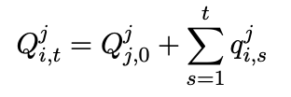
Make series for level of inventory of dealer j in stock i at time t
          - $Q_{i,0}^{j}$ is inventory at beginning of sampling period
          - $q_{i,s}^{j}$ is trade by dealer j in stock I at time s
            - q > 0 if he executes sell order from trader
            - q < 0 if he executes buy order from trader
(q = -x from the theory)

      - Risk aversion of dealer is unobserved (spread depends on this)
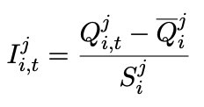
Use standardised inventory to make levels comparable
          - ${\overline{Q}}_{i}^{j}$ is average level of inventory
          - $S_{i}^{j}$ is standard deviation of sample
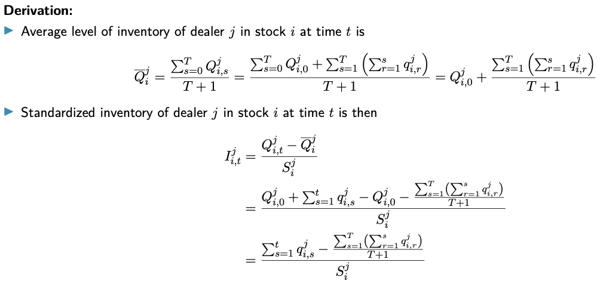
      - Derivation, independent of $Q_{i,0}^{j}$ :
- Theory: dealer with most extreme inventory should execute all trades
    - Distance between inventory of executing dealer and dealer most favourably placed to execute the trade should be 0
    - All trades may not hold in practice
      - Dealer doesn’t precisely know other inventories: dealer posting touch doesn’t need to be dealer with shortest/longest inventory
      - LSE order flow can be preferenced to any dealer if he wants to match best order price: dealers not posting competitive prices can obtain part of public order flow
    - Impact of inventory should be largest for largest trades
    - Results: big portion of large trades are executed by extreme inventories
- Because of order flow preferencing, does posting competitive quotes have value in markets?
    - Dealers offering competitive prices on one side of the touch execute greater portion of the order flow
    - Evidence suggests that dealers on the LSE have an incentive to post competitive prices
- Theory: inventory is mean reverting
    - Expect strength of mean reversion should be increasing with inventory
(more competitive prices if inventory deviates greater)
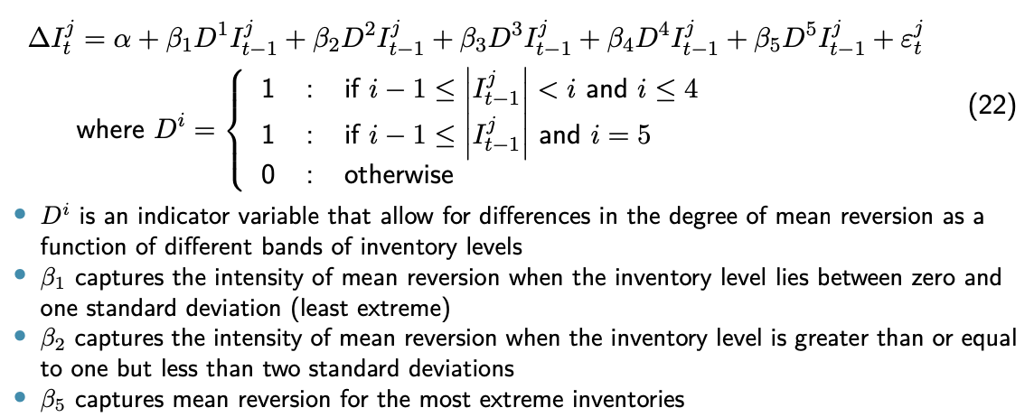
    - Test: use piecewise regression model
    - Concern: relative inventories matter more
Use same regression but with RI instead of I
    - Results: inventory is mean reversing and variation in degree of mean reversion is strongly related to level of inventory

2.3 Asymmetric Information Models

EMH Recap
- EMH states that the price of an asset reflects all available information
    - Price at which one can trade p_{t} should be equal to expected value of the asset, given all available information at that time
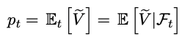
    - Question: how do markets become informationally efficient, what process
    - Need more specific info about detail of trading process and nature of info participants have
- Assumptions
    - Dealers are risk neutral & competitive
    - Investors don’t have more information than dealers
      - Order flow does not contain any relevant information
      - Innovations (news) and direction of trades are independent
      - Dealers have no reason to update their value estimate
    - Trading cost is free

Market Making with Asymmetric Information
- Assumptions
    - One risky asset being traded in a dealer market
      - A dealer is the counterparty in every trade
      - Sets ask & bid quotes
      - Competitive, risk neutral and uninformed
    - Fundamental value of asset is random variable $\tilde{V}$which has 2 possible values
      - Value chosen before trading starts
      - With probability $θ$ the value is low, V^{L}
      - With probability $1-θ$ the value is high, V^{H}
    - Informed traders
      - Fraction k of trader population
      - Receive information about fundamental value before trading starts
      - If news is V^{H}, they buy, otherwise they sell
    - Uninformed traders
      - Fraction 1 – k of population
      - No information about $\tilde{V}$
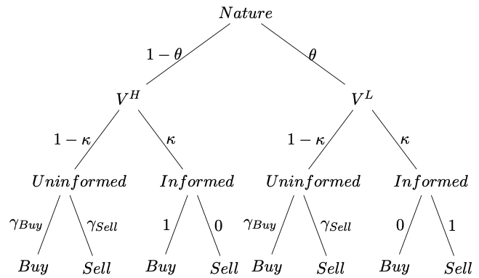
      - Trade for exogenous reasons
    - Timing
      - Sequential trade model: time in discrete intervals, indexed t
      - Fundamental value realises before trading starts
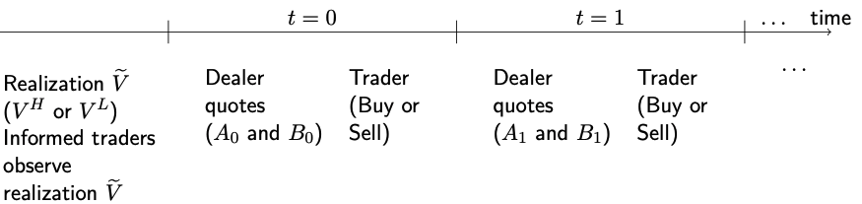
      - First within each period, dealer sets bid-ask: is uninformed, but observes $k,θ, γ_{buy}, γ_{sell}, V^{H} \& V^{L}$
      - Second within each period, exactly one trader arrives: can buy or sell
      - Dealer can revise his quotes before next trader arrives at t + 1
- Implications of the assumptions
    - Informed trader can’t decide when to trade or how much to optimise profit
    - Focus lies on the dealer
    - Assumptions prevent immediate revelation of fundamental value (would occur if informed trader would want to trade as much as possible)
    - Dealer always faces same population of traders
    - Informed traders trade at expense of uninformed traders (make a loss)
- Problem
    - Informed trader will only make trade if they profit
    - If dealer trades with informed trader, they make a loss
- Question: how does the dealer set his bid-ask each period ($B_{t}, A_{t}$)
  - Solution 1: adjust price if order comes from informed trader (not feasible)
  - Solution 2: compensate expected loss with profit from uninformed traders
    - Set quotes equal to conditional expected value of the asset, given information in period t: $p_{t}=E\left[\tilde{V} | F_{t}\right]$
    - No risk compensation because dealer is risk neutral
    - Prices of bid-ask are not the same, because information sets for both differ
    - Dealer has information about all past trades and trade at time t, how?
      - Bid-ask quotes are conditional
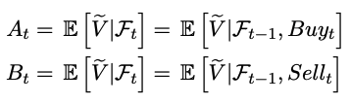
      - The set prices give information on the order if one is executed
Initial Bid & Ask Quotes
- Dealer always sets quotes equal to expected value of the asset, given its information
- At time t = 0
    - Dealers cannot have learned from previous trades/periods
    - Dealer knows parameters, $θ, γ_{buy}, γ_{sell}, V^{H} \& V^{L}$, but supress this
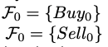
    - When setting prices, only price info is that this is buy order from a trader
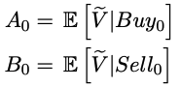
    - So, we get
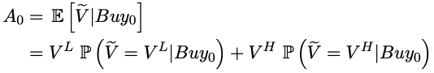
    - Given that $\tilde{V}$can take two potential values, we get for A₀
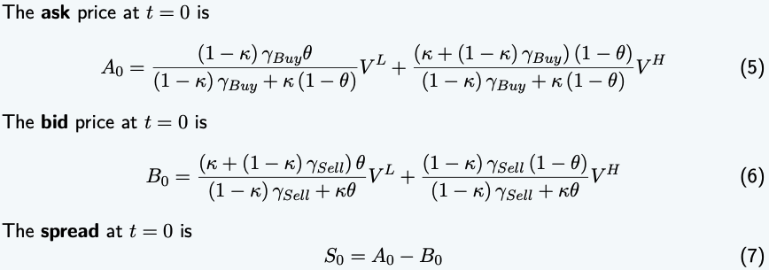
- Theorem 1

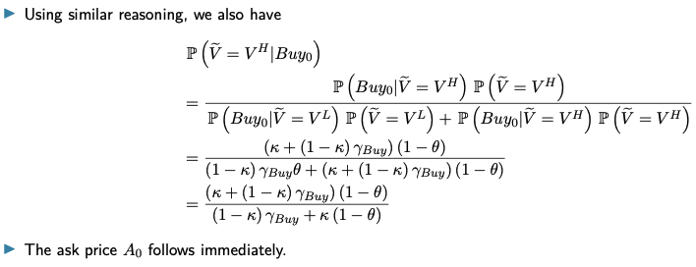
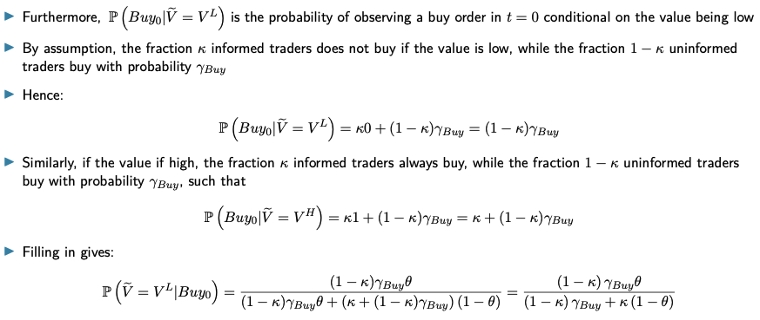
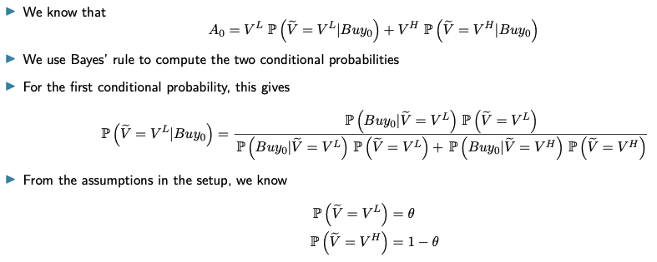
- Proof

- Analytical expressions are relatively intractable: 2 simplifying assumptions to focus on ideas
  - Uninformed traders are equally likely to buy or sell
    - Without informed trading, markets would be perfectly balanced
    - $γ_{buy},=γ_{sell}=\frac{1}{2}$
  - Initial beliefs of dealer assign equal probability to asset having a low or high value
    - In complete absence of information, probability between 2 options is 50%
    - $θ=1-θ=\frac{1}{2}$
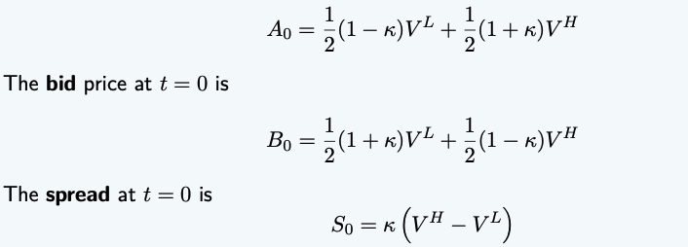
- Theorem 1 under simplifying assumptions becomes
- Even in absence of order processing, risk aversion & inventory, positive spread arises due to asymmetric information
Proposition
    - Spread is increasing in probability of informed trading k and in the variance of the value of the risky asset
    - Proportion of informed traders
      - Larger k, higher chances of dealing at a loss
      - Requires larger compensation, spread widens
    - Variance of fundamental value
      - Measure for the informational advantage of informed trader
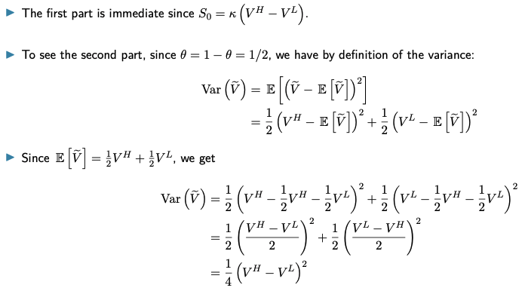
      - Greater variance means greater information advantage, thus greater potential loss for dealer
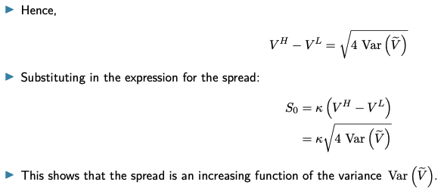
    - Proof
Evolution of Prices over Time
- Assumptions
    - Move from time 0 to time 1
    - Assume trade at t = 0 was a buy
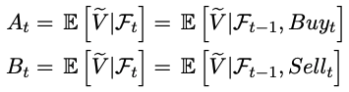
- Solution
    - Still set prices as before, according to this equation
    - F₁ is larger than F₀ (more information, due to previous transaction)
Trader learns over time
      - Dealer learns only from informed trader’s transactions
      - Does not know which trades were with informed trader
      - Learning is not perfect
      - Sets new value based on learnings previous transaction
Bayesian updating
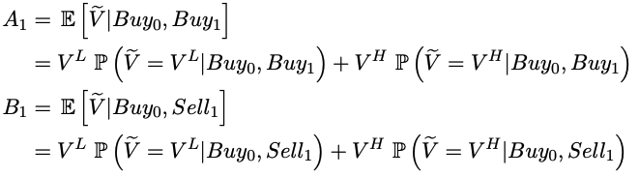
    - Ask (bid) equals expected value of asset, conditional on first order being a buy (sell) and that the ask (bid) is valid for a buy (sell) to arrive at t = 1
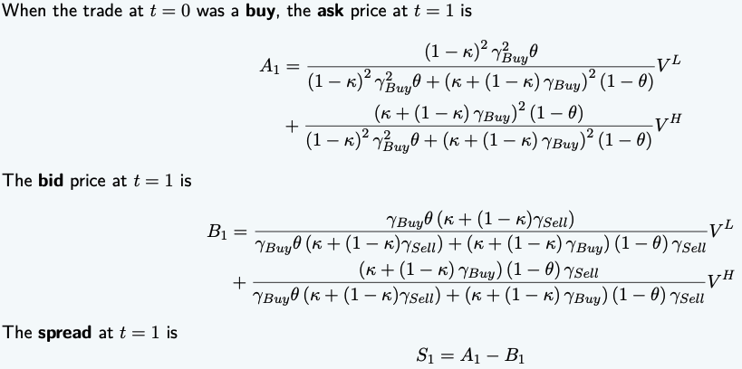
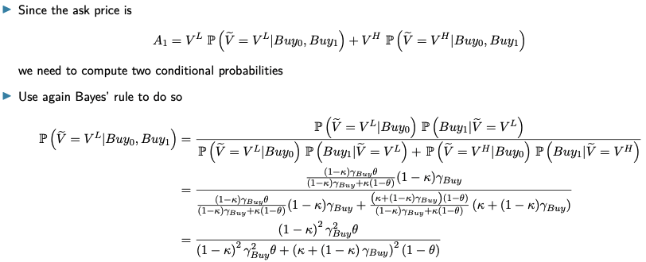
- Theorem 2
- Proof
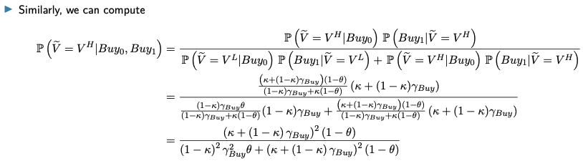
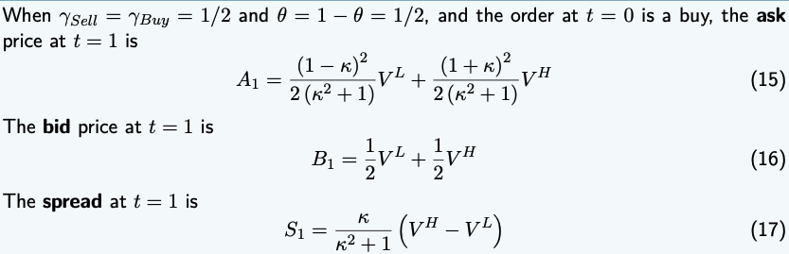
- If we use the same simplifying assumptions as earlier, we get
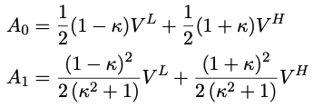
- To gain more intuition on the update of the ask price, compare the ask in both periods
    - Since clearly, 0 < k < 1, we see that A₁ > A₀
    - So, the ask is revised upwards after a buy at t = 0
    - Makes sense, as there is a positive probability the buy was performed by an informed trader
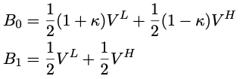
- Similar, we get for the bid price
    - Since clearly, 0 < k < 1, we see that B₁ > B₀
    - So, the bid is revised upwards after a buy at t = 0
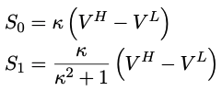
- For the spread, we get
    - Such that S₁ < S₀
    - If the order flow is informative for the dealer, he can learn from it
    - Needs less compensation for asymmetric info in period 1
Spread declines relative to previous period

Implications: PI of Trades
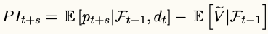
- For s = 0, we get the immediate (short-term) price impact
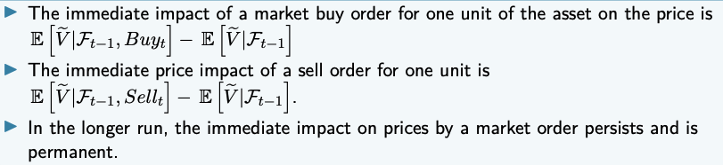
- We then get the following theorem
- Price impact was investigated for order processing and inventory models, but now with information included in the model, new questions arise
    - At time t, how much information is incorporated into prices?
    - Given that the market is dynamic, how fast is info incorporated?

Price Discovery
- The extent to which transaction prices reflect information, and the speed at which information is incorporated into prices
- Theorem: the market in our model is semi-strong-form efficient at each t
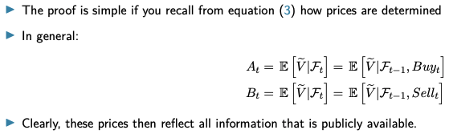
- Proof
- Counterintuitive; If the EMH holds, then why do bid & ask prices differ?
    - Spread is a compensation for asymmetric information (friction)
    - This drives transaction prices away from the fundamental value
    - Buy & sell order convey different info to the dealer
- Two prices not related to inefficient markets
    - It’s a result from the learning process of the dealer
    - It’s the process by which information in the order flow is incorporated into the prices
- Corollary
    - Semi-strong form efficiency implies that transaction prices in the model form a martingale
    - First differences of transaction prices are serially uncorrelated
    - In contrast with negative serial correlation implied by the inventory model
- Theorem: if there are informed traders in the market, prices converge to the fundamental value in the limit (when t goes to infinity), the market becomes strong-form efficient
    - Proof is beyond scope of this course, but is intuitive
- Speed at which price is discovered
    - Assume
      - Direction of trade at t is d_{t}
      - d_{t} = 1 for a buy and -1 for a sell order
    - Transaction price
    - Complete discovery if prices reflect all information ($p_{t}=V^{L}$)
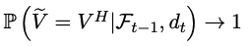
    - Speed of discovery measured by how fast transaction prices converge to V^{L}
    - We know that $p_{t}→V^{L}$ if
    - So, the speed of discovery is the speed at which
- Theorem: the speed of price discovery increases with the fraction of informed traders k
    - Proof is beyond scope of this course, but is intuitive
    - If the order flow is highly unbalanced, dealer can be certain of V^{H} faster
- Theorem: due to informed trading, there is a trade-off between market liquidity and informational efficiency
    - Impact of informed traders along the path to a strong-form efficient market leads to a trade-off that trading venues and regulators are face with
    - More informed trading leads to wider spreads and thus to market illiquidity
    - More informed traders also lead to faster price discovery

Measuring Asymmetric Information: PIN
- How can dealer estimate the risk of informed trading?
Model very similar to previous one, but ads event uncertainty
- Model setup
    - Single risky asset is traded over D trading days, indexed d = 1, … D
    - Within each trading day, time is continuous and indexed by t
    - Dealer sets bid-ask price at each point in time
    - Before trading, chance determines whether information event takes place
      - Information event occurs with probability $α$
      - The information event is bad news with probability $δ$
    - At end of trading day, full information is realised before new event occurs
    - Information events are independently distributed
    - Random variable that gives asset value at end of day d denoted as V_{d}
      - $V_{d}^{H}$ value if good news
      - $V_{d}^{L}$ value if bad news
      - $V_{d}^{no}$ value if no news
      - ${V_{d}^{L}<V}_{d}^{no}<V_{d}^{H}$
    - Informed traders
      - Can observe whether an event happens
      - Know if an event is good or bad
      - Arrive in the market according to a Poisson process at a rate $μ$
      - Are risk neutral & competitive
      - Optimal for them to buy when news is good, sell when it is bad
    - Uninformed traders
      - Don’t observe events or their outcome
      - Arrive according to two independent Poisson processes
$ε_{buy}$ for buyers and $ε_{sell}$ for sellers
    - Dealer
      - Risk neutral & competitive
      - Knows all model parameters
      - Doesn’t observe events or their outcome
      - Arrival of trades allows to learn and update beliefs about value
      - Assume updating is Bayesian
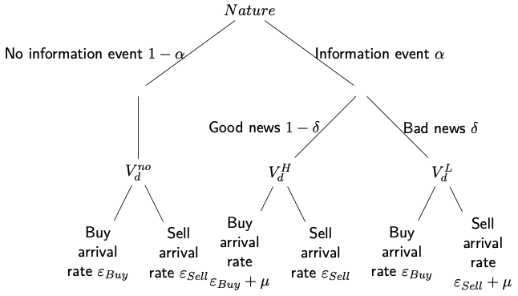
- Visualisation of the model
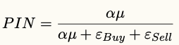
- Probability of informed trading (PIN)
    - Positively related with the spread
- Estimation procedure: how to estimate PIN based on data observable by market participants
    - Cannot observe whether there was information a given day
    - Observe order flow instead
      - On a good (bad) day, we expect more buy (sell) orders than normal
      - On days without event, less trading occurs (no informed trading)
    - Number of orders on day d
      - #Buys_{d} for amount of buy orders
      - #Sell_{d} for amount of sell orders
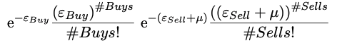
    - On a bad day (probability $α*δ$), we get
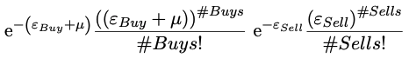
    - On a good day (probability $α*(1-δ)$), we get
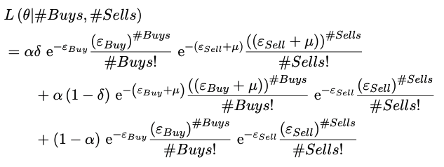
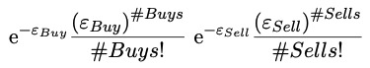
    - On a day without news (probability $1-α$), we get
    - Likelihood of observing #Buys and #Sells a given day, is the weighted avg.
    - On a particular day, information events only occur once
If we estimate the parameters of this model, they will be either 0 or 1
    - If data contains number of trades over multiple days, we can estimate parameters using series of daily numbers of buys & sells over D days
Denoted ${\left({\#Buys}_{d}, {\#Sells}_{d}\right)}_{d=1}^{D}$
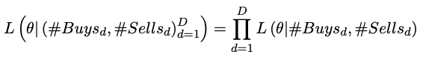
    - Days are assumed independent, so likelihood of observing ${\left({\#Buys}_{d}, {\#Sells}_{d}\right)}_{d=1}^{D}$is product of daily likelihoods
    - Maximising this likelihood over $θ$ given the data, provides estimates for the underlying structural parameters of the model
- Caveats
    - $α \& δ$ are probabilities and should be between [0, 1]
Can be achieved by a logit transformation of the unrestricted parameters
    - Arrival rates are positive, so $ε \& μ$ are restricted to the interval $[0, ∞]$ by logarithmic transform

2.4 Strategic Trading

Introduction
- Focus now on maximising trader profits, who has private information
- Trader trading as much as possible
    - Not good, as the dealer will learn quickly from the many trades performed
    - Trader has to try to hide its trades in the order flow of uninformed orders
    - Easier when variance of trades is high
Trader needs to carefully decide timing and trade sizes

Intuition of the Model
- Trader & dealer information
    - Uninformed traders (UT) who trade randomly for exogenous reasons
    - One informed trader (IT) who knows the fundamental value of the asset
    - Dealer sets price efficiently (semi-strong sense), conditional on information they have about quantities traded
    - Trading modelled as a series of auctions, each takes 2 steps
      - Informed & uninformed traders simultaneously choose quantities they will trade (market orders)
      - Dealer sets a price and takes the quantity which makes market clear
- One auction in detail
  - Step 1
    - IT’s info consists of private info and previous trading volumes & prices
    - IT does not observe future prices or volumes
    - IT takes into account effect its trading has on the auction and future ones
    - Random quantity of trading by UTs is distributed independently
  - Step 2
    - Dealer’s info consists of observations of current & past aggregate quantities
    - Dealer cannot distinguish trading between IT and UTs
    - Prices set by dealer equal expectation of fundamental value of the asset, conditional on the dealer’s information set
Dealer earns zero profit on average
Setup differs from Glosten & Milgrom (1985) in several ways
    - Timing: dealer sets price after order flow is observed
    - Traders choose their trade sizes
    - No bid-ask spread, only one clearing price
    - The model is a batch auction
    - Model does not analyse price of one individual trade
Model Setup
- Assumptions
    - One period
    - One risky asset with fundamental value $\tilde{V}$, assume $\tilde{V}\sim N(\overline{V},σ_{V}^{2})$
    - Traders can only submit market orders
    - Group of UTs
      - Trade a total quantity of $\tilde{u}$, assume $\tilde{u}\sim N(0,σ_{u}^{2})$
      - Trade for exogenous reasons, $\tilde{V} \& \tilde{u}$ are independently distributed
    - One risk neutral informed trader
      - Receives perfect informative signal about $\tilde{V}$
      - Has monopoly on private information
      - Trades a quantity $\tilde{x}$
    - Dealer is risk neutral and sets price $\tilde{p}$ after observing order flow
- Trading in 2 steps
  - Exogenous values $\tilde{V}$ and $\tilde{u}$ are realised
    - She observes $\tilde{V}$ but not $\tilde{u}$
    - IT chooses strategy: quantity $\tilde{x}$ she trades, depending on $\tilde{V}$
$\tilde{x}=X(\tilde{V})$
Aims to maximise profits: $E\left[\tilde{π} | \tilde{V}=V\right]=E[(\tilde{V}-\tilde{p})\tilde{x}|\tilde{V}=V]$
      - Optimal strategy depends on dealer’s pricing function $P(\tilde{V})$
      - Takes pricing rule of dealer as a given
      - Has monopoly on private info and exploits it
  - Dealer determines price
    - By choosing pricing $\tilde{p}$ at which he trades quantity necessary to clear market
Pricing rule: $\tilde{p}=P(\tilde{w})$
If perfectly competitive: $\tilde{p}=P\left(\tilde{w}\right)=E[\tilde{V}|\tilde{w}]$ (expected profits are 0)
    - Observes total order flow $\tilde{w}=\tilde{x}+\tilde{u}$, but not $\tilde{x}$ or $\tilde{u}$ separately
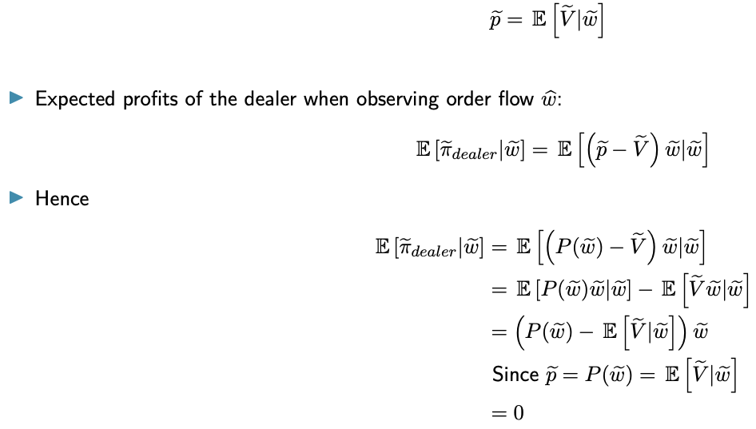
    - Proof that expected profits are 0
Model Solution
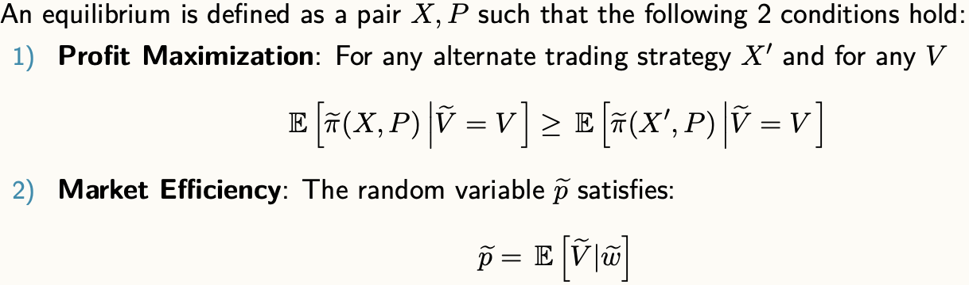
- Definition of an equilibrium
    - Dealer doesn’t explicitly maximise any particular objective
      - Competing market makers observe order flow and bid for it
      - Result is profits are driven to zero
    - Informed trader cannot condition quantity she wants to trade on the price
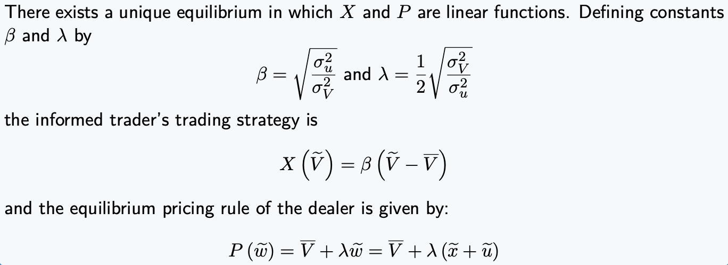
- Theorem 1
    - Optimal strategy of IT depends on variance of UT’s order flow
      - The higher the $σ_{u}^{2}$, the more the IT will trade
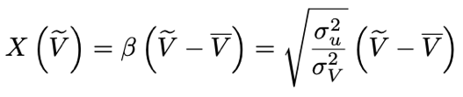
      - Uses variance to hide its trades from the dealer
    - Optimal strategy depends on variance of the asset’s value
      - The higher the $σ_{V}^{2}$, the less the IT will trade
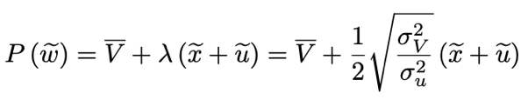
      - Dealer takes this into account, link between order size and price adjustment: $λ$ gives price adjustment of the dealer to order flow
      - Higher advantage of IT ($σ_{V}^{2}$), the stronger the dealer response ($λ$)
- Proof for theorem 1
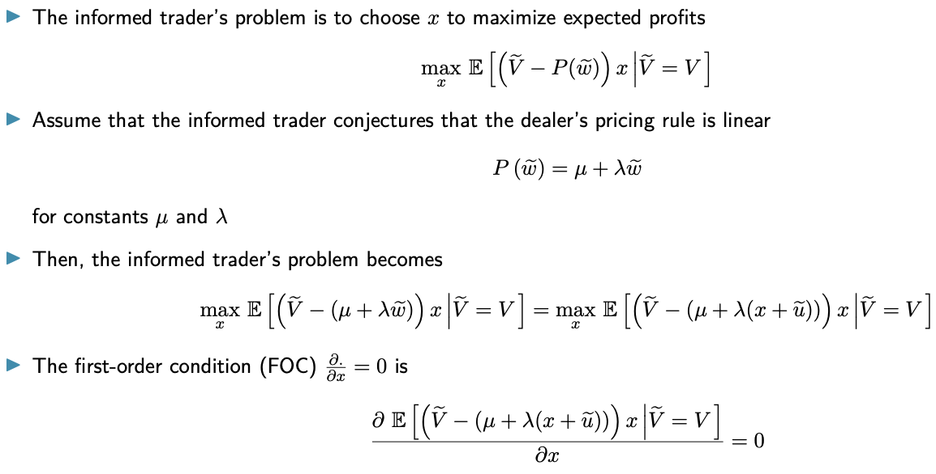
  - Conjecture that dealer uses linear pricing rule, then compute optimal strategy of IT

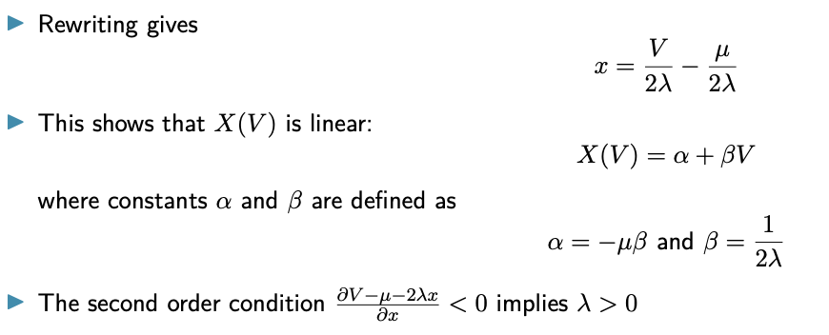
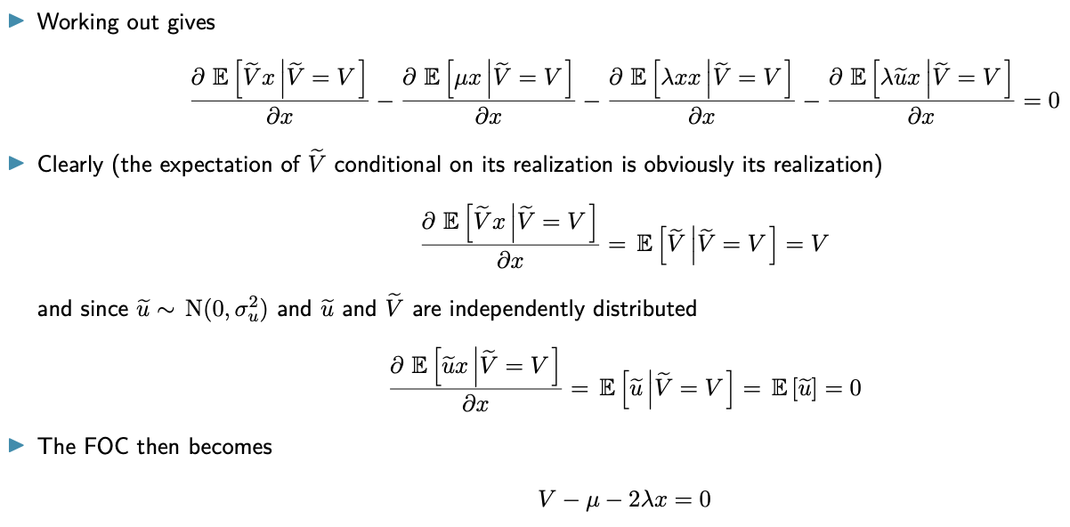

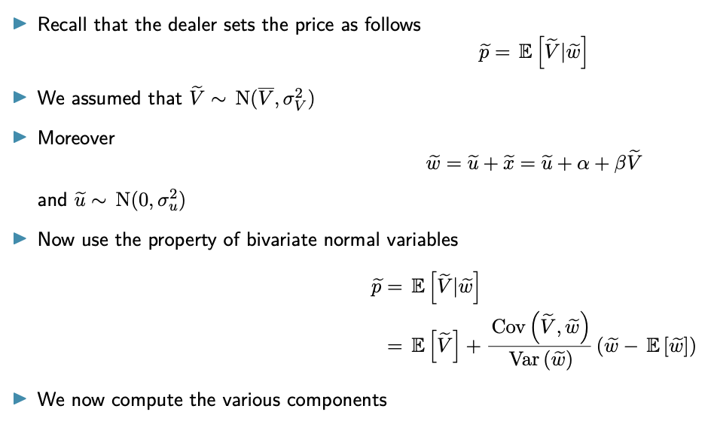
  - Show that conjectured pricing rule is consistent with optimal strategy of the IT

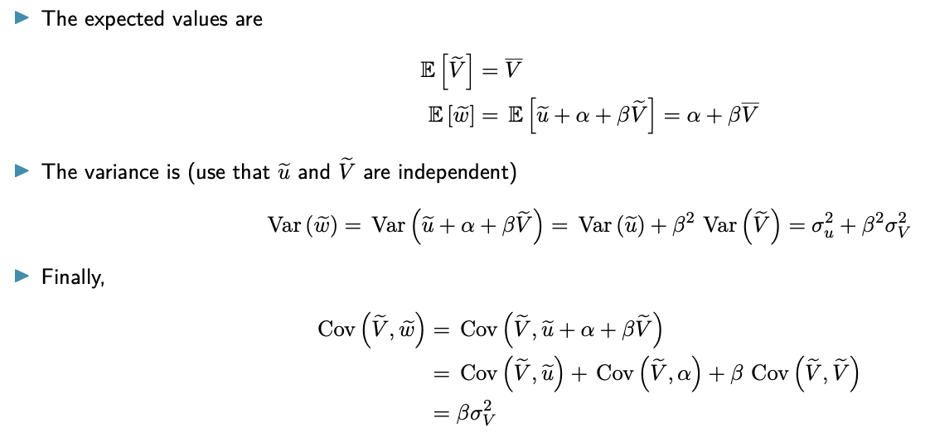
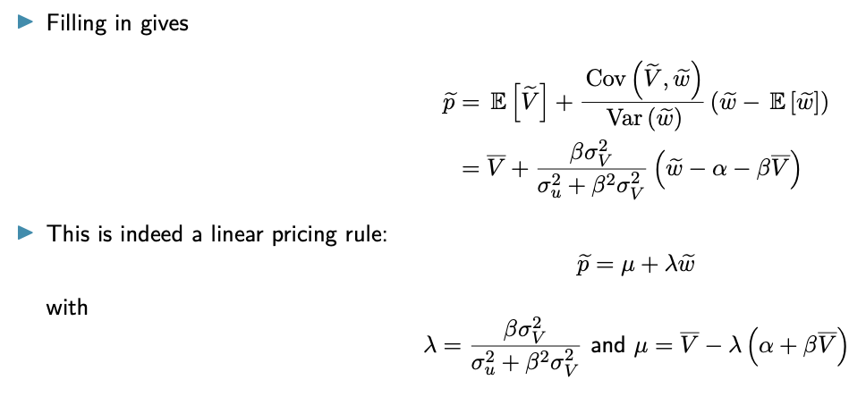
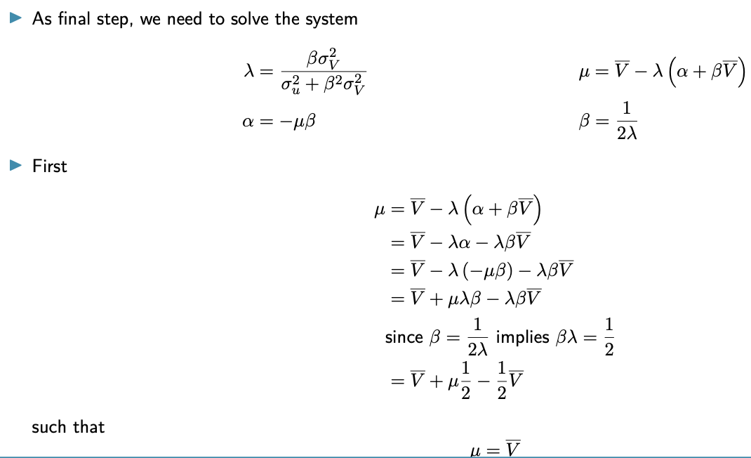

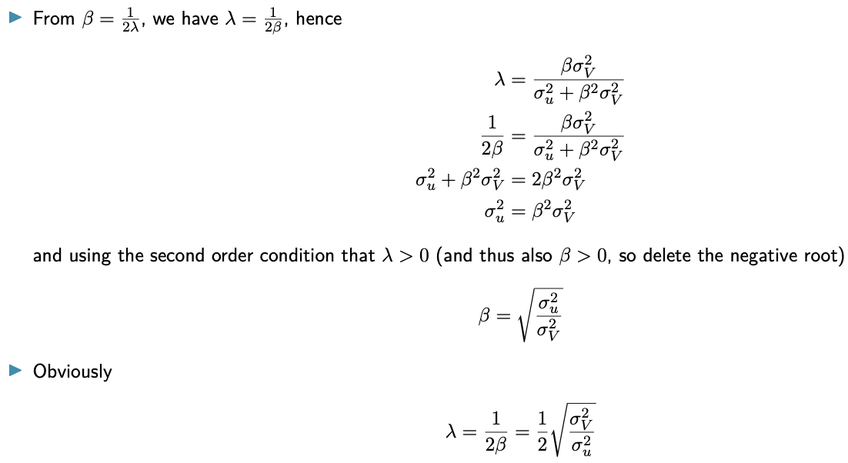
Equilibrium: Discussion & implications
- Market liquidity
    - Measured as the depth of the market
      - Order flow necessary to induce prices to rise/fall by €1
      - $1/λ$
      - Recall, $P\left(\tilde{w}\right)=\overline{V}+λ\tilde{w}$
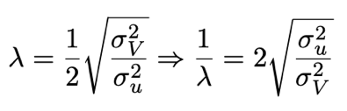
    - From theorem 1
      - This means depth is increasing in $σ_{u}^{2}$ and decreasing in $σ_{V}^{2}$
      - $σ_{u}^{2}$ is a measure of uninformed order flow
      - Dealer compensates himself for bad trades due to adverse selection of the IT by making market less liquid
- Price discovery
    - Measure of price informativeness is defined as:
$Σ_{1}=Var\left(\tilde{V} | \tilde{p}\right)=\frac{1}{2}σ_{V}^{2}=\frac{1}{2}Σ_{0}$
      - $Σ_{0}$ is variance of fundamental value before trading ($σ_{V}^{2}$)
      - $Σ_{1}$ is the variance of fundamental value after one round of trading (after the price has been observed)
      - Shows half the IT’s information is incorporated into the price
      - Volatility of prices unaffected by level of uninformed trading $σ_{u}^{2}$
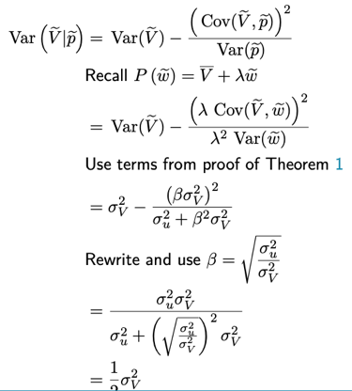
    - Proof: use property of bivariate normal projection
- Expected profit of the informed trader
    - $E\left[\tilde{π}\right]=\frac{σ_{V}^{2}}{4λ}=\frac{1}{2}\sqrt{σ_{V}^{2}σ_{u}^{2}}$
    - Expected profit of IT always positive
    - Does not mean they always make a profit
      - Assume IT buys x > 0
      - Dealer’s price depends on total order flow, incl. from UTs
      - Large surge of UT buying (u >> 0) leads to strong price impact above the realisation of V
      - Profits of IT can become negative then
    - In contrast with sequential trade model, where IT only trade if they profit
- Expected trading costs for the uninformed traders
    - $E\left[\tilde{TC}\right]=\frac{1}{2}\sqrt{σ_{V}^{2}σ_{u}^{2}} (=E\left[\tilde{π}\right])$
    - Intuitive, dealer makes zero expected profit
    - Expected transaction cost for UT should equal profit of IT

N-Period Model
- For multiple rounds of trading
    - IT must account for multiperiod impact of trades
    - Trading decisions in multiple periods are linked
    - Optimal strategy has to account for current & future profits
- There is a unique recursive linear equilibrium

(Setup & modelling of n-period model is not exam material, it is left out here)

- Equilibrium intuition & properties
    - Price discovery
      - $Σ_{n}$, measuring informativeness of prices declines monotonically
Information is gradually incorporated into prices
      - $Σ_{n}>0$, so not all information is incorporated by the end of trading
    - Informed trading
      - Has to ‘slice & dice’ their order flow, distributing over N auctions (corresponds to real world practice of splitting orders)
      - In sequential trade models, orders are positively autocorrelated (buys are followed by buys)
      - Here, orders are split but still on the same side
Expect positive autocorrelation to persist (diluted by noise)
But total order flow is uncorrelated!!!

2.5 Empirical Models

Introduction
- We studied
    - Three determinants of bid-ask spread
      - Order processing costs
      - Inventory
      - Asymmetric information
    - Immediate long-run price impact of buy transaction according to models of these 3 factors
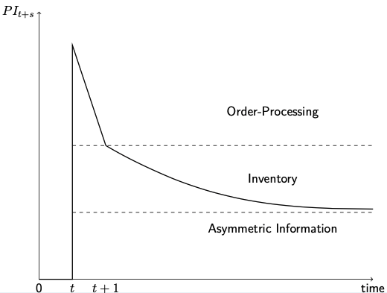
- Graphically: impact of buy order at time t, on expected future prices
- Insights drawn from this figure
    - Size of spread and immediate price impact is determined by the 3 effects
Immediate price impact
      - Spread composition to determine relative contribution of order processing costs
      - Inventory and asymmetric information to the size of the spread
    - Long run price impact determined entirely by asymmetric information
Long run price impact
    - Order flow contains information
Measure for contribution of order flow to price discovery

Components of Bid-Ask Spread
- Which determinant of the bid-ask spread is the most important one?
Answer has important policy implications
    - Spread can be seen as a friction to trading (cost)
    - How can we decrease friction (lower the spread)?
    - We need to know what drives the spread
      - Real frictions: improve trading system
      - Market power: increase competition
      - Asymmetric information: improve transparency
- Different approaches applied to measure components of bid-ask spread
    - Autocorrelation methods (Roll, 1984)
    - Trade indicator models (Glosten & Harris, 1988 and Madhavan…, 1997)
    - General method by Huang & Stoll in 1997
- The econometric model
  - $V_{t}$: Fundamental value of asset at time t
    - Influenced by news (public $ε_{t}$ or private)
      - Private new reflected in trades (see earlier)
      - $α$: percentage of the half-spread S/2 due to asymmetric information
Total amount of private information in previous trade is $α\frac{S}{2}$
    - $d_{t-1}$
      - Direction of the trade at t – 1
      - 1 if it was a buy, -1 for a sell
    - Two components driving change in V
      - $V_{t}=V_{t-1}+α\frac{S}{2}d_{t-1}+ε_{t}$
      - Problem: $V_{t}$ is unobserved
      - Need to look at variable we can observe, like midquote $M_{t}$
  - Midquote $M_{t}$
    - Dealer adjusts midquote depending on inventory level, to reduce inventory
    - Assume trades are of size one: inventory at time t – 1 is $\sum_{i=1}^{t-1}{d_{i}}$
    - Denote proportion of half-spread that is due to inventory effects as $β$
    - Due to inventory effect, midquote will deviate from fundamental value by $β*\frac{S}{2}*\sum_{i=1}^{t-1}{d_{i}}$
    - So we get $M_{t}=V_{t}+β\frac{S}{2}\sum_{i=1}^{t-1}{d_{i}}$
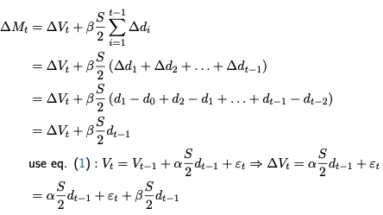
Take first differences to get $∆M_{t}=(α+β)\frac{S}{2}d_{t-1}+ε_{t}$
  - Price of a trade $P_{t}$
    - Price is either the ask or the bid
    - This is equal to the midquote plus or minus half the spread
$P_{t}=M_{t}+\frac{S}{2}d_{t}$
    - In practice a min. price variation (tick size) exists, so prices aren’t continuous
      - Discreteness in prices may lead to rounding errors
      - Account for this using $η_{t}$, deviation of observed half-spread $P_{t}-M_{t}$
$P_{t}=M_{t}+\frac{S}{2}d_{t}+η_{t}$
    - Taking first differences we can rewrite
      - $∆P_{t}=(α+β)\frac{S}{2}d_{t-1}+\frac{S}{2}(d_{t}-d_{t-1})+e_{t}$
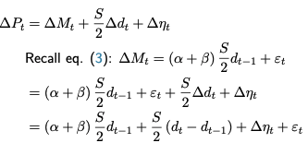
      - Where error term is $e_{t}=∆η_{t}+ε_{t}$
    - Take equation to data and estimate
      - Spread S
      - Percentage due to inventory & asymmetric information $(α+β)$
      - Part of spread due to order processing costs $1-α-β$
      - Doesn’t allow to disentangle inventory & asymmetric information
  - Disentangle inventory and asymmetric information components
    - Dealer adjusts midquote to eliminate inventory over time
      - After buy: dealer increases bid & ask to attract sellers
      - After sell: dealer decreases bid & ask to attract buyers
    - Implications
      - After a buy, probability of observing a sell is higher than 50%
      - Negative serial covariance in trades and changes in prices according to inventory models
Use this to identify inventory component
    - $π$ is probability that trade at t – 1 is opposite to trade at t – 2
      - $E\left(d_{t-1} | d_{t-2}\right)=π\left(-d_{t-2}\right)+(1-π)d_{t-2}$
$E\left(d_{t-1} | d_{t-2}\right)=(1-2π)d_{t-2}$
      - Implies there is predictable information contained in trade at t – 2
      - Trade at t – 1 is consequence of private information and of predictable information due to inventory effects
    - To get information effect of trade at t – 1, need to remove predictable part
      - $V_{t}=V_{t-1}+α\frac{S}{2}[d_{t-1}-\left(1-2π\right)d_{t-2}]+ε_{t}$
$V_{t}=V_{t-1}+α\frac{S}{2}d_{t-1}-α\frac{S}{2}\left(1-2π\right)d_{t-2}]+ε_{t}$
      - When $π=50\%$, then trade is totally unpredictable and equation reduces again
    - Change in transaction price becomes
$∆P_{t}=\frac{S}{2}d_{t}+\left(α+β-1\right)\frac{S}{2}d_{t-1}-α\frac{S}{2}\left(1-2π\right)d_{t-2}+e_{t}$
  - Putting it all together
    - Estimate model jointly
      - $∆P_{t}=\frac{S}{2}d_{t}+\left(α+β-1\right)\frac{S}{2}d_{t-1}-α\frac{S}{2}\left(1-2π\right)d_{t-2}+e_{t}$
      - $E\left(d_{t-1} | d_{t-2}\right)=(1-2π)d_{t-2}$
    - Using this, we can estimate
      - Traded spread S
      - Part of spread due to asymmetric information $α$
      - Part of spread due to inventory costs $β$
      - Part due to order handling costs $1-α-β$
      - Probability of a trade reversal $π$
    - If traded spread is not needed, you can estimate more parsimonious model
      - $∆M_{t}=\left(α+β\right)\frac{S_{t-1}}{2}d_{t-1}-α\left(1-2π\right)\frac{S_{t-2}}{2}d_{t-2}+e_{t}$
      - $E\left(d_{t-1} | d_{t-2}\right)=(1-2π)d_{t-2}$
      - Constant traded spread replaced by posted spread
- An example and its empirical consequences
    - Empirically possible but theoretically impossible
      - $α<0$: adverse information cannot be negative if one investor can be better informed than the ones setting quotes
      - $π<50\%$: impossible as negative serial covariance is required
    - How are these results possible then
      - Large order can be negotiated at a single price but reported in a series of smaller trades
      - Single large limit order can be executed at a single price against various incoming market orders
    - Solutions
      - Collapse sequences of related trades to just one order
      - Treat clusters of trades at same price & quotes as single orders
    - Grouping in this way will overcorrect (also bundle unrelated trades)
Will provide an upper bound on
      - The adverse information component
      - The probability of price reversal

Price Impact of Trading
- Price impact of trades contains information (Glosten-Milgrom), there are two components
    - Permanent (persistent) component: related to informed trading
    - Temporary (transient) component: related to inventory, order-processing…
- Information impact of a trade according to Hasbrouck (1991)
    - Ultimate impact on stock price resulting from unexpected component
    - Persistent price impact of the trade innovation
    - Preferred to the immediate impact because not contaminated by transient
    - Trade innovation taken to exclude predictable portion of the trade
- The econometric model
  - Assumptions
    - Denote ask and bid quotes as $A_{t}$ and $B_{t}$, midquote as $M_{t}$
    - Follow timing convention
      - Trade at t occurs at the quotes in the beginning of the period
      - Prices therefore where set in t – 1
      - After trade in t, public information arrives
      - The dealer then updates quotes
    - Focus on the midquote, ask & bid are set symmetrically around midquote
      - Information contained in trade t is given by revision in the midquote
      - Revision denoted as $r_{t}$ and measured in dollars: $r_{t}=M_{t}-M_{t-1}$
      - Revision can be due to public and private information
    - To make meaningful interpretation of price impact of trade, we must
      - Assume the function relating the quote revision to the information contained in trade is constant over time
      - Assess the ‘average’ price impact of the trade
  - First specification
    - Denote size of trade as $x_{t}$ and assume linear relation
$r_{t}=β_{0}x_{t}+ε_{r,t}$
      - Error term $ε_{r,t}$ reflects public information (news)
      - $β_{0}$ measures price impact of trade
    - Assume error terms have zero mean and are jointly and serially uncorrelated
    - Clear this specification is incomplete, considering other information
      - Inventory effects result in serial dependence in midquotes
      - Serial correlation from price smoothing imposed by exchanges etc.
      - Price discreteness induces threshold effects
  - More flexible specification
    - $r_{t}=α_{1}r_{t-1}+α_{2}r_{t-2}+…+β_{0}x_{t}+β_{1}x_{t-1}+…+ε_{r,t}$
    - Inventory model predicts there is serial correlation in trades, so we model them in a similar way
$x_{t}=γ_{1}r_{t-1}+γ_{2}r_{t-2}+…+δ_{0}x_{t}+δ_{1}x_{t-1}+…+ε_{r,t}$
    - Together, these equations form bivariate vector-autoregressive model (VAR)
    - Specification of VAR implies
      - Quote revision follows the trade
      - $r_{t}$ cannot contemporaneously influence $x_{t}$
      - Agents in market use VAR to estimate the t^{th} trade
      - If any news in trade $x_{t}$, it must be in the innovation $ε_{xt}$
    - Impulse response functions, computed on basis of VAR and its estimated coefficients, then allow to compute information content

  - Intuition
    - Assume start in steady state
      - All lagged values of r and x are zero
      - Ask & bid quotes are equal to unconditional expectation of the value
      - At t = 0, order of size $ε_{x0}$ arrives, this makes $x_{0}=ε_{x0}$ (see earlier)
      - Assume no innovations in r
$ε_{rt}=0$ for all t
No further innovations in trades such that $ε_{xt}=0$ for $t≥1$
      - Filling in $x_{0}$ in equation for $r_{t}$ then allows to compute $r_{0}$
      - This value then can be put into equation for $x_{t}$ to get $x_{1}$ and so on
    - Iteration computes $E\left(r_{t} | ε_{x0}\right)$ and $E\left(x_{t} | ε_{x0}\right)$ for $t≥1$
      - Sum of predicted quote revisions until step s is $\sum_{t=0}^{s}{E\left(r_{t} | ε_{x0}\right)}$
      - Expected cumulative quote converges to revision in efficient price
      - $\sum_{t=0}^{s}{E\left(r_{t} | ε_{x0}\right)}$ can be interpreted as information revealed by an unexpected trade and is the permanent price impact
- Trade size problem
    - VAR model is linear in trade size $x_{t}$
      - Makes comparisons between stocks difficult
      - Results may depend on small number of large trades
    - Solution: replace $x_{t}$ with indicator value $d_{t}$ where
      - $d_{t}=1$ if $x_{t}≥0$
      - $d_{t}=0$ if $x_{t}=0$
      - $d_{t}=-1$ if $x_{t}<0$
    - Hasbrouck includes 5 lags of each endogenous variable
    - $r_{t}$ is the change in the midquote in dollar
    - Hence the VAR becomes
      - $r_{t}=\sum_{i=1}^{5}{α_{t-i}r_{t-i}}+\sum_{i=1}^{5}{β_{t-i}d_{t-i}}+ε_{rt}$
      - $d_{t}=\sum_{i=1}^{5}{γ_{t-i}r_{t-i}}+\sum_{i=1}^{5}{{δ_{i}d}_{t-i}}+ε_{dt}$
      - Estimated using OLS estimates of multiple equation system
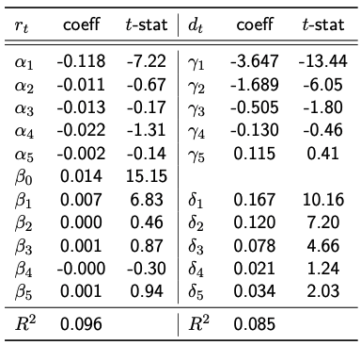
- Example and insights
    - After unexpected buy order, midquote revised upwards by $0,014 ($β_{0}$)
    - Coefficients of lags of $d_{t}$ in the $r_{t}$ equation remain positive, decline quickly
    - Positive serial correlation in trades (see $δ$ in $d_{t}$ equation)
      - Axiomatic: negative serial correlation predicted by inventory model
      - Consistent with lagged adjustment of prices to new information
    - Compute cumulative response to unexpected buys
      - After 20 transactions, response converges to roughly $0,028
      - Convergence thus happens fast but not instantaneous

- Extension
    - Possible that both size and direction of trade provide information
There may be non-linear effects
    - Account for this using a VAR model containing 4 variables (4 equations)
      - {$r_{t}, d_{t}, x_{t}, x_{t}^{2}$}
      - Where $x_{t}^{2}=d_{t}{|x_{t}|}^{2}$

Price Discovery: Information in Order Flow
- What is the contribution of trades to price discovery
    - Trades have both permanent and temporary impact on prices
    - Trades are driven by private information and need of liquidity
- Econometric model
  - Assume at time t
    - Signed trade volume is $x_{t}$
    - Midquote $M_{t}$ is sum of unobservable components: $M_{t}=M_{t}^{*}+s_{t}$
    - Prices specified as logarithms: quote revisions can then be interpreted as returns
  - Timing assumptions
    - Trade $x_{t}$ is executed at prices set in previous period
    - Then, non-trade public information arrives
    - Dealers posts new quotes $M_{t}$
    - Midquote $M_{t}$ is thus the quote after trade t
  - First component $M_{t}$
    - $M_{t}^{*}=E_{t}[\tilde{V}]$
      - Can be interpreted as efficient price
      - Is expectation about asset’s fundamental value conditional on all public information at time t
    - Assume efficient price follows a random walk $M_{t}^{*}=M_{t-1}^{*}+ε_{t}$
      - $ε_{t}$ is public news arriving in the market
      - $E\left[ε_{t}\right]=0$, $E\left[ε_{t}^{2}\right]=σ_{t}^{2}$ and $E\left[ε_{t}ε_{t'}\right]=0$ for all t’ ≠ t
  - Second component
    - Captures all temporary, transient microstructure frictions that cause midquote to deviate from efficient price (order processing costs…)
    - Assume it is zero mean non-deterministic stochastic process, jointly covariance stationary with $ε_{t}$
    - Covariance stationarity assumption models transient property as it implies that as $k→∞$, we have $E_{t}\left[s_{t+k}\right]→0$
    - Allow $s_{t}$ to be serially correlated and partially correlated with the $ε_{t}$ history
  - Trade innovation
    - Informativeness of a trade is then measured as the ‘trade innovation’
      - Is equal to the private information captured by a trade
      - $x_{t}-E\left[x_{t}|Φ_{t-1}\right]$ with $Φ_{t-1}$ the public information set at t – 1
    - Impact of trade innovation on efficient price innovation is
      - $E[ε_{t}|x_{t}-E\left[x_{t}|Φ_{t-1}\right]]$
    - Measure of trade informativeness becomes: $\frac{Var(E[ε_{t}|x_{t}-E\left[x_{t}|Φ_{t-1}\right]])}{Var(ε_{t})}$
      - Variance of the contribution of the trade innovation to public news, relative to the variance of public news
      - Percentage of the variance in the random-walk component of the stock price that is attributable to trades
    - Measure can be estimated using the VAR model from before
      - Technically, move to a vector moving average (VMA) representation
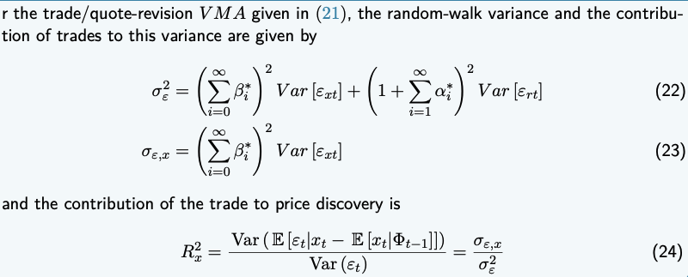
      - Assuming public information set only contains past quote revisions and trades, trade informativeness can be measured as follows
- Illustration: results in Hasbrouck (1991) for one representative stock
    - Most econometric packages will estimate VAR, VMA and compute the variance decomposition
    - Panel A: VAR model uses only
      - Quote revisions
      - The signed trade indicator variable $\{r_{t},d_{t}\}$
      - Truncated at lag 3
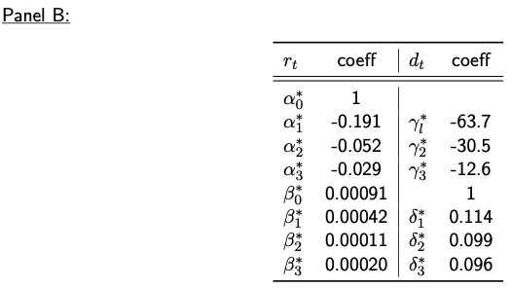
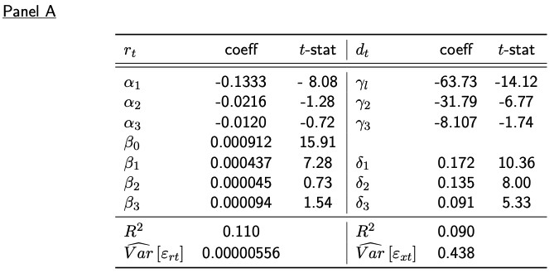
    - Panel B: VMA also truncated at lag 3

    - Sum of $ε_{xt}$ coefficients in VMA equation for $r_{t}$ causes an ultimate log price charge of 0,00164 ($\sum_{i=1}^{3}{β_{i}^{*}}$)
    - Trade innovation variance is $Var\left(ε_{xt}\right)=0,438$ (per event)
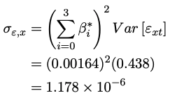
    - From equation (23) in the proposition, the random walk decomposition is
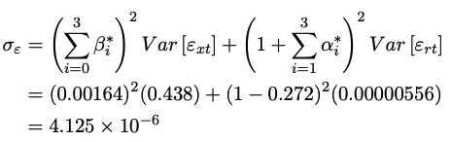
    - From equation (22) we then get
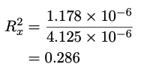
    - From these values: 28,6% of variance in random-walk component of stock price is attributable to trades
- Extension
    - Allow $x_{t}$ to be a column vector of trade variables
    - Coefficients then also become matrices with dimensions conformable to the size of the trade variables vector
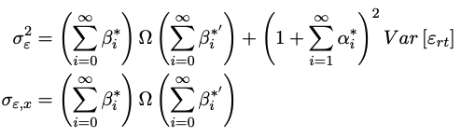
    - Let $Var\left(ε_{t}\right)=Ω$ then the formulas in the proposition become

3.1 LOM Introduction: Order-Driven Markets

Introduction
- Focus of this part are limit order markets (LOM, order-driven markets)
  - Almost all major exchanges have an important order-driven element
  - Some alternative trading systems function as anonymous limit order books
  - Other securities trade in LOM: bonds, derivatives, forex…
- Intriguing result in Glosten (1994)
  - Order book has small-trade positive spread
  - Limit orders profit from small trades
  - Exchange provides as much liquidity as possible in extreme situations
  - Limit order book doesn’t invite competition from third market dealers, while other trading institutions do
  - If entering an exchange earns nonnegative trading profits, consolidated price schedule matches the limit order book price schedule
- Difference between market and limit orders
  - Dealer market: sharp distinction between liquidity suppliers and demanders
  - LOM: distinction becomes blurred
  - Agents dynamically chooses whether they want to supply or demand liquidity
Order choice will be a main topic in this part on LOMs
- Differences
  - No dealers with an obligation to post quotes
  - Trading is directly between traders
  - Traders have to choose between submitting limit order (LO) and market order (MO)
    - We ignore other order types
    - Marketable limit orders are considered to be market orders
  - LO are stored in limit order book for possible future execution against incoming MO
    - MO are said to demand liquidity from the market
    - LO are said to supply liquidity from the market

Continuous Order-Driven Market
- Assumptions
  - Empty limit order book (LOB)
  - Tick size is €0,01
- Look at how LOB is affected by a number of incoming orders
  - Stage 1: 5 limit orders come in
    - Sell at price €10,2; quantity 100
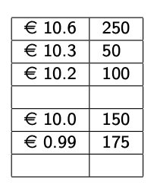
    - Sell at price €10,3; quantity 50
    - Sell at price €10,6; quantity 250
    - Buy at price €10; quantity 150
    - Buy at price €0,99; quantity 175 (typo)
  - Stage 1: outcome
    - Best ask is €10,2, best bid is €10
    - Spread is €0,2 (2 ticks)
    - Depth at best ask is 100 shares, at best bid is 150
  - Stage 2
    - Order precedence rules
      - Price priority: order with better price executed first
      - Time priority: when orders have same price, earliest executed first
    - Market order comes in to buy 50 shares
Depth at best ask decreases by 50 shares (100 50)
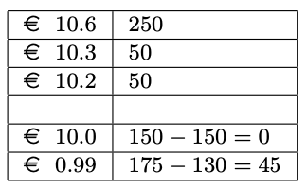
    - Market order to sell 280 shares is placed
      - Order is first executed at best bid of €10
      - Other 130 shares are sold at €0,99
Market orders without price limit is dangerous!
  - Stage 3
    - Limit buy order comes in for 50 at €10,3
Marketable limit order, execute at best possible price (€10,2)
    - Limit buy order comes in for 100 at €10,3
Partly marketable limit order, execute where possible and add 50 to book

Limit Order Markets Close-up
- Buy & sell orders from investors matched directly without intermediaries
  - Exception: brokers = agent who transmits orders but does not take own positions
  - Buyers & sellers interact directly
  - Matching is via computer (occasionally via trading floor)
- Matching can be
  - Immediate upon submission (continuous LOM)
  - At discrete intervals (call or batch auction)
- Other order types
  - Reserve (iceberg) or hidden order: order party or fully hidden, executed in parts
  - Stop order
    - Order triggered when a specified price limit is reached
    - Above stop limit for a buy order, below for a sell order
    - Stop loss order: LO or MO generated when price is hit
  - Pegged order
    - LO to buy/sell a stated amount at price set to track current order book
    - Associated price of each pegged order will be assigned a new entry time with new time priority
    - Can have limit price which will cause pegging to stop
Basically, order adjusts price to minimise costs
- Wide range of order parameters are possible, depending on exchange
  - Validity: good till cancelled, end of day, one hour…
  - Execution parameters: immediate or cancel, fill or kill, minimum quantity…

Non-continuous LOMs
- Execution happens periodically, at discrete points in time: call (or batch) auction
  - MO and LO are collected in a book
  - If all orders cleared at the same price = uniform (or single) price auction
- Procedure
  - All buy orders collected & sorted by decreasing limit price (buy MO highest possible)
  - All sell orders sorted by increasing limit price (sell MO highest possible price)
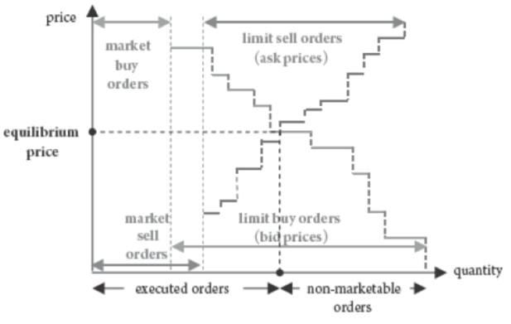
Result: cumulative quantity to be bought or sold at each price
  - Price set in the auction is point where 2 schedules intersect (market equilibrium)
    - Buy orders with higher price and sell orders with lower price are executed
    - Order with clearing price may be executed partially depending on volume
    - Other orders are not executed and remain on the books if not cancelled
  - Opening price on Euronext is determined by a batch auction
  - Some exchanges use the same to determine the closing price

Complexity of LOMs
- Despite simplicity of Los, economic interactions in LOMs are complex
- Associated state and action spaces are extremely large
  - Which limit prices to choose?
  - Which quantity at which price?
  - Combination of LO & MO?
  - High dimensionality of limit order markets is a challenge for theoretical modelling and empirical estimation as well as for trading
- Trading with LOs generates non-linear payoffs and is dynamic
  - LOs execute against future MOs and competes against existing LOs and future ones
  - When choosing limit prices & quantities for LOs and choosing quantities for MOs
    - Trader needs condition on everything that can affect the future evolution of trading process
    - This can include complete description of existing LOB (all quantities for multiple orders at multiple prices from multiple past investors at multiple points in time)
    - Dynamic trading strategies involve decisions about how frequently to monitor market conditions and when/how to modify unexecuted LOs

Order Choice
- Choice of traders between MOs and LOs is important; it determines liquidity in LOM
- Traders face dilemma: which type to choose, what are main trade-offs?
  - Limit order
    - Better price: you earn spread
    - Execution risk: part of order may not get executed
    - Picking off risk
      - LO gives option to other traders to trade at quoted prices
      - Are at informational disadvantage, picked off by later investors
      - LO can become mispriced after new public information is known
      - More likely LO will trade at a loss (winner’s curse)
  - Market order
    - Worse price: you pay the spread
    - Price impact
    - Certain execution
- Most important determinants of the choice between both are
  - Bid-ask spread
  - Volatility of the fundamental value of the asset
  - Depth at the own and other side of the market
  - Composition of the trading population
- Models analysing determinants
  - Parlour (1998): focus on time priority rule, shows how choice between MOs & LOs depends crucially on the depth of both sides at time of submission
  - Foucault (1999): focus on winner’s curse problem, arises when LO submitters cannot cancel their order. Picked off by new public information (volatility important!)
  - Foucault, Kadan & Kandel (2005): determinants of price formation process and of strategic order submission choice are speed of agents’ arrival, their waiting costs and the composition of the trading population

3.2 LOM Theory: Endogenous Order Choice

Execution risk
- Simplified version from Foucault (1999) model
- Model setup
  - Consider the market for 1 asset, all orders are for 1 unit of the asset
  - Trading day divided into discrete time intervals indexed t = 1, 2, 3… $\tilde{T}$
    - $\tilde{T}$ is random and unbounded end date at which trading stops and payoff of the asset realises
    - Random since each period t there is a probability $1-ρ>0$ trading stops
    - $ρ$: captures trading risk, probability that trading continues the next period
  - Each time interval t, one trader arrives in the market
  - Asset has fundamental value V, which we assume constant over time
  - Traders have different personal value they attach to the target
    - Difference can stem from different sources (opinion, preference…)
    - Reservation price difference generates gains from trades, transaction motive
    - Traders are risk-neutral and maximise expected utility
    - Traders account for other traders’ optimal strategies
  - Value of for a trader at t is $V+{\tilde{β}}_{t}$, which exists of
    - V: fundamental value of the asset
    - ${\tilde{β}}_{t}$: personal value
      - Fraction k has a high personal value for asset $β_{h}$
      - Fraction 1 – k has a low personal value for asset $-β_{l}$
    - To simplify, assume $β_{h}$ traders only submit buy orders, $-β_{l}$ only sell
  - Assume limit orders remain in the book for one period and expire afterwards
    - LO can only be executed if hit by the next trader
    - Once submitted, an LO cannot be modified or cancelled
  - If trader at t is type $β_{h}$
    - Person will only consider buying; has 3 strategies
      - Submit a buy limit order, LOBuy
      - Submit a market order, MOBuy
      - Submit no order
    - If indifferent between MOBuy and LOBuy, will choose market order
    - If book is empty, will submit a limit order
    - Similar for trader $-β_{l}$, can choose between LOSell, MOSell or no order
- Optimal pricing of orders
  - Assume trader at t is a buyer ($β_{h}$) and submits an LOBuy
    - Needs to determine the bid price accounting for the execution probability
    - Only executed if
      - Trading continues next period (probability $ρ$)
      - Next trader is a seller ($-β_{l}$, probability 1 – k)
      - Next trader submits an MOSell
    - First two are exogenous, third one endogenous
      - Next trader more attracted to MOSell if posted bid price is attractive
      - Trader wants to maximise gains, cannot set bid price too low
  - Key insight: buyer at t has to set bid price equal to level at which seller at t + 1 is indifferent between LOSell and MOSell, if he sets price higher than this:
    - Higher bid does not increase execution probability: seller at t + 1 is already convinced to submit an MOSell
    - It does reduce expected profit from LOBuy at time t
  - Denote optimal bid price at t as ${\hat{B}}_{t+1}={\hat{B}}_{t+1}(V,β_{l})$
    - Is function of optimal value V and personal value of seller $β_{l}$
    - If trader $β_{h}$ submits LOBuy at t and a seller $β_{l}$ appears at t + 1, it will execute through an MOSell
Expected gain of LOBuy at t is $V+β_{h}-{\hat{B}}_{t+1}$ is sale is certainly executed
    - There is uncertainty about trading and the type of trader at t + 1
We get an expected gain of $ρ(1-k)(V+β_{h}-{\hat{B}}_{t+1})$
  - Gain from an MOBuy submitted at t
    - Ask at which $β_{h}$ is indifferent between MOBuy & LOBuy: ${\hat{A}}_{t}={\hat{A}}_{t}(V,β_{h})$
    - Gain of MOBuy is then $V+β_{h}-{\hat{A}}_{t}$
    - Buyer indifferent if both MOBuy and LOBuy yield same return
$V+β_{h}-{\hat{A}}_{t}=ρ(1-k)(V+β_{h}-{\hat{B}}_{t+1})$
    - Same reasoning for seller $β_{l}$ arriving at t
${\hat{B}}_{t}-(V-β_{l})=ρk({\hat{A}}_{t+1}-\left(V-β_{l}\right))$
- Equilibrium order strategies
  - Problem does not depend on period
    - Fundamental value remains the same
    - Traders at t or at t + j solve the same problem
Can drop time subscripts, use stationary solution for equilibrium
  - For $\hat{A}, \hat{B}$ independent over time, use following system
    - $V+β_{h}- \hat{A}=ρ(1-k)(V+β_{h}-\hat{B})$
    - $\hat{B}-(V-β_{l})=ρk(\hat{A}-\left(V-β_{l}\right))$
  - We receive the following optimal equilibrium bid & ask quotes
    - $A^{*}=\hat{A}=V-β_{l}+\frac{1-ρ\left(1-k\right)}{1-ρ^{2}k\left(1-k\right)}(β_{h}+β_{l})$
    - $B^{*}=\hat{B}=V+β_{h}-\frac{1-ρk}{1-ρ^{2}k\left(1-k\right)}(β_{h}+β_{l})$
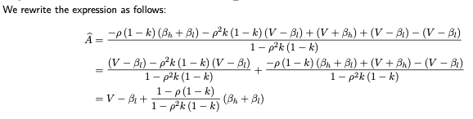
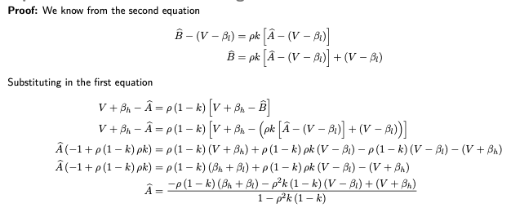
  - Proof

  - Now assume proportion of each type of trader is 0.5
    - $A^{*}=V-β_{l}+\frac{2(β_{h}+β_{l})}{2+ρ}$
    - $B^{*}=V+β_{h}-\frac{2(β_{h}+β_{l})}{2+ρ}$
Spread $=(β_{h}+β_{l})\frac{2-ρ}{2+ρ}$
    - Spread is increasing in execution risk; intuition:
      - Decrease in $ρ$ means probability of continued trading decreases
      - Lowers probability that LO will get executed, so MO more attractive
      - Means LO must be less aggressively priced to attract next trader
      - Less aggressive price means higher ask & lower bid, so wider spread

Volatility
- Now present picking-off risk
- New & updated assumptions (building on previous ones)
  - Value of asset is ${\tilde{V}}_{t}+{\tilde{β}}_{t}$
    - ${\tilde{β}}_{t}$ is still personal valuation of trader
    - Fundamental value not constant, assume random walk ${\tilde{V}}_{t+1}={\tilde{V}}_{t}+{\tilde{ε}}_{t+1}$
    - ${\tilde{ε}}_{t+1}$ is the arrival of public information
      - Is independent and identically distributed
      - Takes values $+σ$ or $-σ$, each with probability 0.5
  - If value of asset changes, limit orders can become mispriced when new info arrives
    - Trader at t prices order according to current information
    - Trader at t + 1 knows realisation of news in that period ($+σ$ or $-σ$)
    - This may cause order from t to become mispriced
Winner’s curse: LO more likely to become executed (at a loss) if mispriced
Trader at t + 1 more likely to submit an MO to profit from mispricing
  - Corollary: all other things equal, proportion of LOs in order flow increases with the volatility of the fundamental value of the asset
    - If volatility is high, picking off risk for LO traders is high
    - Their reservation spreads rise and post less attractive offers
    - Cost of MO trading rises, LO trading is more frequently the optimal strategy
  - Possible test: regress proportion of LOs on volatility
    - Sign of volatility coefficient should be positive
    - Problem: volatility not directly observable
    - Solution by Hasbrouck (1991)
      - Decompose mid-quote into random walk and residual discrepancy
      - Interprets random walk component as asset’s efficient value
      - Shows how to estimate volatility using changes in mid-quotes and trade innovation
- Fill rate of LOs: total number of LOs executed divided by total number of LOs submitted
  - Corollary: Other things equal, expected LO fill rate decreases with asset volatility
    - In markets with high volatility, LO traders shade prices more because there is a higher risk of being picked-off
    - Execution probability is lower when volatility is high

Trader Population
- Foucault, Kadan and Kandel (2005)
  - Dynamic LO market populated by strategic liquidity traders of varying impatience
  - In equilibrium, patient traders submit LOs while impatient traders submit MOs

  - Key determinants of the LO book dynamics in equilibrium
    - Proportion of patient traders
    - Order arrival rate
- Setup
  - LOs infinitely lived, cannot be changed or cancelled
  - Investors’ heterogenous preferences for immediacy captured by penalty on waiting
  - Analytical expressions obtained for equilibrium trading strategies and expected time until execution at the cost of several strong assumptions
    - Sequential arrivals, alternate deterministically between buyers & sellers
    - No quantity choice (all orders are for 1 share)
    - Only quote improving LOs are allowed
  - Main idea: patient traders (small willingness to trade) will submit LO, others MO
- Results
  - Rate at which MOs are submitted is decreasing with the spread size
  - Spread improvements are larger when
    - Proportion of patient traders is large ($θ_{P})$
    - Waiting cost is large ($δ_{P})$
    - Order arrival rate is small ($λ)$
- Resiliency is also studied
  - Defined as probability that after a liquidity shock, spread reverts to its former level before the next transaction
  - When traders are heterogenous, resiliency of limit order book R
    - Increases in proportion of patient traders $θ_{P}$
    - Increases in waiting cost $δ_{P}$
    - Decreases in order arrival rate $λ$
  - Suppose proportion of patient traders in market increases
    - Reduces demand for liquidity
    - Increases expected time to execution of LO and waiting costs
    - Consequence: traders submit more aggressive LOs, spread will decline faster
    - Resiliency is higher
- In fast vs. slow markets
  - Spreads tend to be lower in fast markets
  - Slow market is more resilient
  - Both have opposite impact on avg. spread
Cannot determine which has lowest avg. spread
- LOB has ‘holes’, ranges of prices which investors jump over when submitting LOs

Model of Depth
- Model by Parlour (1998), intuition:
  - Traders with different valuations of asset arrive randomly and trade
    - Immediately by submitting an MO
    - Wait and choose better price at risk of nonexecution by submitting an LO
  - LO is only executed when enough MOs arrive during remainder of the day to execute all preceding orders in the book that have time priority
  - Endogenous probability of execution depends on
    - State of the book when trader submits the order
    - How many MOs she believes will arrive over the remainder of the day
  - When trader makes decision, she explicitly takes into account how her order affects incentives of future traders to submit MOs or LOs

- Outcome
  - Arriving trader looks at both sides of book to determine optimal order strategy
  - Systematic patterns exist in any generated transaction data because placement strategy of individuals is affected by both:
    - The past, through the state of the order book
    - The future, through the expected order flow
  - Even in absence of asymmetric information and with random arrival of trader types, over the course of the day one will observe non-random patterns in:
    - The transaction data
    - The order placement strategies
- Model setup
  - Market for one asset with ask A and bid B, constant spread normalised to 1
  - Trading day divided into T intervals indexed t = 1, 2… T
    - In each interval 1 trader arrives
    - Always trade only 1 asset
  - Each trader characterised by two properties
    - Trading orientation
      - Probability $γ_{sell}$ he is a seller, one unit for sale denoted -1
      - Probability $γ_{buy}$ he is a buyer, one unit to buy denoted +1
Trader cannot submit both a buy and sell order
    - Personal valuation of the asset $β_{t}V$
      - Parameter $β_{t}$ captures how eager one is to trade
        - Drawn from continuous distribution F(.)
        - Can take values in range of $[\underline{β},\overline{β}]$, where $0<\underline{β}<\overline{β}$
        - Can also be interpreted as degree of patience
      - Seller with low $β_{t}$ has low personal valuation, so is eager to sell
      - Buyer with low $β_{t}$ has low personal valuation, so is not eager to buy
  - Arriving trader at t makes choice between MO, LO or no trade
    - Trade types
      - Seller can choose between MOSell_{t}, LOSell_{t} or no trade
      - Buyer can choose between MOBuy_{t}, LOBuy_{t} or no trade
    - Pricing
      - MOBuy executed at ask A, MOSell at bid B
      - LOBuy_{t} recorded in LO book at bid price, LOSell_{t} at ask price
    - Once submitted orders cannot be modified or cancelled
  - One tick market implies we don’t study effect of price priority, only time priority
    - MO to buy is matched with LO to sell that was submitted first
    - If no LO in book, assume trading crowd exists at ask & bid who executes MO
Interpretation: there is a market maker obliged to provide liquidity
  - Order choice of trader a t depends on LO book observed on arrival
    - Book contains single ask & bid prices and depth at these prices (AD_{t} & BD_{t})
    - As we consider signed order flow
      - AD_{t} < 0: stems from sell LOs
      - BD_{t} > 0: stems from buy LOs
    - Queue at the bid (ask) price BD_{t} (AD_{t}) is collection of all buy (sell) LOs submitted before time t
is queue that trader at t observes before making order choice

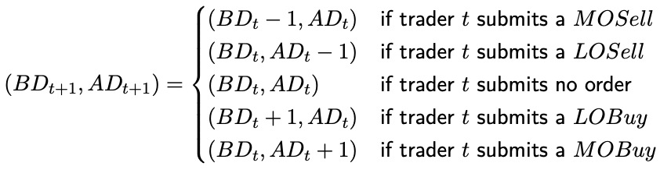
  - If queues at beginning of t were (BD_{t}, AD_{t}), book can evolve as follows after different trading choices of trader at time t
    - Line 1 & 2: MOSell reduces bid queue, LOSell increases ask queue by 1
    - Line 4 & 5: LOBuy increases bid queue by 1 unit, while MOBuy reduces queue of sell LOs at the ask (since sell order has a negative sign, positive sign from the buy makes the queue one unit less negative)
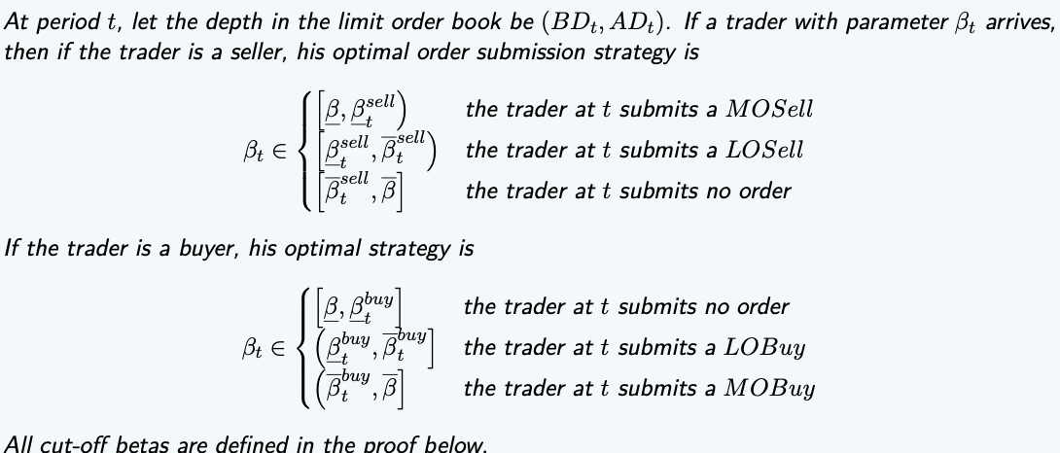
- Theorem 2
  - Recursive structure is implied by previous setup
    - Compute cutoff $β$
    - Each $β$ gives value at which trader t is indifferent between two order choices
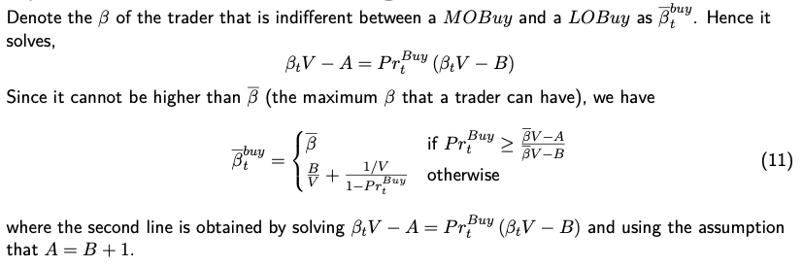
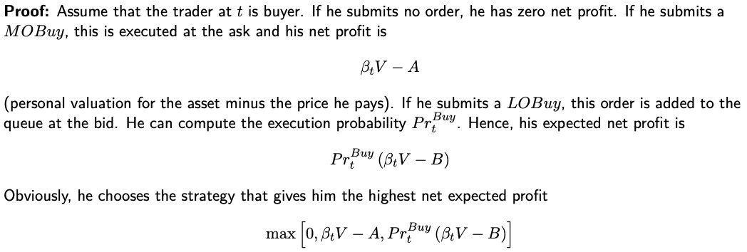
  - Proof to define cutoff bèta’s

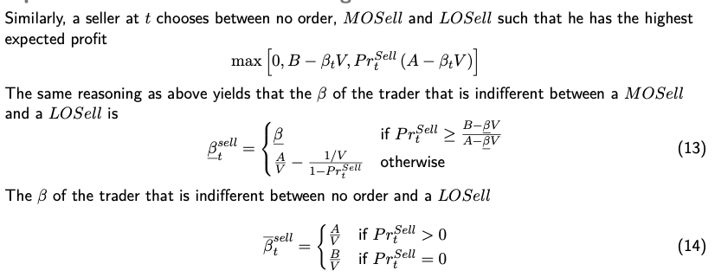
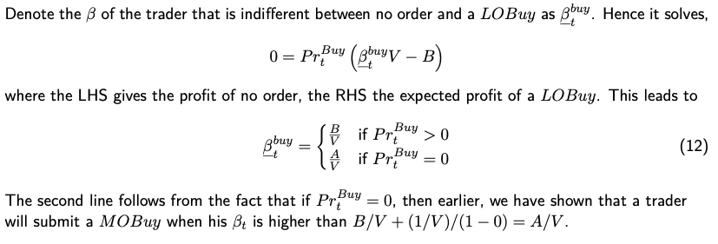

  - Cutoff bèta is dependent on
    - Execution probability of the limit order at t
    - State of the LOB_{t}
    - The time that remains until the end of the trading day
    - All parameters of the problem
    - Varies over time!

  - Equilibrium order choices
    - If execution probabilities for LOs > 0
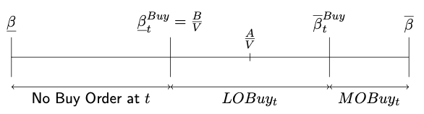
      - Buyer
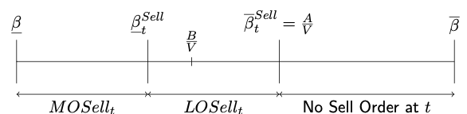
      - Seller

    - If execution probabilities for LOs = 0
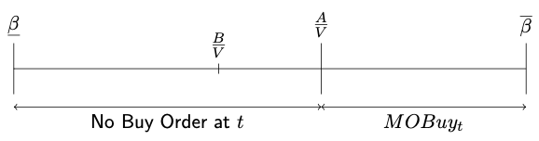
      - Buyer
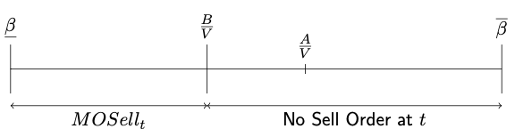
      - Seller
- Noteworthy remarks
  - Traders with extreme valuations place market orders
    - Buyer with high bèta has high personal value, eager to own asset, MOBuy
Won’t take risk of placing limit order
    - Willing to pay spread for certainty of owning the asset
    - Seller with low bèta has low personal value, is eager to sell, MOSell
  - Trader with intermediate bèta is not eager to trade, needs better price
    - Obtain better price by placing an LO
    - Earn the spread
  - Trader with $β ϵ [\frac{B}{V}, \frac{A}{V}]$ would prefer to place both an LOBuy and LOSell
    - Our assumptions rules this out
    - Trader has either cash or the asset, not both
- Intuition & definition of $β$: Anything increasing probability of LO execution increases range of $β$ types who submit LOs and decreases range of $β$ types who submit MOs
- Lemma 1: the higher probability of execution of an LO, the more trader types prefer to submit LOs over MOs
- Lemma 2: in equilibrium at any time t we have for each book LOB_{t} that
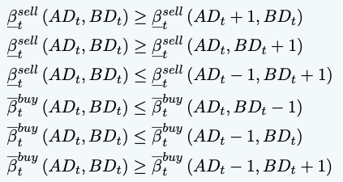
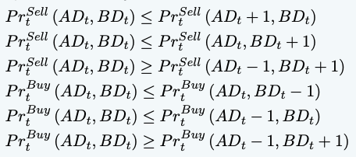

  - Lemma follows from time priority, ex. if LOBuy is first in queue at the bid, it will be matched with next MOSell to arrive, if it were the fifth in the queue, 5 MOSells would have to arrive in order to execute
Place in queue matters crucially for execution probability of a limit order
  - Lemma 2 shows this by comparing 2 LO books (all other things equal)
    - If length of a queue at the bid is shorter, the execution probability of an LOBuy increases
    - If depth at ask side is 1 larger, this increases execution probability of LOBuy
(longer ask queue makes LOSell less attractive, so more MOSell orders)
    - If book is 1 thicker at both bid and ask, execution probability is lower
Corollary: optimal choice depends on depth at both sides of the book
    - Trader also takes into account effect of his order on future trades
Order Flow Patterns
- Even without asymmetric information or changing value of the asset, there are systematic patterns in the order flow
Counterintuitive: a persistent relationship from random draws & fixed spread
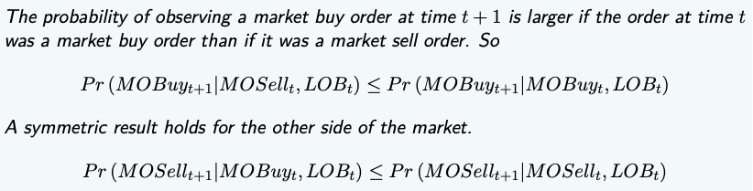
- Proposition 1

- Intuition first part of model
  - If trader submits MOSell at t, it is executed at bid and bid depth reduces by 1
  - Queue at bid becomes 1 unit shorter (not the case with MOBuy)
  - At t + 1 an LOBuy has higher execution probability after MOSell
  - Buyer at t + 1 more likely to submit LOBuy than an MOBuy
- Intuition second part of the model
  - If trader submits MOBuy at t, it is executed at ask and ask depth reduces by 1
  - Queue at ask becomes 1 unit shorter (not the case with MOSell)
  - At t + 1 an LOBuy has lower execution probability after MOBuy than MOSell
  - Buyer at t + 1 more likely to submit LOSell after MOBuy than after MOSell

For propositions 1 – 4 and their proofs, see T&E 09 LOM Theory, slides 77 – 96

3.3 LOM Empirics: Endogenous Order Choice

Order Choice: LOs vs. MOs
- Paper: do traders indeed make their order choice as predicted by theory? – Ranaldo 2004
Examine relationship between state of LO book & trading aggressiveness of order choice
- Dataset
  - 15 stocks of the Swiss exchange (SWX) between March – April 1997
  - Information on MOs and best buy & sell LOs, no data outside prevailing spread
- Order classification
  - Submitted orders differ in aggressiveness
  - MOs are more aggressive than LOs as they demand immediacy
  - Use classification scheme of orders according to aggressiveness
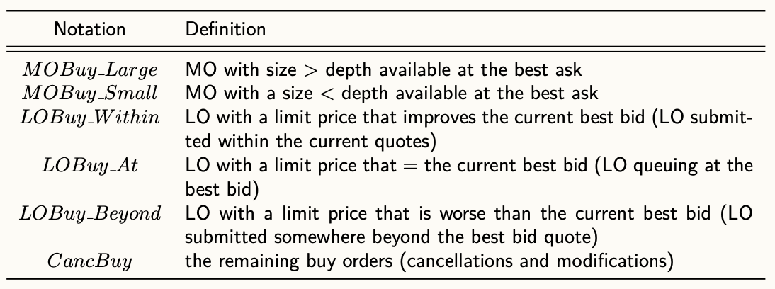
  - Buy orders

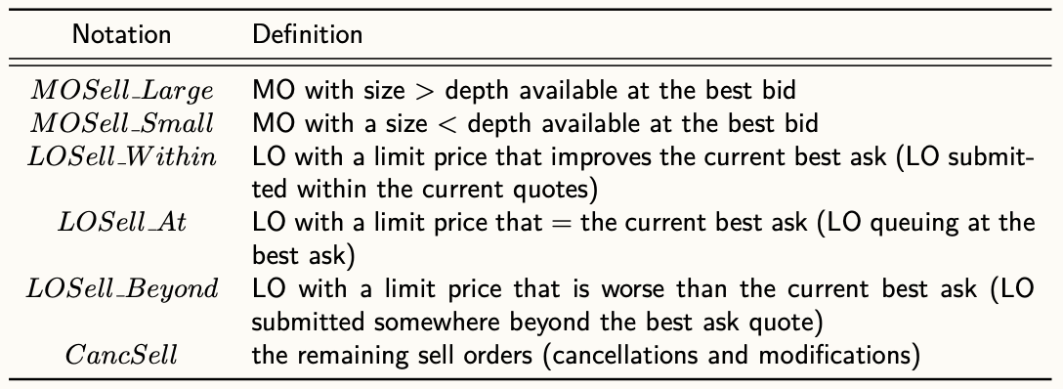
  - Sell orders

- Hypotheses derived from previous chapter
  - H1: orders are less aggressive if the spread is wider
  - H2: orders are less aggressive if the volatility is higher
  - H3: buy/sell orders are more aggressive if the LO book at the bid/ask side is thicker
  - H4: buy/sell orders are more aggressive if the LO book at the ask/bid side is thinner
  - H5: orders are more aggressive if the process of order submission is slower
- Econometric model
  - Econometric framework: ordered probit technique
  - Analysis for buy and sell side done separately (two subsamples)
    - Model is estimated per stock
    - Ranaldo (2004) also estimates model separately for volatility
  - Assumptions
    - Model is in transaction time, not clock time
    - $y_{t}^{*B}$: unobservable continuous var denoting buy side order aggressiveness
    - $y_{n,t}^{B}$: discrete dependent variable in which n indicates order type
    - $α_{i}^{B}$: regression coefficient
    - $x_{i, t}^{B}$: are the regressors i
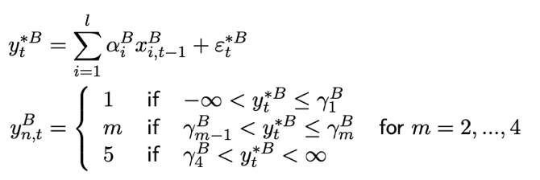
  - Ordered probit regression model is then
  - Estimated per stock (and using transaction time), similar for sell side
  - Dependent variable is order aggressiveness ranked from most to least aggressive
  - Independent variables
    - Spread: quoted spread (best ask – best bid)
    - Volat: standard deviation of last 20 midquote returns (transitory return vol.)
    - Depth_Same: depth (in number of shares /10k) at best price in LO book at same side of the trader
    - Depth_Opp: depth (in number of shares /10k) at best price in LO book at opposite side of the trader
    - Wait: avg. waiting time in seconds between last 3 subsequent orders, /100
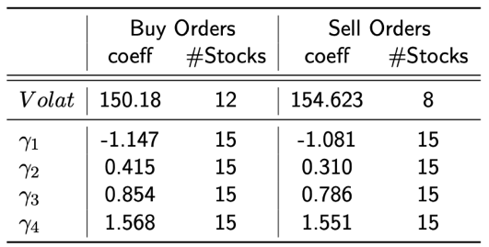
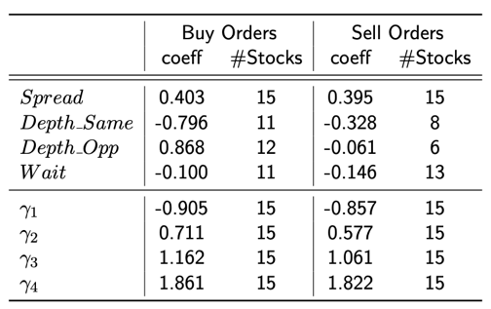
- Results
  - Interpretation
    - First type (1) is most aggressive, last type (5) is least aggressive
    - Negative estimated coefficient means explanatory variable is positively correlated to order aggressiveness
    - Negative coefficient means increase in variable is associated with lower order type, but this is more aggressive
  - Outcomes
    - H1 Spread: orders are less aggressive if the spread is wider
      - Model outcome in support of hypothesis
      - Suggests traders actively monitor book and exploit opportunities associated with a wider spread size
    - H2 Volatility: orders are less aggressive if the volatility is higher
      - Model outcome in support of hypothesis
      - Supports Foucault’s (1999) model
    - H3 & H4 Market depth: buy/sell orders are more aggressive if the LO book at the bid/ask side is thicker, less when the LO book is thinner
      - Model outcome partially in support of hypothesis
      - Thickness of book significantly expresses execution probabilities
      - Buyer
        - Thicker buy-side book means more aggressive buy order
        - Thicker sell-side book means less aggressive buy order
      - Seller
        - Thicker sell-side book means more aggressive sell order
        - Thicker buy-side book: sign in contrast with theory, but only significant for 6 of the 15 researched stocks
    - H5 Speed: orders are more aggressive if order submission process is slower
      - Model outcome in support of hypothesis
      - Slower trading (higher wait) more likely to lead to more aggressive orders and vice versa
    - Order book symmetry
      - Table presents evidence against order book symmetry
        - Differences in magnitudes of the coefficients
        - Buyers more concerned about opposite side of the book
        - Sellers more concerned about own side of the book
        - Depth_same larger coefficient in absolute value than depth_opp for sellers, opposite holds for buyers
      - Paper explanations
        - Market performance during the sample period
        - Buyers and sellers behave differently because of liquidity and institutional trading

- Order Flow Patterns: test predictions of Parlour (1998) model, mixed support
  - Main support: continuation in same direction of LOs occurs less frequently than does the change in direction or any increase in order aggressiveness
(ex. sell LO followed by a sell or buy MO)
  - Contrary to predictions: sequence of LOs in opposite directions is not more likely than an MO followed by an LO in the same direction

Resiliency
- Paper: How does a limit order market recover after a shock without the presence of dealers? – Degryse et al. 2005
- Liquidity is crucial aspect of well-functioning markets, has multiple dimensions
  - Width: bid-ask spread for a given number of shares
  - Depth
  - Immediacy
  - Resiliency: how quickly prices revert to former levels after they change in response to large order flow imbalances initiated by uninformed traders
- Our definition of resiliency: speed of recovery of the market (terms of price, depth and spread) after a relatively large shock, defined as a trade that increases the bid-ask spread
Natural period for studying resiliency therefore is the time span after aggressive orders
- Dataset
  - Sample of 20 stocks of Paris Bourse (now Euronext Paris), February – August 1998
    - All orders and trades (eliminate pre-opening orders) of the 123 trading days
    - Do not observe cancellations/modifications separately
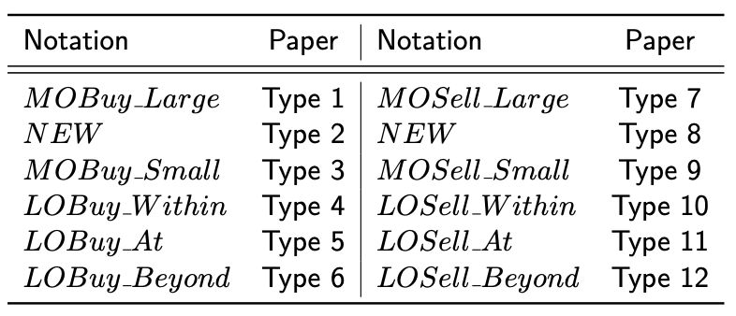
  - All order types as before, with one extra
  - Type 2
    - Buy order for larger quantity than available at best ask, but does not walk up
    - Reason can be twofold
      - Order can be LO with price equal to best ask, but larger quantity than
      - Order can be MO with larger order size than available at best price
(rules or Paris Bourse forbade in this case to walk up the LO book)
    - Part of order not executed immediately is converted into limit buy order
  - Type 8
    - Sell order for larger quantity than available at best bid, but does not walk up
    - Similar as type 2 but for a sell order
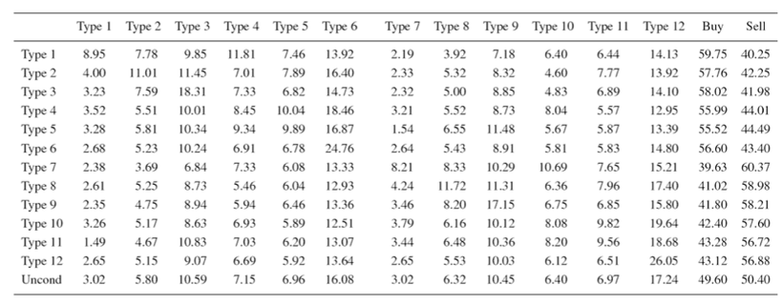
- Patterns & probabilities
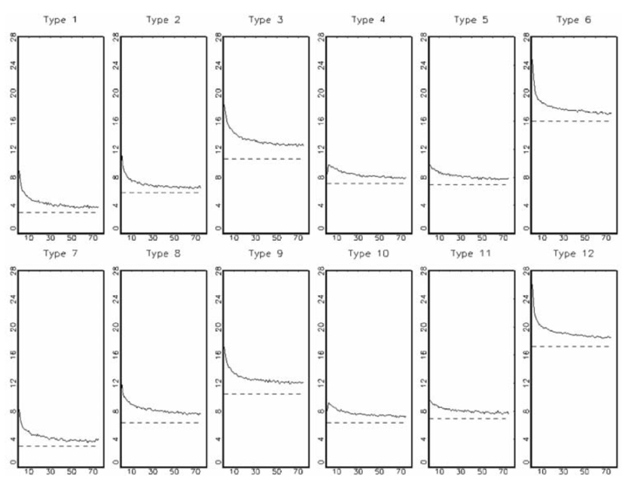
- Table: probabilities that next order is of a certain type, conditional upon aggressiveness of current order (unweighted avg. across groups)
- Graphs
  - Diagonal effect over time
  - Probability that an order of type i at time t is followed by order of same type at t + k
  - Dashed line is the unconditional probability (last line in previous table)
  - It extends the previous table beyond the next order
- Event study methodology
  - Start from most aggressive orders (types 1 and 7)
    - Time t = 0, the state of LO book just before aggressive order
    - Time t = 1, state of LO Book when the effect of the shock is visible
  - Around submission of most aggressive order, create window of 10 best limit (blim) updates before and 20 blim after the order
  - Blim updates defined as update of either best bid/ask price or depth at these prices
  - Within each window, analyse evolution of best bid/ask prices, depth, spread and duration between blim updates
    - For each stock, take avg. value t = -10, -9… 20 around an aggressive order
    - Then, the unweighted averages across the 20 stocks are calculated
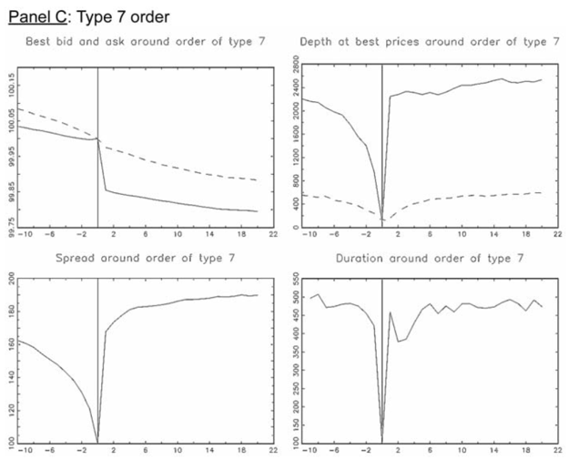
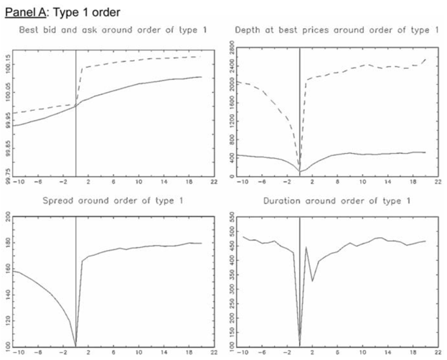
- Results
  - Values of variables calculated relative to value at the time of submission of order type i, set equal to 100
Implies lines express change of variable compared to time 0 (right before order)

  - Two tables, presented in order time (not calendar time)
    - 1: comparison with pre-aggressive order level
    - 2: comparison with avg. over time value
      - Normalise depth, spread & duration by sample avg. of the variable
      - Reason: LOB in event window might not be avg. representative book
      - Reason: sample avg. may be a proxy for the competitive level
- Main findings
  - Spreads & depth decline in run-up to aggressive order: best prices, depth, spread and duration remain significantly larger compared to their values at time of submission of aggressive order
    - Diagonal effect: +-50 orders before flow turns back to unconditional pattern
Serial correlation in order flow is persistent
    - All other variables return to initial level within 20 blim updates
No long-term effect
  - LOB around aggressive order differs from the avg. book over time
  - Compared evolution of different variables to their avg.
    - After aggressive order, depth recovers within a few quote updates to avg.
    - Spread returns to its avg., but more slowly than the depth
Shows market is quite resilient
  - Both firm size & tick size contribute to variation of impact in order aggressiveness

4.1 Competition Between Trading Venues: Introduction

Introduction
- Trading stock market is very fragmented
- Different trade categories
  - Auction: scheduled auction period on an exchange, buyers and sellers submit to be matched at a single clearing price
  - Lit: trades on public exchange with order book visible to all participants
  - Dark: trades in dark pools, private platforms where orders aren’t displayed
  - Off-book: outside an exchange, often over-the-counter (OTC) through deals
  - SI (systematic internaliser): regulated entity executing client trades on own accounts outside of a regulated exchange, providing liquidity on a bilateral basis
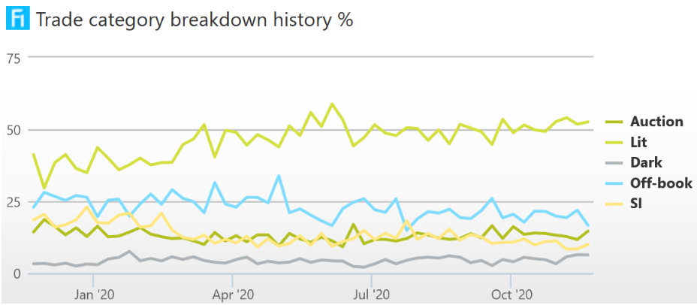
- BEL20 breakdown

Pros & Cons of Fragmentation
- Advantages
  - Competition effect
    - Reduce costs and fees
    - Improved performance
    - Fosters innovation
  - Different types of markets can cater to needs of different types of traders
- Disadvantages
  - Exchanges have natural monopoly under certain assumptions
  - Arbitrage between different exchanges possible (inefficient)
  - Informed traders may be more difficult to detect
  - Potential for risk sharing is lower
  - Search costs to detect best price is higher
  - Liquidity externalities

4.2 Competition Between Lit Venues

Two Limit Order Markets
- Foucault & Menkveld (2008) study competition between two LO books
- Theoretical model
  - Assumptions
    - Incumbent trading venue and an entrant (alternative trading system)
    - Two types of brokers exist
      - Smart routers: route orders across markets to obtain best price
      - Non-smart routers: ignores quotes of entrant market
  - Empirical predictions of model
    - Consolidated depth at certain price should be larger after entry
      - Assuming all other things equal
      - Result driven by absence of time priority across markets
      - Reasoning: allows traders to jump ahead of queue of LOs in one market by submitting an LO in the competing market
    - Predicts increase in proportion of smart routers coincides with increase of liquidity supply by the entrant market
      - More smart routers, means higher execution probability for entrant
  - Empirical analysis
    - Analyses entry of new market (EuroSETS) next to incumbent (Euronext)
    - Finds increase in consolidated depth after entry
Confirms predictions
    - Depth on incumbent market also increased after entry
      - Reduced fees to compete with new market
      - Depth increase compensated loss of order flow to entrant
    - EuroSETS has lower spreads and larger share in consolidated depth for stocks with larger proportion of smart routers

Ghost Liquidity
- Is the liquidity you see also what you get?
- Theory of Van Kervel (2015)
  - Model competition between two markets with market makers, fast & slow traders
  - After market maker observes trade in a venue, update belief on fundamental value
  - Quickly cancel or revise LOs on same side of order book of the competing venue
- Another effect
  - Want to trade: place same LO in both venues to increase execution probability
  - When one executes, other is cancelled, risk to strategy is multiple execution
- Empirical evidence
  - Van Kervel, 2015: trades on most active venues are followed by cancellations of LOs on competing venues of more than 53% of the trade size
  - Degryse et al., 2020: execution of avg. participant’s LO on particular venue, leads to her cancellation of 20% of the quantity on other venues where she posted

Additional Empirical Evidence
- Traditional exchanges lost significant market share last decade
- Wide range of alternative trading systems (ATSs) are popping up worldwide at amazing pace
- ATSs can be divided into two broad groups
  - Lit markets: operate as fully autonomous public order books
  - Dark pools: see later
- Advantages seem to dominate potential negative effects of fragmentation
  - Liquidity improves on incumbent venues: quoted, effective and relative spreads are lower and depths are larger
  - New platforms provide competition to existing ones (including dealers)
  - Trading costs decreased (regularly lower on alternative platforms)
  - New platforms contribute to price discovery: they post quotes containing new info
- Visible vs. dark fragmentation by Degryse et al. 2015
  - Effects of visible fragmentation on global liquidity has inverted U-shape
  - Dark activity has a negative impact: dark pools attract uninformed order flow away from exchange market, decreasing liquidity
  - Local liquidity is reduced by fragmentation regardless of whether it is dark or not

Contribution to Price Discovery: Trading Venues
- Venue with largest information share is most important, as it is the price leader
  - Venue where most value-relevant information is first revealed
  - Intuition: prices of other markets follow the leader’s moves
  - Welfare importance of informationally efficient price is appreciated by regulators
  - Dominant market can assert that it is largest producer of an important social good
Can make case for regulatory preference based on not only on self-interest
- Assumptions
  - Stock trades on two trading venues (indexed 1 and 2)
  - Discussion for n venues and technical details, see Hasbrouck 1995 and 2007
  - Denote trade price on each venue as $p_{1,t}$ and $p_{2,t}$
  - Goal: measure contribution to price discovery from trades at each venue
- Econometric framework
  - From Chapter 7: stack price changes in a vector ${∆p}_{t}=[\begin{matrix}{∆p}_{1,t} \\ {∆p}_{2,t}\end{matrix}]$
  - Can then estimate following VAR-model: ${∆p}_{t}=ϕ_{1}{∆p}_{t-1}+ϕ_{2}{∆p}_{t-2}+…+ε_{t}$
  - Issue
    - Prices on both venues could diverge relative to each other without bound
    - Makes no sense, same asset with same fundamental value is traded
    - Prices can differ, but not without bound as arbitrage will prevent this
  - Solution: new concept of cointegration
    - Assume two (or more) variables individually are integrated processes (non-stationary), but there exists a linear combination of them that is stationary
These variables are then called cointegrated
    - Prices in different venues can be expected to be cointegrated
  - Add concept to our VAR model to get the VECM (vector error correction) model
    - ${∆p}_{t}=ϕ_{1}{∆p}_{t-1}+ϕ_{2}{∆p}_{t-2}+…+β(z_{t-1}+b)+ε_{t}$
    - Where we have
      - $z_{t-1}=p_{1,t-1}-p_{2,t-1}$
      - $b$ is the mean error of the error correction term
  - Based on VECM model, can apply same tools as in Chapter 2.6
    - Principles are identical
    - There, used prices and trades, the variables were two prices
  - Can then compute
    - Impulse response functions
    - Variance decompositions (information shares)
  - Issues
    - Causal ordering
    - Time
- Causality ordering
  - Don’t have chronological order for trades, want to trade each price symmetrically
  - Can impose causal ordering through Cholesky decomposition, but results will depend on assumption of ordering
  - In practice: calculate information shares for each possible ordering and report the minimum and maximum information share over all possible orderings
    - For two venues, only have two orderings
    - For n venues, need to consider all permutations (heavy)
- Time issue
  - In Chapter 2.6, subscript t referred to trades (event or trade time)
    - Not so straightforward in VECM model
    - t cannot refer to a trade occurring in both venues
    - Very few trades take place on venue 1 and 2 at exactly the same time
  - Solution 1: say t refers to event of a trade in either one of the venues
    - Is also strange
    - Trades occurring sequentially will then be separated by intervening trades on other venues
  - Solution 2: use clock time
    - Use reported time as minimum interval (if in seconds, then use 1 second)
    - Short intervals advantages
      - Aggregation reduces information in a sample, may report separated events as if they appear simultaneous
      - Information shares become more sensitive to causal ordering imposed by the Cholesky factorisations
      - Then, over all permutations, upper & lower bounds will be wider
      - Shorter intervals are desirable because it implies tighter bounds
    - Short intervals drawbacks
      - Necessary to propagate prices past the time of their initial posting
        - Ex. Trade at 00:14 and next at 00:24
        - With sample at 1s, record same price at 00:14, 00:15… 00:23
        - Strange, trade occurs at particular time and is not repeated
      - Series of price changes may contain many zero observations
      - VECM specified for short intervals may have excessive large number of parameters
      - Comparability of timestamps between venues can be an issue
        - To integrate data from multiple venues, rely on time-stamps
        - Quality of stamps depends on accuracy of reporting & clocks
        - Trades in some markets are at such a rapid pace, multiple events are recorded at the same time-stamp
Then sequencing of reporting is suspect

- Results: empirics of econometric model
  - Hasbrouck 1995 estimates VECM of four prices
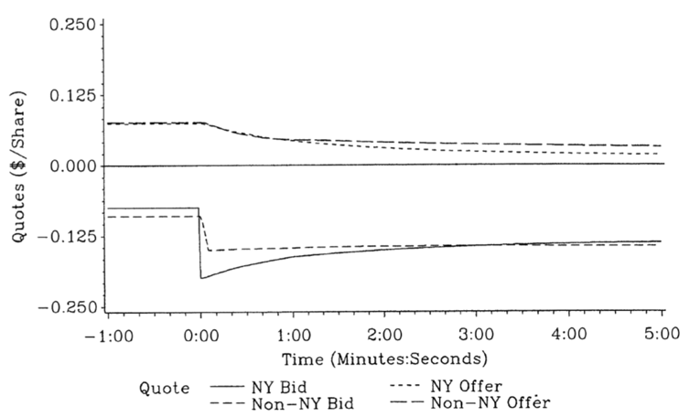
  - Impulse response function
  - Upper & lower bound for NYSE information share was computed for each stock
  - Bounds differ only to the extent there is contemporaneous correlation between NYSE and off-NYSE quote movements with a 1s frequency of observation
    - Time resolution fine enough that this correlation is negligible
    - Upper & lower bound are very close (within 0,001 of each other)
    - For brevity, only lower bound is reported
  - Result for IBM: information sharing of NYSE = 96,1%

4.3 Competition Between Trading Venues: Dark Pools

Dark Pool vs. Dealers
- Dark liquidity pools
  - Operate next to traditional exchanges
  - Offer extra liquidity
  - Not transparent (no bid or ask prices shown)
- LSE (London Stock Exchange) vs. ITG POSIT
  - LSE
    - Dealer: reports bid & ask quotes + depth
    - Continuous trading
    - Order to LSE: to dealer and immediate execution
  - POSIT
    - Periodic trading: 10 intraday crosses & 1 after-hours cross
    - Between crosses orders can be submitted
    - Around time of cross
      - Price of cross is determined
      - Price of cross equals midquote of dealer in LSE at random point in time in one-minute interval (avoid price manipulation)
      - Volume/price matching algorithm to match buy & sell orders
    - Order to POSIT
      - Recorded in order book until cross, ex. at 11:00
      - In one-minute interval around 11:00, time of cross chosen randomly
      - Price of cross = midquote of LSE at this time
      - Matching of buy & sell orders, longest queue only partially executed

- Determinants influencing choice of trader
  - LSE
    - Certain & immediate execution
    - Pre-trade transparency
    - Worse price & price impact
    - Visibility of your order
  - POSIT
    - Better price, no price impact
    - Anonymous execution
    - Execution risk as execution happens in the future
    - No pre-trade transparency

Model Setup
- Model from Degryse et al. (2009) to analyse order choice between dealers and dark pools
- Assumptions
  - One asset with fundamental value V, constant over trading day and publicly known
  - Trading day divided into T intervals, indexed t = 1, 2… T, in each one trader arrives
  - Trader characterised by
    - Trading orientation (buy or sell)
      - Probability of seller $γ_{Sell}$, can trade one asset denoted -1
      - Probability of buyer $γ_{buyer}$, can trade one asset denoted +1
      - Trader cannot both have the funds and the asset
    - Personal valuation
      - Value $β_{t}V$ is personal value
      - $β_{t}$ drawn from continuous distribution F(.) with corresponding density function f(.) and support $[\underline{β}, \overline{β}]$, we assume $0≤\underline{β},≤1≤\overline{β}$
      - Intuition: $β_{t}$ captures how eager trader wants to trade (patience)
- Actions
  - Buyers can choose between
    - Submit order to dealer market: DMBuy
    - Submit order to dark pool (organised as crossing network CN): CNBuy
    - Submit no order: NOBuy
  - Seller can choose between
    - Submit order to dealer market: DMSell
    - Submit order to dark pool (organised as crossing network CN): CNSell
    - Submit no order: NOSell
- Markets
  - Dealer market
    - Constant ask price A and bid price B with $B<V<A$
    - Assume one-tick spread ($A-B=1$)
    - No inventory risk, no asymmetric information
  - Crossing network
    - Orders to CN stored in an order book; cannot be modified or cancelled
    - Matching of orders takes place after period T, according to time priority
    - Price of cross is midquote $\frac{A+B}{2}$ derived from the DM
No price uncertainty at CN
    - Only relevant variable for traders thus is order imbalance in the book
      - $n_{t}$ = number of buy orders – number of sell orders in the book
      - Contrast to Parlour 1998 where length of queues matter
      - $n_{t}>0$ means more buy than sell orders
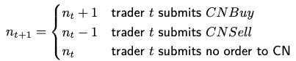
    - After action at time t, there are three possible evolutions of the imbalance
    - Order execution determined by final net imbalance
$n_{T+1}$ is the CN book at time of cross
      - $n_{T+1}=0$, no imbalance, all submitted orders are executed
      - $n_{T+1}<0$, given time priority, last $|n_{T+1}|$ sell orders are unexecuted
      - $n_{T+1}>0$, last $n_{T+1}$ buy orders remain unexecuted
- Comparison of two informational settings
  - Transparency vs. partial opaqueness
  - Common to both: trader arriving at t knows
    - Own trading orientation
    - Own $β_{t}$
    - Bid & ask price of the dealer (B & A)
    - Distribution of $β$ [F($β$)]
    - Distribution of buyers and sellers ($γ_{Sell}$ & $γ_{Buy}$)
    - Length of the trading day (T)
  - With transparency, traders observe
    - Past DM trades
    - Past CN order flow and thus imbalance $n_{t}$ in the CN
  - With partial opaqueness traders observe
    - Only past DM trades
    - No past CN order flow, don’t know imbalance $n_{t}$ in the CN
Traders need to form expectation of $n_{t}$

Equilibrium
- Dealer market only, subscript DM (no CN)
  - If trader at t is a buyer: profit of a DMBuy is $β_{t}V-A$, NOBuy has 0 profit
  - If trader at t is a seller: profit of a DMSell is $B-β_{t}V$
  - Compute cutoff values from these: values for $β_{t}$ at which trader is indifferent between no order or placing an order at the DM
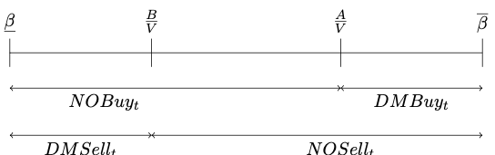
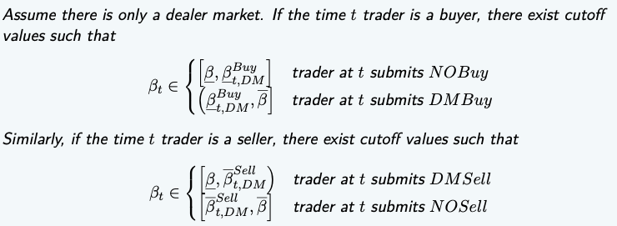
  - Theorem

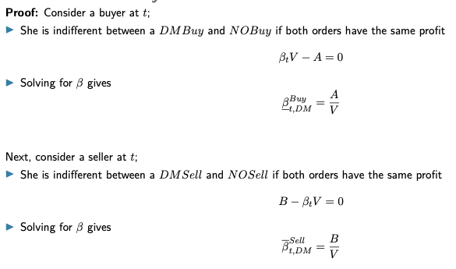
  - Intuition for buyer (symmetric for seller)
    - Buyer arriving at t with higher $β_{t}$ than ${\underline{β}}_{t,DM}^{Buy}$ buys at the DM
    - All other buyers submit no order
- Crossing network only, subscript CN (no DM)
  - Is there is only a CN, which is assumed transparent, trader submits CN order as long as it results in a positive expected profit
  - Profits
    - Expected profit of a CNBuy_{t} is $p_{t, CN}^{Buy}(β_{t}V-\frac{A+B}{2})$
    - Expected profit of a CNSell_{t} is $p_{t, CN}^{Sell}(\frac{A+B}{2}-β_{t}V)$
  - Consider expected profit because execution is uncertain ($p_{t, CN}^{Buy}$ or $p_{t, CN}^{Sell}$)
    - Hinges on order imbalance in the CN
    - Next to $n_{t}$, execution probability also depends on
      - F(.)
      - $γ_{Sell}$ & $γ_{Buy}$
      - Time left until end of trading day $T-t$
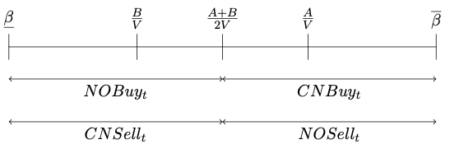
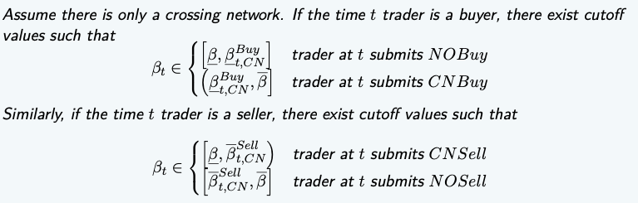
  - Theorem 2
  - Proof: exercise
  - Intuition for buyer (symmetric for seller)
    - Buyer arriving at t with higher $β_{t}$ than ${\underline{β}}_{t,CN}^{Buy}$ buys at the CN
    - All other buyers submit no order

  - Comparison with DM case
    - More buyers & sellers submitting orders
    - No range of bètas in which neither a buyer or seller submits an order as CN does not have a spread, while DM has a one-tick spread
- Coexistence of DM and CN with transparency
  - Traders can choose between a DM and a CN
  - Consider transparency in informational setting, traders observe imbalance in CN
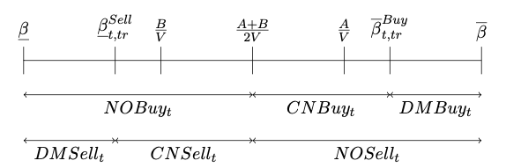
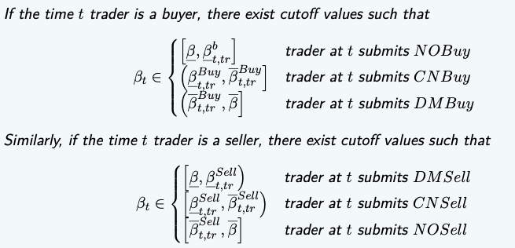
  - Theorem 3
  - Proof: exercise
  - With coexistence, cut-off values become dynamic and may change every period t due to changing execution probabilities
  - Effects
    - Order creation by adding CN to DM
      - Compared with DM, order creation stems from CN-only traders
      - Buyers with $β_{t }ϵ (\frac{A+B}{2V},\frac{A}{V}]$ & sellers with $β_{t }ϵ [\frac{B}{V},\frac{A+B}{2V})$ now submit orders to CN, but would never participate at the DM
    - Trade diversion from DM to CN
      - Some buyers will submit orders to CN instead of to DM
      - Buyers with $β_{t }ϵ (\frac{A}{V},{\overline{β}}_{t, tr}^{Buy}]$ & sellers with $β_{t }ϵ [{\underline{β}}_{t, tr}^{Sell},\frac{B}{V})$ now go to CN
    - These two could lead to trade creation or trade reduction
Reduction if flow is redirected to CN and then not executed
- Coexistence of DM and CN with partial opaqueness
  - Traders only observe previous DM trades, not CN order flow or net order imbalance
  - This setting corresponds closest to reality
  - A time t trader observes in each past period either a DM buy, DM sell or no trade
  - When no trade is observed at DM, traders doesn’t know if a CN buy, CN sell or no trade was submitted
Allows to form expectation about $n_{t}$

  - Expected net order imbalance for trader under partial opaqueness (po) is $E_{t,po}(n_{t})$
    - Allows to calculate expected execution probability of a CN order
    - $p_{t,po}^{b}(E_{t,po}(n_{t}))$ for a buy order, $p_{t,po}^{s}(E_{t,po}(n_{t}))$ for a sell order
    - Denote in short as $p_{t,po}^{b}$ and $p_{t,po}^{s}$
    - Determine cut-off bètas
      - ${\underline{β}}_{t, po}^{b}(p_{t,po}^{b})$ and ${\overline{β}}_{t, po}^{b}(p_{t,po}^{b})$ for a buyer
      - ${\underline{β}}_{t, po}^{s}(p_{t,po}^{s})$ and ${\overline{β}}_{t, po}^{s}(p_{t,po}^{s})$ for a seller
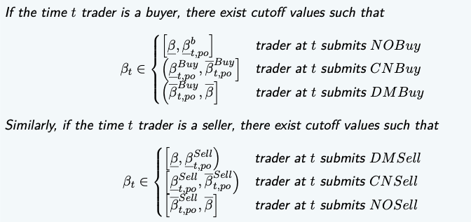
  - Theorem 4
  - Proof is not exam material
  - Proposition similar to transparency setting
    - Cut-off bètas hinge on past traders’ decisions, which are partly observed
    - Cut-off bètas under transparency and partial opaqueness are in general not equal because info at time t differs in both settings

Order Flow Patterns: Transparency
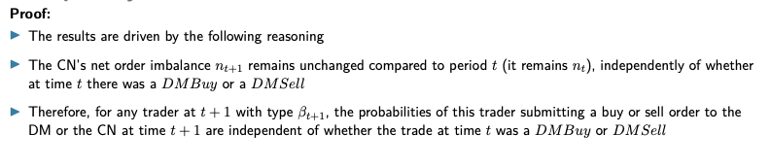
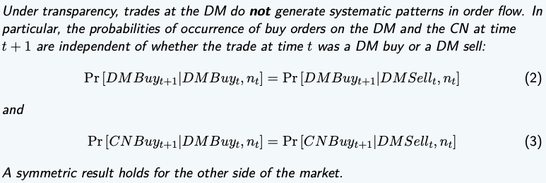
- Proposition 1
  - Conclusion changes when we assume order at t was a CN order instead of DM trade
In this case, we obtain systematic patterns although traders arrive randomly

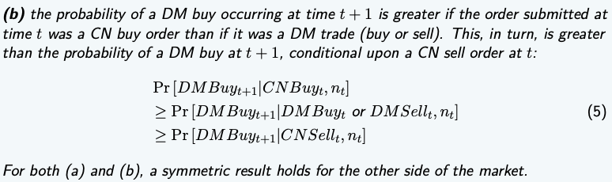
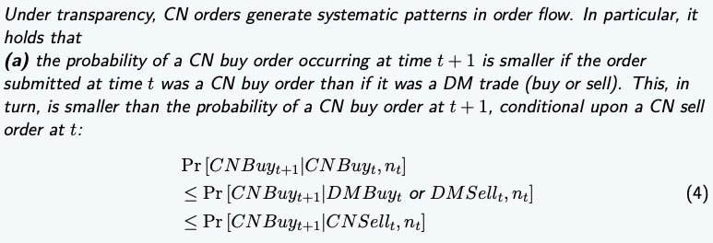
- Proposition 2
  - Intuition for (a)
    - Assume t + 1 trader is a buyer (with type $β_{t+1}$)
    - Decides where to trade based on imbalance$n_{t+1}$
This determines execution probability in the CN
    - $n_{t+1}$ is determined by what trader at time t did
    - CNSell at t gives more favourable imbalance in CN for buyer at t + 1
Higher execution probability of a CNBuy at t + 1
  - Demonstrates existence of systematic patterns in order flow
    - Earlier in course, this was attributed to informed trading
    - Current model shows it may also result from unfavourable imbalance in CN
    - CN has 2 externalities
      - Positive liquidity externality: adding order to the CN is beneficial for counterparties arriving later (liquidity attracts liquidity)
      - Negative crowding externality: traders with low negative personal value pre-empt later arriving traders with higher personal value (who would realise higher gains from trade)
    - Underlying patterns different from those of Parlour (1998)
      - In a limit order market
        - Individual lengths of queues at bid & ask are important
        - Both MOs & LOs change length of queues and impact execution probabilities of LOs
        - Both MOs & LOs thus cause patterns in order flow
      - In a CN
        - Imbalance in CN matters
        - Only CN orders affect this imbalance
        - Only CN orders (not DM trades) cause systematic patterns

Order Flow Patterns: Partial Opaqueness
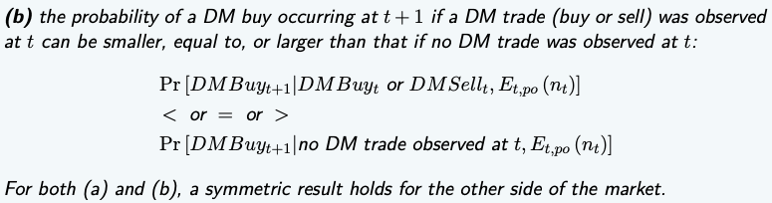
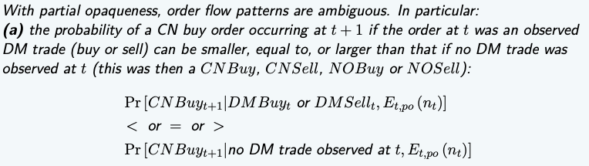
- Proposition 3
  - Proof is not exam material
  - Intuition
    - Systematic patterns can change over time and work in 2 directions
    - For a successive CN order, observing no DM trade relative to a DM trade
      - Could be good news because no DM trade may reveal addition of counterparties
      - Bad news because no DM trade suggests that an interesting opportunity at a CN could have been pre-empted by a time t trader
    - Result in contrast with transparency setting (determined unambiguously)
    - CN’s transparency level plays an important role for order flow patterns to both the CN and the DM
    - Changing this institutional property of CN could therefore affect order flow

Welfare
- Overall welfare measure denoted $\overline{OW}$
  - $\overline{OW}$ = sum of all agents’ expected gains from trade (traders + dealers)
  - Upper bar stresses we consider avg. per-period overall welfare
- As benchmark, determine maximum overall welfare ${\overline{OW}}^{max}$
  - ${\overline{OW}}^{max}=OW$ if all buy & sell orders execute with probability one at midquote
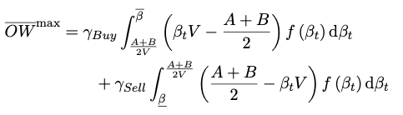
  - Algebraic:
  - Interpretation
    - Equals welfare in a financial market without inefficiencies
    - Take gains from trade of buyer & seller trading with execution probability 1
    - Integrate over all participating traders
- ${\overline{OW}}^{max}$ equation shows why overall welfare in practice may be lower
  - Order at the CN may execute with a probability less than 1, lowering expected gains
  - Set of traders that submit an order could differ from that in ${\overline{OW}}^{max}$
  - Degryse et al. (2009) use these insights to define 2 inefficiencies (not on exam)
- Numerical illustration
  - Assumptions
    - $β$ is uniformly distributed over [0.8, 1.2], $γ_{Sell}=γ_{Buy}=0.5$ and $\frac{A+B}{2}=V$
    - Consider 3 period model (T = 3)
    - Define relative spread as spread divided by V, so as $\frac{A-B}{V}$
    - A & B are constant: higher V means lower relative spread (more liquid asset)
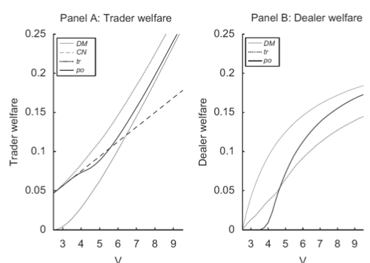
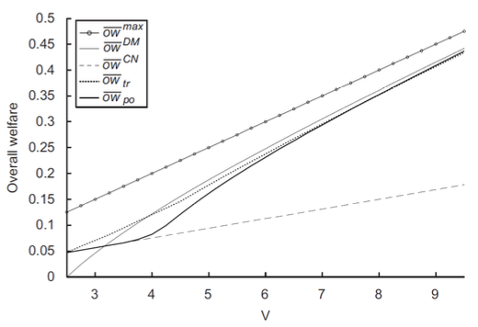
    - Numerical simulation yields following graph
  - Welfare results: overall
    - Coexistence of trading systems does not necessarily improve overall welfare
    - Overall welfare of a DM in isolation (${\overline{OW}}^{DM}$) outranks coexistence for all information settings, except for lower values of V
    - Greater opaqueness results in increased overall welfare for higher V
    - Transparency is only better at lower values of V
  - Welfare results: traders & dealers
    - Traders prefer transparency, dealers only prefer this at low V values
    - For avg. per period trader welfare
      - Coexistence always produces greater trader welfare than DM only
Widens traders’ opportunity sets
      - Greater transparency always increases trader welfare because they anticipate their orders will be revealed to potential counterparties
Contrast with overall welfare
    - For avg. per period dealer welfare
      - Welfare highest in DM in isolation, trading in DM then at its max.
Under coexistence, part of flow redirected to CN (lowers welfare)
      - Welfare only higher for high transparency under low V values
Trade diverted is minor, as traders choose DM when informed about lack of counterparties at the CN

Price Discovery
- Price discovery model by Zhu (2014)
  - Assumptions
    - 2 periods and 2 exchanges
      - Exchange: Glosten & Milgrom (1985)
      - Dark pool: organised as CN or hidden LOB
    - Agents
      - Informed traders (IT): can be informed at a cost
      - Liquidity traders (LT): have collateral requirements, trade delays are very costly

- Results: adding dark pool improves price discovery on the exchange
Not always, LTs can push net order flow far opposite of the Its
- Intuition: trade-off between potential price improvement and execution risk
  - ITs more likely to cluster on heavy side of the market
Face lower execution probabilities in the dark pool
  - LTs are less correlated with each other, less likely to cluster on heavy side of market
Have higher execution probabilities in the dark pool
  - Difference in execution risk pushes ITs to exchange and LTs to dark pool
  - Under natural conditions, self-selection lowers noisiness of demand & supply on the exchange and improves price discovery

Empirical Key Results
- Result 1
  - Dark pools allow traders for saving on transaction costs
  - These have to be compared to execution risk, which is usually substantial (lower execution probability)
- Result 2: what drives dark pool trading?
  - Spread in the exchange: larger spread means more cost savings in the dark pool
  - Asymmetric information
  - Execution time
  - Probability of execution
- Result 3: does dark pool trading adversely affect market quality?
  - Empirical evidence is mixed

