Summary Chapter 1
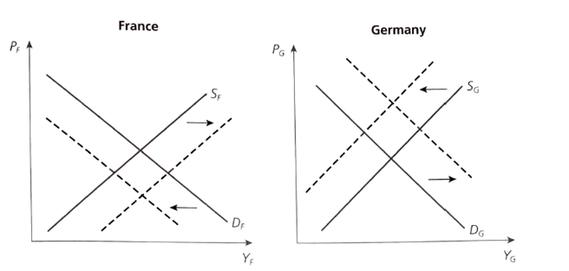
- Explain how wage flexibility allows countries to reduce the cost of a monetary union when an asymmetric demand shock occurs. Graphically.
If wages are rigid & if labour mobility is limited, countries in MU will find it harder to adjust to asymmetric demand shifts than countries that have maintained their own national money and that can devalue or revalue their currency.
Leads to a new equilibrium. Makes French products more competitive, stimulating demand and the opposite happens for Germany.
French unemployed will reduce their wage claims and Germans will push up the wage claims Result in AS curve of France shift downwards, & shift Germany’s upwards.
Wage decline in France implies less demand for goods Income effect of a wage decline further shift left
- Explain how distrust about the solvency of a MU member state can amplify the effects of asymmetric demand shocks, lead to a liquidity crisis that can become a solvency crisis. What happens in the money market, in the bonds market, in the exchange market? What would happen if the country were not in the monetary union?
If investors distrust a member’s government, they will sell bonds raise IRs trigger a liquidity crisis turns into solvency problem as IRs rises so does government debt burden forces government to reduce spending & to increase taxes politically costly government stops servicing debt.
Not in MU = monetary independence = This doesn’t happen = Stand-alone countries issue their debt in their own currencies and can always create the liquidity to pay out the bondholders.
In MU: If investors fear the default of the Spanish government, they will sell the government bonds, interest rates increase, and the proceeds of these sales are used to invest in other eurozone assets. Thus, the total amount of liquidity in Spain shrinks, and there is no foreign exchange market and flexible exchange rate to stop this. There is the possibility of a liquidity crisis as the Spanish government cannot guarantee pay out to holders of government bonds as it cannot force the ECB to buy Spanish government bonds.
MU does not strengthen the position of national governments vis-à-vis financial markets; on the contrary, national governments in a monetary union lose power when confronted with financial markets.
- Explain why the spread of the Spanish/Greek/Italian governments bonds became very high in 2010-2011.
Financial crisis 2007Great Recession GDP significantly declined2010: GDP grew but at unequal pace
6 northern EU countries (Ireland, Germany, Belgium, France, Austria & NL) succeeded in overcoming 2009 recession, lifting their GDP above level of 2008. However, GDP in southern EU (Spain, Greece, Italy) remained below 2008 level.
Asymmetric shocks had big implications for Eurozone government finances. Northern countries experienced a small increase in government debt ratios, whereas southern countries experienced large surges.
Negative correlation between the cumulative growth experience and increase in their government debt ratios.
2008 start: bonds rates = same in all Eurozone countries, 2008 End: large divergences. Financial markets lost confidence in the capacity of the southern countries sold these government bonds (raising IRs) and bought northern countries bonds. As a result, the long-term interest rate in these countries declines significantly.
Different business cycle developments in the Eurozone divergences in long-term bond rates. Adjustment problem of countries hit by negative shocks = more severe very high IRs low economic activity. Opposite for +ve shocks
- What do we mean by the solvency condition?
Solvency = ability of a company to meet its long-term debts and other financial obligations.
Solvency condition S >= (r-g)D : primary surplus >= (nominal interest rate – nominal growth rate) * Debt ratio.
Primary surplus: The budgetary surplus without the interest payments should be high. At least as high as the nominal interest rate – the growth rate of the GDP. When the investors asked to have higher interest rate, it becomes harder for the govt and imposes budgetary problem to satisfy this condition.
- Explain why countries with a very centralized wage bargaining system may find it easier to avoid wage price spiral after an oil shock than countries with less centralized wage bargaining.
Wage bargaining is centralized = labour unions consider the inflationary effect of wage increases. They know that excessive wage claims lead to more inflation, so the real wages will not increase. Therefore, they have no incentive to make these excessive wage claims. So, when a supply shock occurs, they know that the loss in real wages cannot be compensated by a nominal wage increase.
Wage bargaining is less centralized = individual unions that bargain for higher nominal wages know that the effect of these nominal wage increases is small (in aggregated price level). But only represent small part of labour force. Thus, there is a free riding problem. In such a non-cooperative set up, no individual union has the incentive to take the first step in reducing its nominal wage claim, for risk that other do not follow.
- Explain how a symmetric shock may turn out to have a different impact in the economies of members states of a monetary union.
Can have a different impact because labour market institutions react differently. Labour markets can be:
- dominated by highly centralized labour unions (Ex: Germany)
- labour unions are decentralized (Ex: UK)
Differences in institutions divergent wage & price development even if countries face same disturbances
Ex: 2 countries with same oil price increase, effect on domestic wages & prices depends how labour unions will react.
Legal differences can affect the market’s function differences in frequency at which interest rates are adjusted – as a result shocks between member states are transmitted differently.
Krugman: as countries enter MU they trade more with each-other, countries find their competitive advantage & specialize in different activities. So, a shock in one industry, will affect some countries more than others
- Short-term interest rate set by common central bank is the same for all member states. Does this imply that private investors & households face same interest rate when they borrow money from their bank?
ECB decides short-term interest rates, but this rate only applies to commercial banks who will borrow from ECB. Commercial banks from all the member countries borrow with a margin of 1% from the set interest rate. Then these commercial banks lend money to investors or consumers, and they put their extra margin to make money on what they are lending. Thus, investors and households don’t borrow at the rate set by the ECB.
- Does the cost of joining a MU for a country depend on whether that country faces mainly permanent or mainly temporary demand shocks? France as example.
In a MU: permanent negative AD shock must be followed by a nominal wage decline/downward shift of AS curve. There would be a decline of real wages in France.
Without a MU: when government reacts to permanent negative demand shock with a depreciation/ devaluation, the upward pressure on the nominal wage must be resisted. There would be a decline real wages in France.
Regardless of the monetary regime, the French works must accept a decline in real wages.
- The liquidity and solvency crisis like the one in Spain in 2010, can this also happen in a country that maintains its currency pegged to the currency of another country? Explain
Pegged currency = said currency is kept stable with another. In the case of a fixed exchange rate, there is no risk of a liquidity crisis. The government can always give a guarantee to bondholders to pay them in cash as it could eventually force the national bank to provide it with cash money.
BUT, when financial investor doubts the credibility of the fixed exchange rate, speculation will be on the exchange rate itself (not on the government bond market). So, when financial investors believe that a national bank has a limited stock of international reserve, they will speculate on the exchange rate market, forcing the nationa l bank to sustains its own currency by selling its international reserves. Therefore, there could eventually be a devaluation.
So, there isn’t a liquidity risk on the bond market, but there is a devaluation risk on the exchange market (that will lead to another type of risk premium reflecting this risk).
Regarding solvency, when there is a devaluation of the own currency, it follows that the foreign debt suddenly increases in value. When it has a relatively high amount of foreign debt, it has to be repaired in the appreciated foreign currency and the devaluation of the own currency could lead to a solvency crisis for the government.
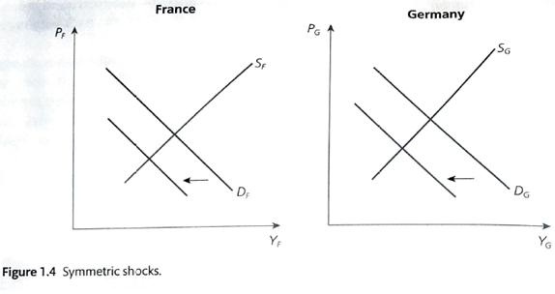
- Suppose a monetary union. There is a symmetric shock. Explain how monetary policies can stabilize output. Illustrate graphically in a AD-AS model.
The Common Central Bank can deal with these shocks, the reaction from the central bank will be good for both countries. The ECB can now lower the interest rate, thereby stimulating AD in both countries.
MU is more attractive than beggar-my-neighbour policies (term used for a set of policies that worsen the economic problems of other countries) under monetary independence.
- Can one design a mechanism that avoids a liquidity crisis? Explain carefully.
2 parts mechanism: 1st role of ECB = possible to avoid liquidity crisis & 2nd = centralizing a part of national budgets into a common union budget. MU with a budgetary union. The budgetary union would:
1st: create an insurance mechanism triggering income transfers from country experiences good times to countries hit by bad luck (reducing the pain). Suppose there is a European government that raises European taxes and pays European unemployment benefits. If there is a recession in France and a boom in Germany, the tax revenues in Germany can by used as employment benefits in France (automatic stabiliser effect).
Nothing changes in Germany (boom but also more taxation so no inflation), and at the same time France gets benefits. This solves the liquidity problem, but there is moral hazard. The transfers reduce the pressure on the regions to adjust (permanent transfers = political resistance).
2nd: a budgetary union allows a part of national government debt to become a common debt (protecting members from forced defaults or liquidity crisis). But it requires a high level of political unification (that is not there).
- Evaluate: “In an MU, a perfectly integrated financial market works as a private insurance mechanism that creates a cushion to asymmetric shocks & budgetary union that acts like a public insurance mechanism”.
A fully integrated equity and bond market would mean French hold stock/bonds of German firms and vice-versa. If there are a fully integrated and there is an asymmetric shock, negatively hitting France but positively Germany:
French firms make losses, pushing down French stock prices. As Germans also hold French stocks, they pay part of the price of the drop-in economic activity in France. Conversely, the boom in Germany raises stock prices. As French also hold German stock, it compensates for the hard economic times in France. Therefore, an integrated stock market works an insurance system – the negative shock is shared by all countries and is mitigated. A similar mechanism works through the integrated bond market. The negative shock means firms in France make losses and may go bankrupt - this lowers the value of French bonds. Some of these French bonds are held by German residents, so that they also pay the price of the economic duress in France.
Advantage of this system is that it based on private financial markets and reduces the danger of moral hazard. There is 1 drawback, the poor unemployed in France who don’t hold financial assets in Germany aren’t helped. As a result, such a private insurance scheme without a public one is certainly going to provide insufficient coverage for a large majority of French citizens.

Summary Chapter 2
- We observe a rising importance of services (to more than 70% 0g GDP). Is this an element that sustains the EC-view or the Krugman-view about the relationship between trade integration and asymmetric shocks?
Element sustains EC- view: Economies of scale do not matter as much for services as for industrial activities. As a result, economic integration does not lead to a regional concentration of services in the way it does with industries.
As services become increasingly more important (account for 70% of GDP of many countries), the trend towards regional concentration of economic activities may stop even if economic integration moves forward.
- For each level of wage bargaining centralized, industry, firm), what is the respective argument that explains unions wage-setting behavior and resulting unemployment outcome at that level?
Centralised: there is a flat labour demand because the union realises that it cannot achieve a real wage higher than on the producer surplus. So there is high employment.
Industry level: the union believes its wage decision has little impact on aggregate employment so there is a steep labour demand, which means there is low employment.
Decentralised: union is concerned that high wage would lead employer to raise price and consumers switch to other suppliers. Therefore, labour demand is a bit flatter than industry level and there is intermediate employment.
- Explain why unemployment in Germany fell during 2008-2011 while it increased and evolved towards long-term unemployment in Spain in the same period.
In Germany the relative unit labour cost declines, one can say that the unit labour cost of Germany declines relative to those of the member countries. Therefore, Germany improved its competitive position. It also made reforms in the labour market, it improved flexibility (cutting hours, not workers).
At the same time, Ireland, Spain and Grece experienced the strongest booms in economic activity and saw an increase in their unit labour costs, so they lost their competitiveness. In addition, there was a dual labour market of insiders-outsiders and young employed on temporary contracts.
- Explain and evaluate the following statement: “Italy and Spain have to go through an internal devaluation in order to restore their competitiveness”.
Unit labour costs = labour costs corrected for labour productivity. Unit labour costs can increase for 2 reasons: they can increase when wages increase or when labour productivity declines.
Countries such as Italy, Spain and Ireland, Portugal have lost significant competitiveness since 2000 because wages in these countries increased faster than the labour productivity. This has led to serious adjustment problems. These countries have had to start a process of reduction of their wage levels relative to the other countries of the Eurozone. This process is an internal devaluation and it is slow and painful.
- Explain and evaluate statement: “The unit labour costs of Italy decrease if productivity in Italy increases”.
Relative unit labour cost = unit labour cost of the country relative to the average unit labour costs in the other member countries of the Eurozone. Unit labour costs can increase for 2 reasons: can increase when wages increase or when labour productivity declines. So, if productivity where to increase – the unit labour costs would decrease.
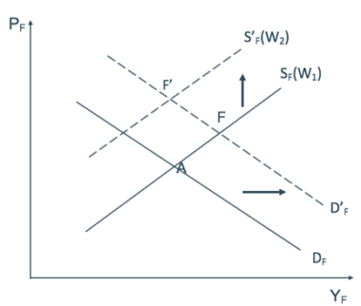
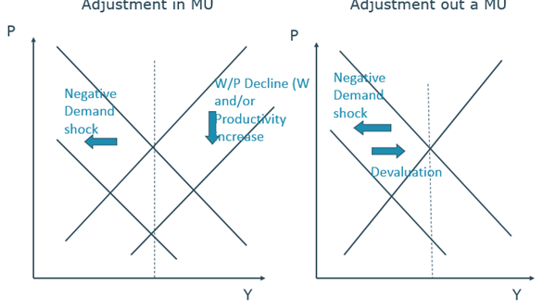
- Demonstrate why, in case of a permanent demand shock, the real wages in a country must change in order to go back to the initial output level, whether the country is in a monetary union or not. Illustrate graphically.

For the initial output level to be restored, nominal wages have to decline. This leads to a downward shift in the supply curve, when the initial output is restored, real wages in France also decline.
When France keeps its national money & adjusts to negative demand shocks by allowing its currency to depreciate, this shifts demand curve upwards. To restore initial output level permanently, upward pressure on nominal wage rate must be resisted. Can only be achieved if French workers are willing to accept the decline in their real wage that is implicit in setting at point F.
In a MU: the permanent negative aggregate demand shock must be followed by a nominal wage decline shift of aggregate supply curve. This will lead to a decline of real wages in France.
Without a MU: when the government reacts to the permanent negative demand shock with a depreciation, the upward pressure on the nominal wage must be resister. There will also be a decline in real wages in France.
- How do you explain that the internal devaluation in Latvia led to a reduction in its budget deficit and debt ratio, while the opposite happened in Spain?
In a MU: country has to reduce wages & prices, the decline in output leads to increasing budget deficit & a surge in ratio of gov debt to GDP. Members of MU have no control over money in which they have issued their debt.
Latvia’s boom, bust & recovery is because the economic responded to a balance-of-payments crisis by maintaining its currency peg and adjusting through internal devaluation and front-loaded consolidation.
Latvia/Lithuania: internal devaluation (20% drop of public wages and a gain in productive in the private sector and limited EPL), & announcement of frontloaded austerity. led to decrease in risk premium & low interest rate for borrowers, which also decreased budget deficit. The internal devaluation worked faster than expected and there was an increase in productivity, an increase in profit margins and a fast response from supply.
Latvian gov & Bank of Latvia, maintained the peg and proceed with frontloaded consolidation. The authorities saw a devaluation as inconsistent with the goal of euro adoption.
2009: new government announced a consolidation program: new measures adding up to 3.4% of GDP (with a full year effect of 6.5% of GDP). +20 % cut in government wage bill, controversial cuts to pensions (unconstitutional), & personal income tax reductions = less progressive.
Credible fiscal plan: restored confidence in peg & led to drop-in interest rates.
Authorities rejected Devaluation of the lat decided to adjust via internal devaluation adjustment of nominal prices & wages increase in productivity is associated with labour shedding, employment decreased in all sectors.
Productivity gains occur quickly Latvia: productivity increases sufficient to require only limited adjustment of nominal wages.
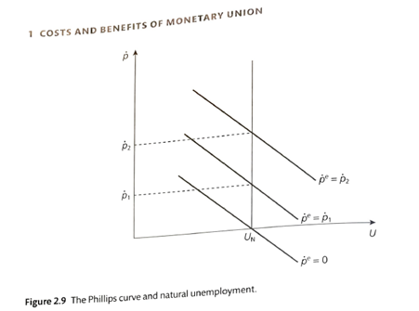
- Explain how the effectiveness of monetary policies may depend on the reputation of a government. Use the Barro-Gordon model graphically.
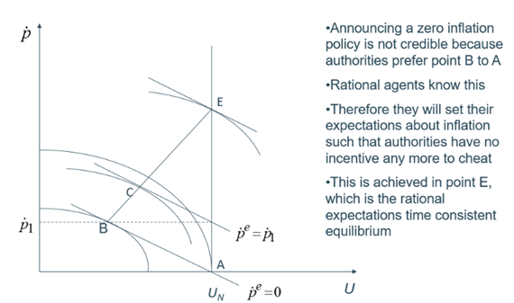
The reputation governments acquire in pursuing announced policies has a great impact on how these policies are going to affect the economy. The Phillips curve considers the role of inflationary expectations.
It explains the relationship between unemployment and inflation. If inflation is equal to the expected inflation, then unemployment will be equal to the natural employment and vice-versa. If unemployment is less than expected, then inflation is higher than expected.
Preferences of monetary authorities: Indifferences curves concave, & slope expresses relative importance of fighting inflation vs employment hard/wet-nose government.

Zero inflation rule (or any other constant inflation rule bellow the level achieved at E) has no credibility in a world of rational economic agents. Reason: economic agents realize that the authorities have an incentive to cheat, they will therefore adjust their expectation up to the point where the authorities do not have an incentive to cheat.
Model is static: If policy game is repeated many times, the authorities will have an incentive & possibility to acquire a reputation for low inflation.
- Explain, on the basis of the Barro-Gordon model, why some countries may decide to opt for dollarization.
Barro-Gordon model for open economies also allows us to understand why some countries decide to opt for dollarization of their economies. (Ecuador, El Salvador and Panama). These have been countries experiencing high inflation and facing great difficulties in bringing inflation down because a lack of credibility of their domestic monetary authorities.
Dollarization = instrument to solve credibility problem by abolishing the national money and by taking over the dollar, which is backed by the credibility of the FED.
- What is the purchasing power parity condition? Use an example.
Purchasing power parity (PPP) = metric compares different countries' currencies via "basket of goods" approach. PPP allows economists to compare economic productivity & standards of living between countries.
Assume 2 countries do not yet form a monetary union. Ex: Germany (assume it is a hard-nosed government: focus on inflation) & Italy (wet government: focus on unemployment).
We use purchasing-power parity condition: if inflation in Italy exceeds inflation in Germany, the Italian Lira will have to depreciate against the German mark to compensate for this inflation differential.
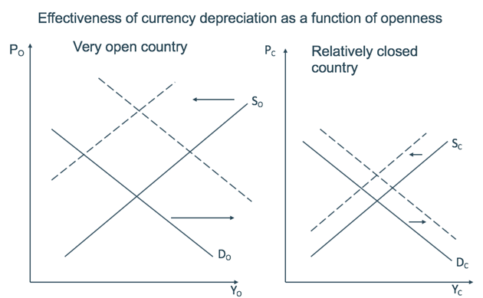
- Explain why the cost of joining a monetary union may decrease with the level of openness of that country. Illustrate graphically.
Same depreciation leads to___ in open than closed economy:
- Higher increase in AD
- Higher upward shift in AS
- Systematic use of exchange rate instrument will lead to more price variability & price variability is costly
More trade integration = asymmetric shocks less likely (EU) Cost of MU declines w country’s degree of openness
- According to the Barro Gordon model, the central bank has to be politically independent. Why?
In many countries political institutions favour short term objectives for politicians. Next election is never far away, leading politicians to give strong weigh to the short-term gains of inflationary policies. Authorities that decide about monetary policies (central bank) should be made independent from politicians and this is the case in many countries.
- Why is the existence of nation-states in a MU a potential source of asymmetric shocks? Is this a strong argument to reject a MU as too costly?
There are many divergencies in different countries and this is due to national budgetary policies and different national economic institutions (wage bargaining and labour market policies).
MU Members exercise considerable sovereignty in economic areas: budgetary field. Most of the spending and taxing powers is controlled by national authorities, only 1% of GDP is in hands of European Authorities. By changing taxes and spending, the authorities of an individual country can create large asymmetric shocks.
Oher aspect of existence of national states: many economic institutions are national, wage bargaining systems differ between countries = asymmetric developments.
Differences in legal systems and customs generate differences in workings of financial markets. Continued existence of nation states with their own policy & institutions creates national animal spirits – waves of optimism/pessimism destabilizing capital flows during downturn.
Absence of political union may set in motion a macro dynamics leading to large asymmetric developments. Therefore, there is a need to embed a MU in a stronger political union.

- Does conclusion that monetary policy is not fully effective in controlling stabilizing output & employment sufficient to conclude that countries don’t bear costs when they relinquish use of national monetary policy?
Not in a MU: country has full monetary control, especially over debt. It is able to devalue & avoid deflationary process and ensuing an increase in budget deficit and debt-to-GDP ratio.
In a MU: country must reduce wages & prices, ensuring decline in output increasing budget deficit a surge in the ratio of government debt to GDP.
As members of MU have no control over the money in which they issue their debt, it makes them vulnerable to self-fulfilling speculative attacks leads to a liquidity crisis, which can lead to a solvency crisis countries may face a sovereign debt crisis.

