This document was made based on other available summaries and a Gemini Notebook containing all lecture recordings + slides (so it should be pretty complete). Good luck!

Lecture 1: Introduction
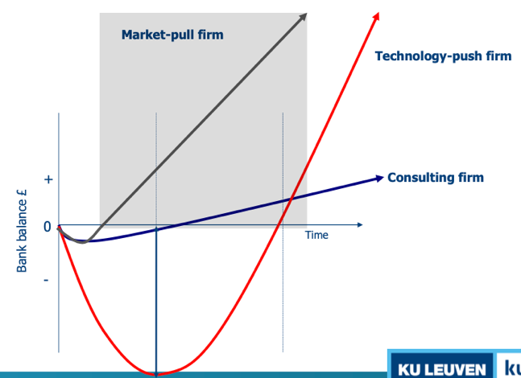
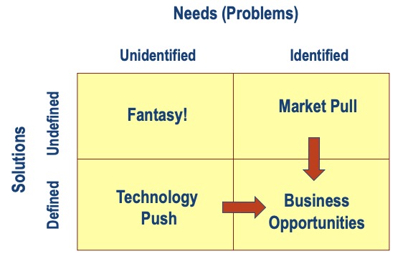
1. Explain the relationship between the type of business opportunity and the cash need (+ related implications)
The type of business opportunity dictates the cash flow curve and funding strategy:
• Technology Push: Starts with a solution looking for a market. Requires massive upfront investment for R&D before generating revenue (deep "Valley of Death").
Highly dependent on external equity (Venture Capital) to survive the long pre-revenue phase. High risk, but high potential return.
• Market Pull: Starts with a verified customer need. Time to first revenue is shorter, resulting in a smaller cash gap.
Less dependent on external capital early on. Founders can often bootstrap or use customer funding, retaining more equity and control.
• Consulting/Service: Sells time/expertise. Cash flow is often positive from day one with minimal investment.
Hard to scale because revenue is linear (tied to hours worked). Unattractive to VCs; raising external capital is often unnecessary and unwise,.
2. Describe the concept “business model” and link it to examples
A business model is the rationale of how an organization creates, delivers, and captures value. It is the architecture of the firm, distinct from just the product or strategy.
• Value Creation: Creating a solution for a specific customer problem (e.g., Nespresso creating high-quality home coffee).
• Value Delivery: How the solution reaches the customer (e.g., Nespresso bypassing supermarkets to sell directly via boutiques/online clubs).
• Value Capture: How the firm makes money (e.g., Nespresso’s "Razor and Blade" model: selling machines cheaply to lock customers into high-margin pods),.
• Other Example: Groupon uses a value network where it captures value by brokering deals between merchants (who get volume) and consumers (who get discounts),.
Because of assumptions, business models always work on paper. Wrong assumptions lead to false expectations. In rapidly changing business environments, assumptions can change so business model must be adaptable.
3. Explain why entrepreneurs have to test the assumptions of their business model. Use insights from the case Genappeal to support your answer
Entrepreneurs must test assumptions because a startup is a "temporary organization designed to search for a business model". Initial plans are merely hypotheses; operating on them without validation leads to building products nobody wants ("building the wrong thing").
• Genappeal Insights: The entrepreneur, Luc, assumed that because his DNA-matching technology worked scientifically (on rabbits), there was a market demand for it among humans. He projected a "hockey stick" revenue curve based on the assumption that 45 million singles would pay €250 for a test,.
• The Failure: He failed to test the desirability hypothesis. Humans did not want to choose partners based on DNA (and low willingness to pay for young people, while they are a large target group). By not validating this customer behavior early, he risked financial ruin on a solution for a non-existent market problem. Testing would have revealed the need to pivot (e.g., to a B2B model for high-end dating agencies) before running out of cash,.
4. Explain why business models often fail in rapidly changing environments. Use insights from the case Mobile Internet startup to support your anwser
Business models fail in changing environments because they are optimized for a specific context. When an environmental shock (technology or regulation change) occurs, the model's logic breaks. Startups often fail to adapt due to inertia—investors and boards commit to the original plan and refuse to pivot quickly.
• Mobile Internet Startup Insights: The company built a B2B model selling expensive "middleware" platforms to web agencies to format content for mobile phones.
• The Shock: The launch of the iPhone and App Store allowed developers to reach consumers directly (B2C), making the startup's middleware obsolete overnight.
• The Failure: The VCs had invested in a B2B model and resisted the necessary pivot to a low-cost B2C tool. This "cognitive rigidity" delayed the pivot for over a year, causing the company to burn through its cash and liquidate

Lecture 2: The LSU method
1. Describe why early market engagement is important for startups, use insights from the case Boo.com to illustrate your answer
Market engagement is important because of feedback from their customers and eliminate problems. This gives startups time to perfect their product in an iterative process before launching in one time. They create so called feedback loops.
• Boo.com Insight: Boo.com failed because they operated in stealth mode, spending over $100 million on complex technology without any customer feedback. They assumed users wanted a 3D shopping assistant and had high-speed internet. When they finally launched, the site was too heavy for 1999 bandwidths, and users hated the digital assistant. Had they engaged early with a Minimum Viable Product (MVP), they would have discovered these fatal flaws before burning their capital.
2. Explain the product development approach of Netscape Navigator/Myo and link it to the LSU method
Netscape Navigator (Software)
Netscape moved away from a strict linear "waterfall" model (where everything is built before release). Instead, they released multiple beta versions to the public during the development phase. By overlapping development with user testing, they gathered feedback on bugs and features before the final "Gold Release," allowing them to iterate based on actual usage.
Myo / Thalmic Labs (Hardware)
Instead of spending heavily to manufacture a perfect consumer device immediately, the founders built a low-fidelity Minimum Viable Product (MVP)—a crude "box with wires" taped to a arm. This cheap prototype proved the core technology (muscle control) worked and validated market interest. They used this evidence to raise $14.5 million in funding without having to build expensive manufacturing molds first.
- Links to LSU: hypothesis testing, MVPs, de-risking.
3. Describe the 3 key principles of the LSU method and discuss why some entrepreneurs still prefer to operate in stealth mode
The three key principles are:
- Day 1: series of hypotheses & assumptions based on own world view
- MVPs test hypotheses: learning, importance of absorptive capacity (Capacity to acquire, absorb and put into practice new information)
- Approach based on BML-cycles (build – measure – learn)
<-> stealth mode of entrepreneurs (under the radar as long as possible)
Why Stealth Mode? Despite LSU benefits, some entrepreneurs prefer stealth mode due to fear of IP theft (competitors stealing ideas) or the "visionary fallacy" (believing they, like Steve Jobs, know what customers want better than the customers do), prevents alerting competition, in control of press.
4. Describe the # mechanisms to seek evidence and illustrate with examples
Entrepreneurs use three main mechanisms to validate assumptions:
1. Analogs and Antilogs: Studying successful companies (Analogs) to mimic their strategies and failed companies (Antilogs) to avoid their mistakes.
2. Interviews: Conducting open conversations to validate the problem before pitching a solution. For example, asking restaurant owners about waste management revealed it wasn't a problem, but staffing was. Problem -> Solution. Surveys are always almost wrong, because they start from your own theoretical frame.
3. Experiments/MVPs: Testing actual behavior with MVP. Examples include the foam pillbox test (testing usability with cheap foam models) or Myo's wire prototype. Failure? => Pivot!
5. Explain how the LSU-method is related to the concept crossing the chasm and firm value creation over time
• Crossing the Chasm: The LSU method helps startups bridge the hurdle between early adopters (who tolerate bugs) and the early majority (who demand reliability) by forcing the company to validate product-market fit rigorously. Without this validation, companies often fail to scale. => Increase chance of crossing the chasm!
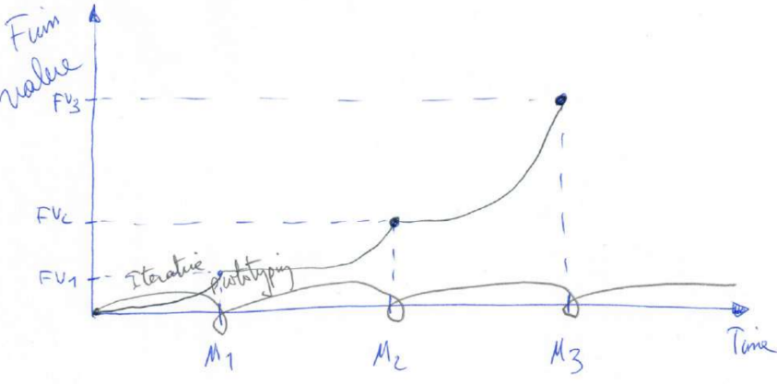
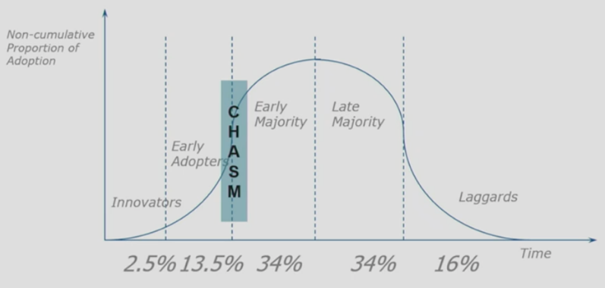
• Firm Value Creation: There is a direct link between the "Build-Measure-Learn" cycle and firm valuation. Initially, a startup is risky because it is 100% assumption-based. Every time a hypothesis is validated through LSU, the venture is "de-risked," causing the firm valuation to rise (the J-curve), even before significant revenue is generated.

Lecture 3: Business model design
1. Describe the business model canvas and the 9 building blocks. Use a figure to support your answer
The Business Model Canvas (BMC) is a strategic management tool used to visualize, design, and assess business models. It describes the rationale of how an organization creates, delivers, and captures value.
- Customer Segments: The different groups of people or organizations your organization aims to help with getting a job done.
- Value Propositions: Describes the bundle of products and services that create value for a specific customer segment.
Desirability
- Channels: Outlines the customer touch points through which an organization interacts with each of its customer segments to communicate and deliver a value proposition.
- Customer Relationships: Describes how an organization’s gets, keeps and grows each customer segment and what type of relationships it entertains with them.
- Key Resources: Describes the most important assets required to make a business model work.
- Key Activities: Describes the most important things a company must perform to make its business model work.
Feasibility
- Key Partners: Outlines the network of suppliers & partners that make the business model work.
- Cost structure: Describes all costs incurred to operate a business model.
Viability
- Revenue streams: Represents the type of revenue an organization generates from each customer segment for a specific value proposition.
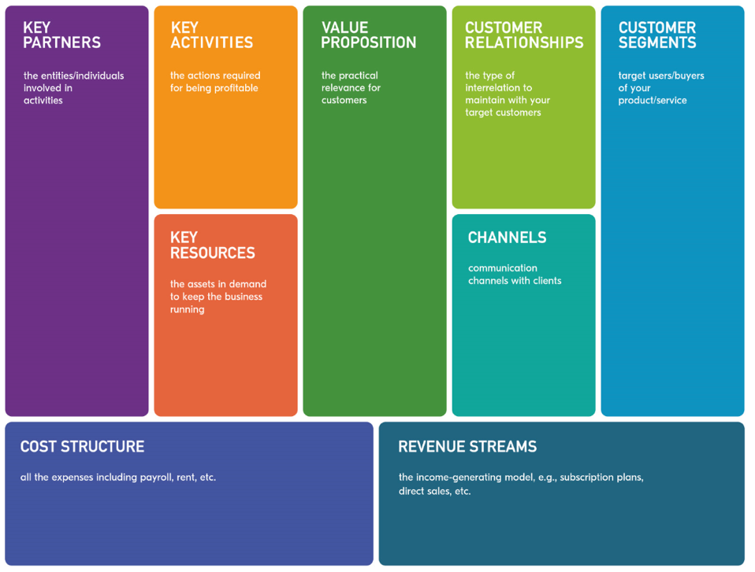

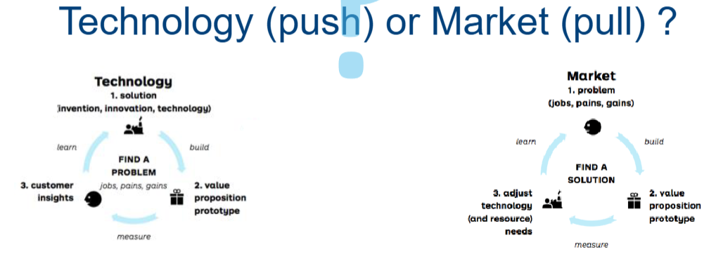
2. Describe the different starting points in developing the business model canvas and related points of attention. Use a figure to support your answer
Market-pull: Start from customer segments/relationships, channels and value proposition. Main challenge: feasibility (left side of BMC) and risk of false assumptions about customer needs.
Technology-push: Start from key resources/activities. Main challenge: desirability (right side of BMC), commercialization, funding.
3. Discuss the business model patterns of Nespresso and Apple, and link it with other examples. Use a figure to support your answer
Nespresso: The "Razor and Blade" (Bait and Hook) Pattern Nespresso shifted the coffee industry by adopting a pattern originally famous in the shaving industry (Gillette).
• Mechanism: Nespresso sells coffee machines at a relatively low margin through widespread retail channels. This locks the customer into their ecosystem.
• Value Capture: The real profit comes from the high-margin, recurring sales of the proprietary coffee pods (the "Hook"), which historically could only be bought through Nespresso’s direct channels (web/boutiques). This created a recurring revenue stream and high switching costs for the customer.
• Link to other examples: HP Printers uses the same logic (cheap printers, expensive ink). Gillette uses this for razors and blades.
Apple (iPod/iTunes): The Platform / Lock-in Pattern Apple innovated not just through hardware, but by combining hardware with a digital platform.
• Mechanism: Apple combined a physical device (iPod/iPhone) with a software platform (iTunes/App Store).
• Value Creation/Capture: This created a "walled garden" or Lock-in. Once a user buys the music/apps, they are tied to the device. Furthermore, Apple acts as a platform connecting third-party developers (Producers) with users (Consumers), taking a commission (30%) on transactions. This generates network effects: more apps make the phone more valuable, attracting more users.
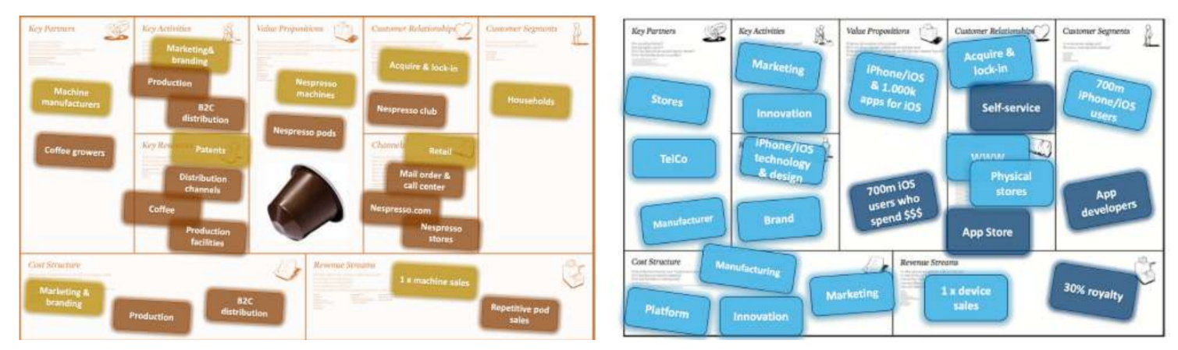
• Link to other examples: Spotify (Subscription/Freemium model shifted music from ownership to access). Airbnb (Platform connecting hosts and guests without owning assets)
4. Define and dimensionalize business model innovation. Use a figure to support your answer
Definition: Business Model Innovation (BMI) is defined as "designed, novel, and nontrivial changes to the key elements of a firm’s business model and/or the architecture linking these elements”. => Fundamentally changing how a company creates, delivers, and captures value for customers. Scope (modular/architectural) & degree of novelty (new to firm/industry).
1. Evolutionary BMI (Modular / New to Firm): Fine-tuning processes that occur naturally. Example: Spotify adding podcasts to its existing platform.
2. Adaptive BMI (Architectural / New to Firm): Adjusting the overall architecture in response to the environment, but using models known elsewhere. Example: Adobe moving from selling licenses (products) to the Creative Cloud subscription model (SaaS).
3. Focused BMI (Modular / New to Industry): disrupting a specific area of the model with industry-new innovation. Example: Amazon Web Services (AWS). Amazon leveraged its existing infrastructure (modular change) to offer cloud services
4. Complex BMI (Architectural / New to Industry): Completely restructuring the value chain to disrupt the industry. Example: Uber/Airbnb. They replaced traditional asset-heavy models (hotels/taxis) with sharing economy platforms, changing the entire architecture of value creation and delivery in the industry.

Lecture 4: Entrepreneurial teams
1. Discuss what factors should be considered when choosing Co-founders and what are the advantages/disadvantages coming with the decision.
Formation Strategies: Founders generally select partners based on two mechanisms:
◦ Interpersonal Attraction: Choosing based on social similarity, friendship, and shared values.
◦ Resource Seeking: Choosing based on instrumental needs, such as specific technical skills, funds, or networks (complementarity)
Functional skills: Skills that can be linked to the specific function.
-> CMO for Simplex: E-marketing, Social skills, Product management skills,…
-> CFO for Simplex: Capital raising skills, CF control, Risk management,…
Domain skills: Skills that can be linked to the domain the organization operates in.
-> CMO for simplex: Selling in Hospitality, local & regional knowledge,…
-> CFO for simplex: Costing & pricing in the industry, Tax system knowledge,…
Startup-context skills: Skills that are specifically needed for a startup.
–> CMO & CFO Simplex: Team player, Communication, Openness, Flexible,…
2. Evaluating candidates on stand alone basis vs the team/context. Discuss and use the case of Simplex Solutions as an example
Candidates cannot be evaluated solely on their individual CV ("stand-alone basis"); they must be evaluated based on how they fit the specific context of the startup's life stage and the existing team composition. Simplex Solutions was a software company facing a cash flow crisis and attempting to scale into a new market (hospitals). They needed a CFO and a CMO.
• Stand-alone evaluation:
◦ Pierre (CFO candidate) and Alan (CMO candidate) have a lot of expertise, highly qualified.
• Team/Context Evaluation:
◦ The Mismatch: Pierre and Alan both displayed arrogance or a "short temper." In a large corporation, their hard skills might suffice. In a fragile startup team, their toxic interpersonal styles could destroy psychological safety and team cohesion. It would be better to have someone on the team that can manage crises.
Conclusion: Startups must assess Functional Skills (role-specific), Domain Skills (industry-specific), and Contextual Skills (fit with the startup phase and team culture)

3. Define Advantages and Disadvantages of Solo and Team Founding & how to deal with it
- Advantages (Disadvantages of team):
  - Retain all equity
  - Decision control
  - Avoid communication, coordination & incentive problems
- Disadvantages (Advantages of team):
  - Rely exclusively founder for all gaps in Human Capital,…
  - Less ability to process complexity
  - Slower response rate
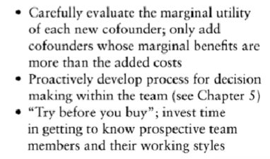
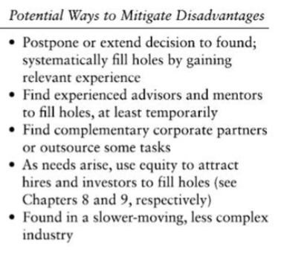
  - Lack of collaboration/support
Building a founding team
Solo

4. Discuss how to use the DEFT Model and The 3Rs Model to assess Team Composition
The DEFT Model helps assess if the team is built correctly:
- D - Diversity: Assess the balance between Knowledge Diversity (functional skills, education—beneficial) and Social Diversity (gender, ethnicity—needs management to avoid stereotyping).
- E - Expertise: Map the team's skills against the venture's needs. Look for gaps in Functional, Domain, and Startup-context skills.
- F - Faultlines: Identify potential dividing lines (e.g., "founders vs. new hires" or "tech vs. business"). Strong faultlines (where attributes align, e.g., all founders are young male engineers) can lead to "us vs. them" dynamics.
- T - Timing: Decide when to expand. Hire based on current fit, anticipation of growth, or confirmed growth

The 3Rs Model helps assess the founding team and prevent "blowups", based on tensions:
- Relationships: Analyze the social tie. Is it a family team (high trust, high risk of relationship damage)? Are they strangers? This assesses the "playing with fire gap" (avoiding crucial, difficult business conversations due to fear of damaging their personal relationship).
- Roles: Define who does what. Is there a clear division of labor? Who has decision-making authority (CEO)?
- Rewards: Determine the equity split. Is it equal or based on contribution? How are exits handled? Misalignment here is a major cause of failure.
5. Explain Advantages and Disadvantages of Team Diversity
- Advantages:
  - Innovation: Diverse teams bring different perspectives and heuristics, fostering creativity and new ideas.
  - Resource Pool: Access to broader networks and distinct skill sets (e.g., one founder knows tech, the other knows sales).
  - Problem Solving: Diverse teams are better at processing complex information and correcting errors.
- Disadvantages:
  - Coordination Costs: It takes longer to communicate and reach a consensus when members think differently.
  - Conflict: Social diversity can lead to stereotyping or "faultlines" (subgroups), causing interpersonal friction.
  - Mistrust: It is harder to build trust quickly among people who share fewer commonalities

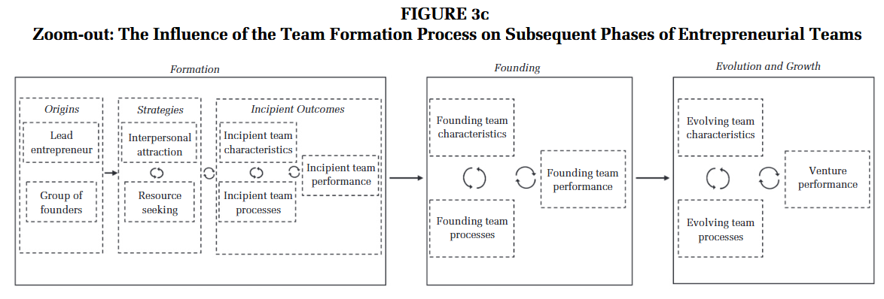
6. Explain entrepreneurial team formation as a dynamic process using the model in Figure 3c
Dynamic, path-dependent process where early-stage decisions "imprint" the venture’s future. The model follows a linear progression through three distinct phases:
1. Formation (The "Incipient" Phase)
This is the most fluid stage, characterized by a feedback loop between three elements:
- Origins: The team starts either with a lone Lead Entrepreneur or a pre-existing Group of Founders.
- Strategies: Founders balance Interpersonal Attraction (hiring friends/family for trust) with Resource Seeking (hiring for specific skills).
- Incipient Outcomes: These strategies produce early team characteristics and processes. The circular arrows indicate team churn—an iterative process of members joining and leaving until the team stabilizes.
2. Founding
The "incipient" outcomes of the first phase harden into the formal Founding Team.
- Endogeneity: The characteristics and processes (how the team communicates and makes decisions) at this stage are a direct result of the formation strategies used earlier.
- Founding Performance: The team’s initial success is tied to how well the "Origins" and "Strategies" were aligned with the venture's needs.
3. Evolution and Growth
As the venture scales, the team enters a continuous cycle of change.
- Evolving Dynamics: Team characteristics and processes are not static; they must adapt as the company grows.
- Venture Performance: This is the final outcome. The model suggests that long-term venture success is deeply rooted in the initial formation process, proving that team assembly is a strategic foundation rather than a one-time event.

Lecture 5: Organizing the start-up
1. Discuss the concept “value chain” and why a value chain analysis is important for start-ups. Use a figure to Support your answer.
The value chain describes the linear sequence of activities required to create, produce, and deliver a product or service to the end customer. For start-ups, the focus extends beyond the internal firm activities to the Industry Value Chain. This involves identifying other players (upstream suppliers and downstream distributors) and the specific functions they perform. => Who are the other players? What is their bargaining power?
- VAC analysis allows you to think ahead about:
  - your competitive position in the value chain;
  - the opportunities and challenges you may encounter with the other
players in the chain
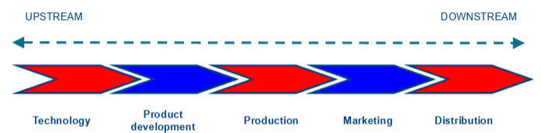
  - the probable consequences for your business model
2. Explain how Native Deoderants disrupted the value chain of traditional players such as P&G. Use a figure to support your answer.
Traditional players like P&G operate a long, vertically integrated value chain where they rely heavily on Retail Chains (downstream complementary assets) to reach consumers. This gives retailers significant power and margin. Native Deodorants disrupted this by adopting a Direct-to-Consumer (DTC) model, by selling products online.
- Eliminated the dependency on powerful retailers.
- Captured the full margin (allowing for higher profitability even with higher production costs).
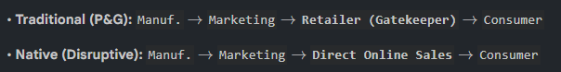
- Established a direct feedback loop with customers, allowing for rapid product iteration (Lean Start-up method) which incumbents lacked

3. Discuss how the value chain relates to product market and cooperation commercialization strategies
The distribution of complementary assets in the value chain dictates the commercialization strategy:
- Product Market Strategy (Competition): If a start-up can build or access the necessary downstream assets (e.g., distribution) cost-effectively, it competes directly in the product market. The focus is on developing a superior customer value proposition and building the entire value chain (e.g., Native Deodorants).
- Idea Market Strategy (Cooperation): If complementary assets are tightly held by incumbents and expensive to replicate (e.g., biotech distribution and regulatory trials), the start-up focuses on upstream activities (R&D). It then cooperates with incumbents (via licensing or acquisition) who own the downstream assets.
4. Explain the Gans and Stern (2003) framework on commercialization strategies for entrepreneurial firms. Use a figure to Support your answer.
This framework helps entrepreneurs decide between competing or cooperating based on two environmental dimensions:
- Excludability: Can the technology be precluded from imitation (e.g., via patents)?
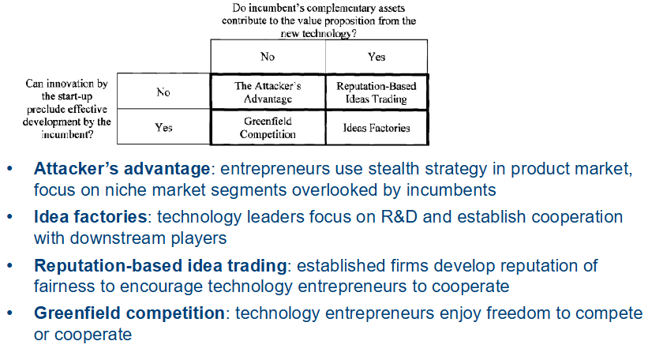
- Complementary Assets: Are incumbents' assets (manufacturing, distribution) necessary to commercialize?

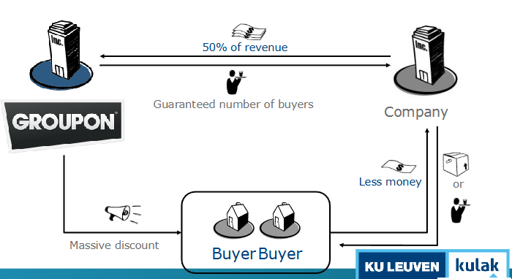
5. Use the example of Groupon to discuss the concept “value network”. Use a figure to Support your answer.
A value network is the set of interconnected actors (firms, partners, customers, complementors) that jointly create, deliver, and capture value through their interactions.
Unlike a value chain (linear flow of activities), a value network is multi-sided and focuses on relationships and exchanges rather than sequential production steps.
- The players (company, partners, clients)
- The flow from company to client (product, service, experience, reputation)
- The flow from client to company (money, attention, exposure)
6. Explain how platforms are reshaping business. Use the case of the mobile phone market to illustrate your answer.
Business is shifting from Pipelines (traditional linear value chains optimizing internal efficiency and control) to Platforms (facilitating external interactions between producers and consumers). Platforms focus on resource orchestration rather than control, and maximize network value rather than just customer value.
Mobile Phone Market Illustration:
• Pipeline (Nokia/Blackberry): Focused on linear supply chains and hardware efficiency.
• Platform (Apple iPhone): Apple disrupted the market not just with hardware, but by creating the App Store. This platform connected App Developers (Producers) with iPhone Users (Consumers).
• Network Effect: More apps made the phone more valuable to users, which attracted more users, which attracted more developers. This allowed Apple to scale exponentially without bearing the costs of developing every app internally.
7. Explain why AirBnB poses a significant threat to incumbent companies like Accor, and discuss the strategic actions of Accor to respond this threat
AirBnB is a Platform business with virtually zero marginal cost of adding inventory (rooms), whereas Accor is a Pipeline business (bricks and mortar). Accor must invest heavy capital (CAPEX) to build or buy hotels to grow. AirBnB leverages existing assets owned by others. Consequently, AirBnB achieved a valuation 5-10 times higher than Accor despite owning no rooms, threatening to render Accor's asset-heavy model obsolete. Accor responded with:
1. Rethink Usage: Leveraged existing infrastructure to attract non-travelers (e.g., renting lobbies as workspaces) to generate new revenue streams.
2. Acquire Tech Players: Created a new business unit to acquire platform startups (e.g., Onefinestay, a high-end AirBnB competitor) to enter the platform market.
3. Divest Assets: Sold off real estate assets to raise the capital needed to finance this digital transformation

Lecture 6: Sources of funding
1. Discuss the Stage of Venture Development and Financing landscape. Use a figure to support your answer.
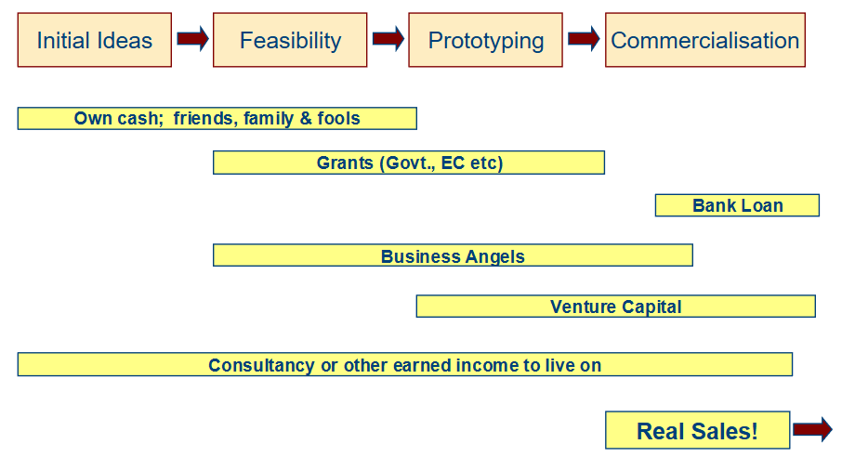
The financing landscape evolves according to the venture's lifecycle stage. In the initial ideas and feasibility phase, startups rely on "Own cash" and "Friends, Family, and Fools" (3Fs) because the risk is too high for professional investors. As the venture progresses to prototyping, grants and business angels (BAs) become relevant. Once the venture reaches commercialization and sales, Venture Capital (VC) and bank loans become accessible options.
Grants still comes at a cost, not direct but indirect. (Request & report documents) Bank’s need to see have a collateral if the loan can’t be payed back on a normal way. BA, VC and Banks need evidence of BM before they enter
2. Explain why startups organize their fund raising in multiple rounds.
Startups raise funds in rounds (Series A, B, C) rather than all at once to minimize equity dilution.
- Valuation Increases: At the early stage (t=0), firm valuation is low (high risk, unproven model). Raising a large amount (e.g., $3.5M) immediately would require giving away a massive percentage of ownership (e.g., 71%),.
- De-risking: By raising smaller amounts to reach specific milestones, the company "de-risks" itself. This increases the valuation for the next round. Consequently, founders give away less equity for the same amount of capital in later rounds, retaining more ownership and incentive

3. Define the concepts burn rate and runway and discuss why these are important to startups
- Burn Rate: The rate at which a business consumes cash to cover operating expenses (e.g., $200k/month). It represents negative cash flow before the company is profitable.
- Runway: The amount of time the company can survive before running out of cash, calculated as Current Cash / Burn Rate.
- Importance: These metrics determine the startup's bargaining power. If the runway drops below 6 months, the entrepreneur is in a desperate position ("water is here"), significantly weakening their negotiation leverage with investors
4. Define the concept “bootstrapping” and different types of bootstrapping techniques.
Bootstrapping is the process of launching and growing a business using limited resources and finding creative ways to avoid external equity financing.
- Customer-related: Obtaining advance payments from customers to fund operations.
- Delaying payments: Negotiating longer payment terms with suppliers or leasing equipment instead of buying.
- Owner-related: The founder taking no salary or a reduced salary.
- Joint-utilization: Sharing resources, such as office space or equipment, with other organizations.
5. Explain why “bootstrapping” is desirable, use the concept “pecking order of finance” in your answer.
Bootstrapping is desirable because it allows founders to retain 100% control and equity while focusing on customers rather than fundraising, which gives the opportunity of a higher valuation once external resources are needed.
Pecking Order of Finance: This theory suggests a hierarchy of preferred funding sources based on cost and control:
- Internal Funding (Bootstrapping): Cheapest, keeps full control.
- Debt (Loans): Non-dilutive (no equity lost), but requires repayment/collateral.
- Equity (VC/Angels): Most expensive (dilutive, loss of control), used only when necessary for high growth
6. What are advantages/disadvantages of using “bootstrapping”
Advantages:
- Focus: Entrepreneur focuses on the business/customer, not fundraising.
- Control: Retain 100% equity and decision-making power.
- Discipline: Forces financial discipline and efficiency.
Disadvantages:
- Slower Growth: Lack of large capital injection limits rapid scaling.
- Limited Applicability: Not possible for capital-intensive sectors (e.g., biotech) that need millions upfront
7. What criteria would u use to evaluate the risk of investing in startups (see case Candice Cake)?
Internal side:
- Founders
- Management team
- Business Model
- Deal
External side:
- Market size
- Competition
- Growth predictions
8. Explain the wealth versus control dilemma and link it to different sources of external financing (Incubator/Business angel/Venture capital). (see case Candice Cake)
The wealth versus control dilemma refers to the trade-off entrepreneurs face between:
- Maximizing personal wealth (by growing the firm with external capital)
- Maintaining control over strategic decisions, vision, and daily operations.
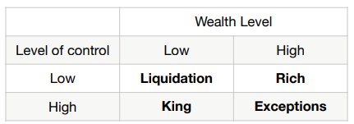
To scale a business, founders often need external financing. However, external investors typically require equity, voting rights, board seats, or contractual control, which reduces the founder’s autonomy.
Founders POV
Incub./accum. => King | BA => moderate/moderate | VC => Rich
9. Define and characterize Business Angels and Venture Capital firms
BA are wealthy private investors, often experienced entrepreneurs. Their objective is FUN and return, they want a hand on involvement and help on the operational side as well. (10k-250k) They use friends and network to spot opportunities. Exp(return) 30-35% Early stage investors. Consider themselves part of the entrepreneurial team => Match with entrepreneur is highly important.
VC is fundamentally different. External investors accumulate their funds in one big VC fund, the VC firm than invest this money in companies. A VC invest thus money from other people, typically IB, Pension funds, wealthy individuals. Large investment in later stage, focus on exit and scaling. Not as hands-on as a BA.
10. Describe the life cycle of a Venture capital fund. Use a figure to Support your answer.
A VC fund typically has a 10-year lifespan.
- Fundraising (Year 0): general partners (GPs) define the mandate and raise capital from Limited Partners (LPs).
- Investment (Years 0-2): Screening and investing in a portfolio of startups (10-15 max).
- Management/Follow-on (Years 2-7): Monitoring, adding value, and follow-on investments in "winners".
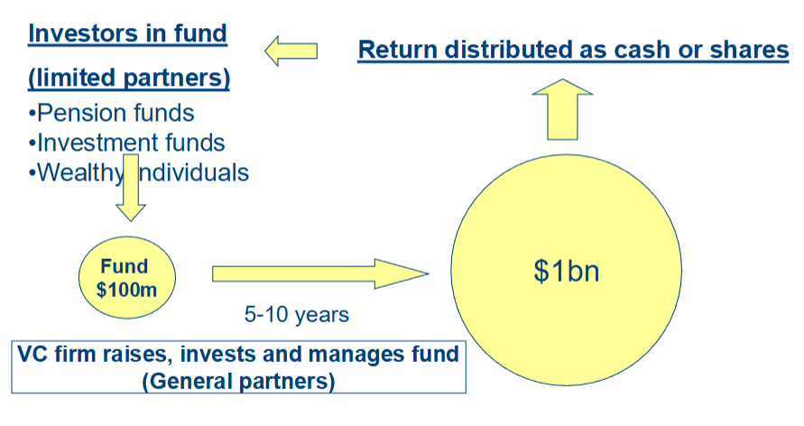
- Exit/Liquidation (Years 8-10): Exiting investments (IPO/Trade Sale) to return capital to LPs
GPs take 20% of PROFIT (+ management fees during lifecycle)
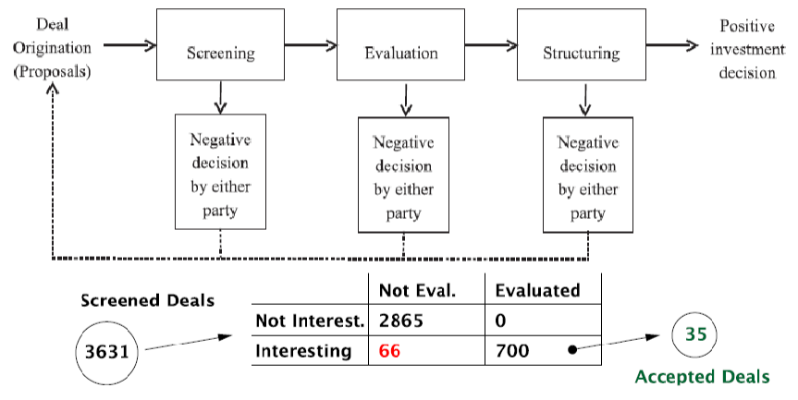
11. Discuss the screening and due diligence process used by Venture capital firms when considering an investment opportunity.
- Screening (5-10 mins): Quick check if the deal fits the fund’s mandate (sector, stage, geography). High rejection rate.
- Due Diligence (6-8 weeks): Deep dive into the team, market size, IP position, and business model scalability. Includes customer calls and expert consultations.
- Deal Structuring: Negotiating the Term Sheet (valuation, liquidation preferences, anti-dilution clauses, board seats)
While screening & DD the startup is carefully analyzed on several domains, economic, juridical, fiscal & financial. Only 1% of submitted plans receive funding from VC.
12. Explain the concept “funding gap” and discuss the typical mechanisms that policy makers introduce to address the “funding gap”.
The funding gap is a lack of capital available for startups that are too mature for "friends and family" funding but not yet ready/large enough for VCs (typically in the seed/early stage). This is also because of information asymmetry: because early-stage ventures lack financial history or collateral (unlike mature firms that can get bank loans), investors cannot easily assess the viability of the venture. Policy helps to bridge the gap between those two stages using a few mechanisms.
Mechanisms: Policy makers address this via:
- Business Angel Networks (BANs): Platforms to match investors with entrepreneurs.
- Co-investment schemes: Government matches private investments to reduce risk, and get BA’s to invest more often.
- Loan Guarantees: Government guarantees bank loans.

13. Discuss the case of Sitra’s “PreSeed Service” and how Sitra innovated the traditional Business Angel Network.
Sitra (Finland) innovated the traditional Business Angel Network to fix the funding gap by adding:
- INTRO: A marketplace to match entrepreneurs, angels, business developers.
- LIKSA: A subsidy (approx. €40k) for business plan refinement and market validation, making startups "investor-ready". Condition: participate in INTRO.
- DIILI: A sweat equity program matching startups with experienced business developers (sales competence) who work for equity rather than salary, addressing the "managerial capacity" problem.

Lecture 7: Growth strategies of entrepreneurial ventures
1. Discuss why growth isn’t always a good thing
While growth is often a goal, it is not always beneficial or possible for every business.
- Business Type: Not all businesses have the potential to be aggressive growth firms. For example, consulting firms struggle to scale because their revenue is linearly tied to human hours, unlike platform businesses.
- Operational Risk: A business can grow too fast, leading to a loss of quality control and operational stability.
- Scalability: Success doesn’t always scale. A business model might rely on founder involvement, niche customers, or local knowledge that cannot be replicated broadly.
Hence, a firm should establish growth-related plans.
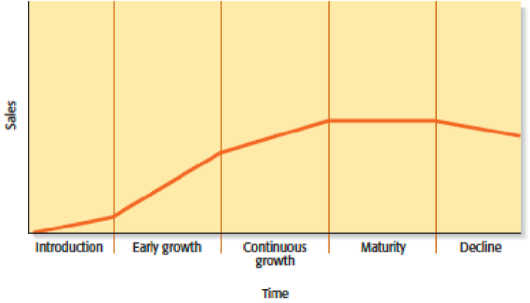
2. Describe the most important factors for firms to focus on during each stage of company life cycle. Use a figure to support your answer
- Introduction: Business Model Development: Focus on the Lean Start-up method, validating assumptions, and finding product-market fit without heavy external funding.
- Early Growth: Scaling & Structuring: Focus shifts to scaling the business model and seeking investment. Crucially, the firm must move from "working in the business" to "working on the business" by formalizing structures and processes.
- Continuous Growth: Expansion: Expand product offering/enter new markets. The top management team often changes to include new skills.
- Maturity: Efficiency & External Growth: Focus on efficiency/exploitation. Growth often comes through acquisitions or partnerships (e.g., Accor acquiring tech startups).
- Decline: Ambidexterity: The firm must manage decline by balancing exploitation of existing assets with exploration of new opportunities to avoid bankruptcy.
3. Describe the managerial capacity problem.
Two kinds of firm services are important for growth:
- Entrepreneurial services generate new market, product and service ideas
- Managerial services administer the routine functions of the firm and facilitate the successful execution of new opportunities
A firm can’t quickly increase it’s managerial services to take advantage of new product or service ideas because:
- Expensive to hire new employees
- Takes time for new hires to be socialized into the culture of the startup
- It takes new hires time to acquire firm-specific skills
If these resources are insufficient to take advantage of new developments, this bottleneck is called the managerial capacity problem.
4. Discuss the challenges for growth imposed by adverse selection and moral hazard. Explain how employee option schemes may reduce these challenges.
Growth requires hiring new employees, which introduces two specific problems:
- Adverse Selection: The difficulty in judging whether a new hire is actually the right fit based solely on interviews (hiring the wrong person) => gets even harder the larger the company is.
- Moral Hazard: New hires typically do not have the same ownership incentives or motivation as the founders, leading to potential avoidance of hard work.
Employee option schemes address these problems by aligning incentives:
- Addressing Adverse Selection: Companies install a Cliff Period (usually 1 year). If the employee leaves or is fired within the first year (due to poor fit), they receive zero options. This protects the firm from giving equity to the wrong hires.
- Addressing Moral Hazard: Options Vest over a long period (e.g., 4 years). This ensures employees are motivated to stay and work hard to increase firm value over the long term to "earn" their equity.
5. Discuss the day-to-day challenges of growing a firm.
- Cash flow management: A firm needs more cash the bigger it gets (burn rate).
- Capital constraints: they are an ever present problem in growing firms
- Price stability: if growth comes at the expense of market share of a competitor, a price war could ensue. This is a losing game for everyone.
- Quality control: An increase in firms activity can result in quality problems because a firm might not be able to increase its resources to handle the extra work.
6. Explain different types of “internal growth strategies”
- New product development
  - Competitive necessity => high risk strategy as it requires a new BM
- Other product related growth strategies
  - Improving quality of an existing product or service
  - Increasing market penetration -> Greater marketing or greater production capacity
  - Extending product lines -> Variations
- International expansion
  - Equity based entry ( Sales Offices, Subsidiary)
  - Non-equity based entry (Direct export, Distributors)
7. Explain different types of “external growth strategies”
- Mergers & Acquisitions (equity-based)
  - An acquisition is the outright purchase of one firm by another
  - A merger is the pooling of interests to combine two or more firms into one
- Licensing (contract-based)
  - Licensing is granting permission by one company to another company to use a specific form of its intellectual property under clearly defined
conditions
  - Virtually any IP a company owns that is protected by a patent, trademark, or copyright can be licensed to a third party
- Strategic Alliances & Joint Ventures
  - A strategic alliance is a partnership between two or more firms
developed to achieve a specific goal (contract-based)
    - Technological alliance: cooperation in R&D, engineering, ..
    - Marketing alliance: use excess distribution capacity
  - A joint venture is an entity created when two or more firms pool a portion of their resources to create a separate, jointly owned organization
    - Common reason is to gain access to a foreign market
8. Discuss the concepts “liabilities of foreignness” and “liabilities of outsidership”, use insights from the case Candice Cake in your answer.
When Candice Cake (a Russian startup) plans to enter the US market, it faces two types of liabilities:
- Liability of Foreignness: The inherent disadvantage of being a foreign company. This includes a lack of knowledge about local market dynamics, different customer preferences (US vs. Russia), and navigating a different institutional/legal environment. => Additional costs
- Liability of Outsidership: The lack of embeddedness in the local network. The entrepreneur (Martianova) lacks connections to local suppliers, partners, and funders in the new market. => Use local distributors
9. Explain how a transaction economics perspective can help entrepreneurs to make entry mode decisions.
Transaction Cost Economics (TCE) helps entrepreneurs decide between partnering (e.g., distribution) or internalizing (e.g., sales office).
- Entrepreneurs must weigh the transaction costs of working with a partner (negotiation, monitoring, risk of opportunism) against the cost of doing it themselves.
- Application:
- Low Complexity/Service: If the product is simple and easy to transfer (e.g., sorting machines), transaction costs are low. Use Distributors.
- High Complexity/Service: If the product requires specialized knowledge and high service levels (e.g., energy management software), transaction costs with partners are high (hard to contract). The firm should internalize (set up a wholly-owned subsidiary).
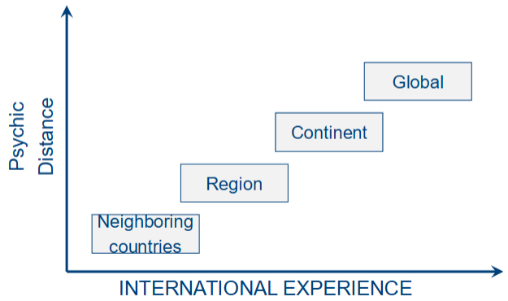
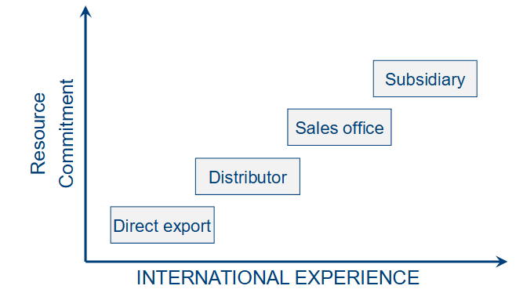
10. Explain the stage model of internationalization
The stage model suggests that internationalization is a gradual, incremental process driven by experiential learning (learning-by-doing). Firm accumulates foreign market knowledge as it internationalises.
- Entry Mode Commitment: Firms start with low-commitment modes (Direct Export) and gradually move to high-commitment modes (Sales Office Subsidiary) as they gain experience.
- Geographic Expansion: Firms start with psychically close markets (neighbors with similar cultures) and gradually move to more distant markets.
However, the Uppsala model doesn’t reflect reality: 30% of high-tech start-ups (HTSU) use higher entry mode than direct export at first market entry, and 55% of HTSU have export outside EU within 3 years. Reasons: see next question.
11. Discuss how the “born global” and “network approach” help to explain the rapid internationalization of startups. Use a figure to support your answer.
High-tech startups often defy the Uppsala model by "leapfrogging" stages and entering distant markets immediately. This is explained by two alternative learning mechanisms.
- Born Global (Congenital Learning): The founding team already possesses international experience and knowledge at the inception of the firm. They don't need to learn from scratch; the knowledge is "congenital" (inborn).
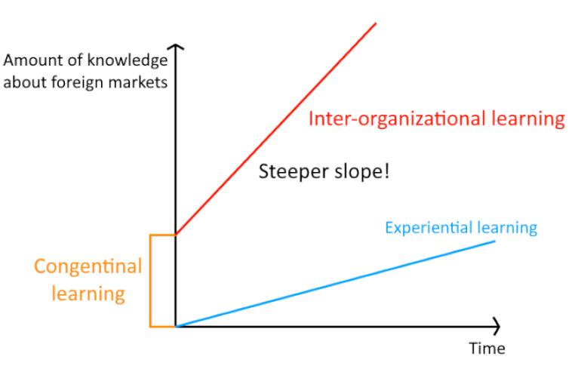
- Network Approach (Inter-organizational Learning): The firm learns not just through its own experience, but by leveraging the knowledge and networks of partners.

Lecture 8: Exit – IPO versus trade sale
1. Explain how the NPV method works and why it is not suitable for the valuation of startups
How it works: The Net Present Value (NPV) method, often calculated using Discounted Cash Flow (DCF), values a company based on its future financial performance.
- Projecting Cash Flows: Estimating the future cash flows the company will generate over a specific period (e.g., 5 years).
- Determining Terminal Value: Calculating the value of the company at the end of the projection period.
- Discounting: Bringing these future values back to the present moment using a specific discount rate (weighted average cost of capital) to account for the time value of money and risk.
NPV is generally considered unsuitable for early-stage ventures because of:
- Unreliable Projections: It is extremely difficult for startups to make reliable forecasts of sales and costs for the next 5 to 10 years. Since the valuation is "only as reliable as cash flow projections," the output is often meaningless for high-uncertainty ventures.
- Discount Rate Estimation: It is very difficult to estimate an accurate discount rate that properly reflects the specific risk profile of a startup,.
2. Describe the valuation method for startups based on multiples/comparables. Which one would you prefer to use? Explain why.
Valuation based on multiples (or comparables) determines a startup's value by looking at how similar assets are currently priced in the market.
- Step 1: Identify similar companies that are publicly listed or were recently acquired.
- Step 2: Calculate a valuation ratio (multiple) for these companies, such as the Price-to-Earnings (P/E) ratio or Price-to-Sales (P/S) ratio.
- Step 3: Apply this multiple to the startup's own financial metrics (e.g., multiplying the industry average P/S ratio by the startup's sales) to estimate its value.
For startups, the Price-to-Sales (P/S) multiple is preferred over the Price-to-Earnings (P/E) multiple. Many startups generate sales but are not yet profitable. Using P/E would eliminate these companies from the analysis or result in undefined values, whereas P/S can still be calculated. On top of this, sales figures are generally harder to manipulate via accounting practices than earnings.
3. Explain what an earnout is in an acquisition deal? Discuss it’s key characterstics and what the implications are for entrepreneurs.
An earnout is a contractual mechanism in an acquisition where the founders and top management team do not receive the full value of their shares in cash immediately at the moment of exit. Instead, the payout is deferred and contingent upon remaining with the company or achieving certain milestones.
Key Characteristics:
- Deferred Liquidity: Founders might only be allowed to sell a small percentage (e.g., 20%) of their shares at the closing of the deal. The remainder is sold gradually over the earnout period (e.g., 3 to 7 years).
- Bad Leaver Clauses: If a founder leaves the company before the earnout period ends, they typically lose the rights to the remaining shares/payouts, often walking away with nothing for the unvested portion.
- Price Determination: The future payout depends on a pre-agreed share price or valuation mechanism.
Implications for Entrepreneurs:
- Lock-in: Entrepreneurs are effectively tied to the acquiring company for years, transitioning from being their own boss to being an employee.
- Risk of Loss: If they leave early or are fired (bad leaver), they risk losing millions in potential value.
- Negotiation: Maximize the percentage of shares you can sell at exit, minimize the earnout period, minimize the IPO demand right hurdle.
4. What is an IPO demand right in an acquisition deal? Discuss how the earnout in an acquisition deal influences the IPO demand right – use a figure to Support your answer.
An IPO demand right is a clause included in a trade sale contract that gives the founders the option to force the acquiring company to take the company public (IPO) in the future. This serves as a safety valve or leverage for the founders if they are unhappy with the acquisition outcomes. This right is usually tied to the founders holding a certain minimum percentage of shares (the "hurdle").
Influence of Earnout on IPO Demand Right: The earnout mechanism directly undermines the IPO demand right. As the earnout progresses, founders sell their shares to the acquirer to realize cash. As they sell shares, their percentage of ownership drops. Once their ownership drops below the negotiated threshold (hurdle), the IPO demand right becomes valueless.
Figure: time (years) on X-axis, ownership (%) on Y-axis. IPO demand hurdle as horizontal line.
5. Explain the link between the environment, type of growth path, and exit of high-tech startups. Use a figure to support your answer
A startup's growth path and exit strategy are heavily influenced by two environmental dimensions: Environmental Complexity (how tightly complementary assets are held) and Environmental Stability (appropriability/IP protection).
High Complexity Environments: Startups here require significant capital to access complementary assets (e.g., distribution). Consequently, they raise Venture Capital (VC). Because they take VC money, they are structurally forced toward an Exit (Trade Sale or IPO) to provide returns to investors.
Growth Paths:
- High Stability (Strong IP): Startups use VC money to build strong IP portfolios. They grow by becoming technology leaders.
- Low Stability (Weak IP): Startups use VC money to aggressively acquire downstream assets (buying distributors or competitors) to secure market share quickly before they are copied.
- Tech development
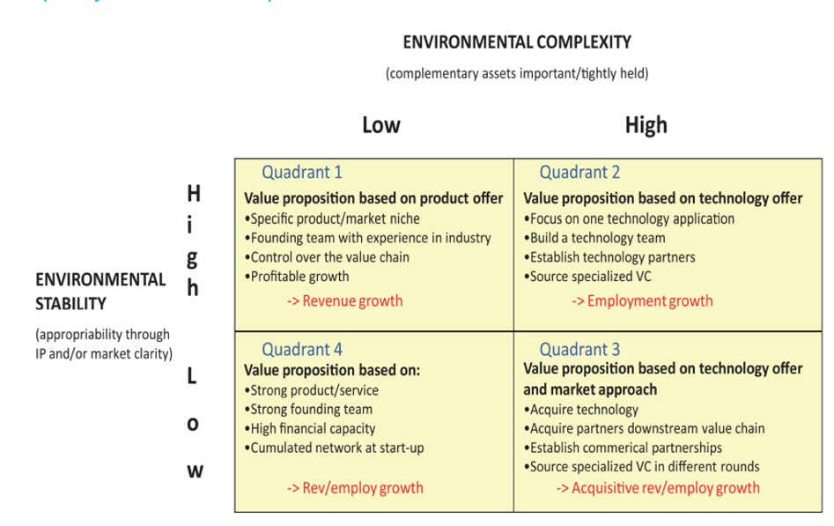
- Invest in signaling activities (prepare exit)
Startups with exit strategy

6. Discuss how exit-driven startups increase their attractiveness towards potential acquirers?
Startups that are VC-backed and destined for an exit (specifically a trade sale) actively engage in signaling activities to make themselves attractive to incumbents.
- Press Releases: They invest heavily in communication to announce milestones, such as securing a major customer or reaching a technology breakthrough. This ensures they are "on the radar" of potential buyers,.
- Top Management Team (TMT) Changes: They hire high-profile external CEOs or executives. This signals professionalization and that the company is transitioning from a chaotic startup to a scalable organization ready for integration.
- Active Roadshows: They do not wait passively; they hire investment bankers to identify potential acquirers (sometimes hundreds) and conduct roadshows to pitch the company confidentially.
These activities are designed to facilitate the acquisition process by proving momentum and reducing information asymmetry for the buyer.

