Capital investment policy – samenv

lecture 1
What is capital investment policy?
- To measure the relative economic attributes of investment alternatives
- For selecting acceptable investments
it should indicate which investments should be chosen to achieve the financial objectives of the corporation
The corporate finance perspective
- Two board questions
  - What investments should it make?
  - How should it pay for these investments?
The financial goal of the corporation
- What is the objective of the company?
  - The goal of a firm is determined by the firm’s owners
  - ! 2 problems
    - Definition of goals
    - Implementation of shareholders’ goals
  - TO MAXIMIZE THE CURRENT MARKET VALUE OF SHARHOLDERS’ INVESTMENTS IN THE FIRM
- What/who is the company?
  - A company group of projects
  - A project series of cash flows
  - A cashflow an amount of money paid at a specific time

KEY = Financial markets are well-functioning and competitive
!! Maximizing shareholder value $≠$maximizing profits
- Maximizing shareholder value
= a objective that all shareholders can agree on
  - !! AGENCY PROBLEMS
    - Private interests might not be aligned with the objective
    - Agency costs = when managers do not attempt to maximize firm value
Investment decisions & present value
- Corporate investment decisions = a way of creating value for shareholders
- choose the most valuable project
  - Present value
    - Invest if $PV\left(benefits\right)=\frac{C_{1}}{1+r}>PV\left(costs\right)= -C_{0}$
  - Future value
  - Net present value
    - Invest if NPV = $C_{0}+ \frac{C_{1}}{1+r}>0$
  - Rate of return
    - Invest if Rate of Return = $\frac{Profit}{investment}>r$

a project only makes us better if its return is higher than the return we could get on other “equivalenty risky” investments
  - Perpetuity = financial instrument that pays … dollar forever
    - PV = $\frac{C}{r}$
  - Growing perpetuity
    - PV = $\frac{C}{r-g}$
  - Annuity = financial instrument that pays … dollar for T periods
    - PV = $\frac{C}{r}(1-\frac{1}{{\left(1+r\right)}^{T}})$
  - Growing annuity
    - PV = $\frac{C}{(r-g)}(1-\frac{{(1+g)}^{T}}{{\left(1+r\right)}^{T}})$
Alternative decision rules
- Most correct criterion = NPV-method
  - Other methods
    - IRR
      - Most popular alternative method
      - The interest rate that sets the NPV of cash flows equal to 0
      - ! lending and borrowing problems with the sign – or +
      - ! multiple IRR values you don’t know which one to use
      - ! mutually exclusive projects IRR does not adjust for a project’s scale
      - ! time varying interest rates more hurdle rates => you must compute a complex weighted average of the spot rates
      - ! No real solutions exist imaginary interest rate
      - SUMMARY
        - It works as long as
          - One discount rate for all periods
          - One negative cash flow in period 0 followed by positive cash flows
          - We are only looking for one investment
    - Payback period
      - Is the amount of time it takes to recover or pay back the initial investment
      - If the period is less than a pre-specified length of time accept the project
      - !! it ignores the time value of money
!! Careful with the interpretation

Interest rates
- Compounding
  - Change the interest rate to another time variable
- EAR = Effective annual rate
- APR = Annual percentage rate
  - Semiannual rate = APR/2
  - Effective rate for the horizon = APR/k
$1+EAR={(1+\frac{APR}{k})}^{k}$
- Nominal cash flow
  - The number of dollars you pay out or receive
- Real cash flow
  - Adjusted for inflation
$Real cash flow=\frac{Nominal cash flow}{{(1+inflation rate)}^{t}}$
$\left(1+ r_{real}\right)*\left(1+i \right)=1+r$
- Rule
  - Discount real cash flows with the real interest rate
  - Discount nominal cash flows with the nominal interest rate

lecture 2
Capital rationing
Pitfall to using the NPV-rule
- A resource constrained firm may have different investment priorities than an unconstrained firm
  - profitability index
    - To identify the optimal combination of feasible projects to undertake
    - $Profitability index=\frac{NPV}{Resources consumed}$
    - 2 conditions
      - The set of selected projects must exhaust all capital/resources
      - There is only one resource constraint
  - Why might a firm be resource constrained?
    - Agency problems restricting outside financing
      - To implement the project, the entrepreneur must raise money from outside investors
      - MORAL HAZARD: Project success depends on entrepreneur’s unobservable and privately costly effort
        - Limited liability: no negative income possible
      - Project succeeds or fails with probability of success p
      - Assumption: NPV positive if entrepreneur works, negative else
        - $p_{H}*R-I>0>p_{L}*R-I+B$

      - Financial contracts
        - Contract specifies how cash flows are shared
        - To provide incentives, the entrepreneur must be compensated more in case of success than in case of failure
          - Failure: both parties get 0
          - Success: $R_{b}$ goes to entrepreneur ( borrower) and $R_{l}=R-R_{b}$to investors (lenders)
      - Entrepreneurial incentives and financing
        - Incentives for entrepreneur incentive compatibility constraint
          - $R_{b} ≥ \frac{B}{p_{H}- p_{\begin{aligned}L \\ \end{aligned}}}$
        - Pledge able income highest expected payoff investors can get without destroying entrepreneurial incentives
          - $PI := p_{H}R- p_{H}\frac{B}{p_{H}- p_{L}}$
        - Investors must at least break even
          - $PI ≥I-A$
      - Determinants of credit racing
        - Credit rationing despite positive NPV if A < A!
      - Who gets the surplus?
        - Net utility to the entrepreneur:
          - If $A ≥ \underline{A}$ get $U_{b}= p_{H}\left(R-I\right)$
          - If $A < \underline{A}$ get $U_{b}=0$
Capital Budgetting
= proces of analyze projects
- Forecasting earnings
  - Capital budget
    - Lists the investments that a company plans to undertake
  - Capital budgeting
    - Process used to analyze alternate investments and decide which ones to accept
  - Incremental earnings
    - The amount by which the whole firm’s earnings are expected to change as a result of the investment
  - Incremental earnings forecast
    - Forecast of how the project affect the total earnings of the entire firm
- !! in capital budgeting decisions, interest expenses should typically not be included
  - The project should be judged on its own, not on how it is financed
- Taxes
  - Marginal corporate tax rate
    - Tax rate on the marginal or incremental dollar of pre-tax income
      - Income tax = EBIT * τ
    - Unlevered net income
      - Unlevered net income = EBIT * (1 - τ)
= (Revenues – Costs – Depreciation) * (1 - τ)

- Indirect effects on incremental earnings
- Opportunity cost
  - Value a resource could have provided in its best alternative use
- Project externalities
  - Indirect effects of the project that may affect the profits of other business activates of the firm
    - Cannibalization when sales of a new product displace sales of an existing product
    - Sales creation when new product increases sales of an existing product
- Sunk costs
  - Costs that have been or will be paid regardless of the decision to undertake the investment
  - They should not be included in the incremental earnings analysis
  - Fixed overhead expenses
    - Typically overhead costs are fixed and not incremental to the project and should not be included in the calculation of incremental earnings
  - Past research and development expenditures
    - Money that has already been spent on R&D is a sunk cost and therefore irrelevant
- Determining Free Cash Flow and NPV
  - The incremental effect of a project on a firm’s available cash is its free cash flow
  - NPV can only be calculated using cash flows, not earnings
  - ONLY DISCOUNT CASH FLOWS
  - Free cash flow
    - = (revenues – costs – depreciation ) * (1-τ) + depreciation – CapEx - ΔNWC
    - = (revenues – costs) * (1-τ) – CapEx - ΔNWC + τ * Depreciation

Depreciation tax shield
  - Capital expenditures and depreciation
    - Capital expenditures
      - the actual cash outflows when an asset is purchased
      - Included in calculating free cash flow
    - Depreciation
      - Non-cash expense
      - The free cash flow estimate is adjusted for this non-cash expense
  - Networking capital
= Current assets – current liabilities
= Cash + inventory + receivables – payables
    - Most projects will require an investment in net working capital
      - Trade credit is the difference between receivables and payables
  - Liquidation/ salvage value
    - Capital gain = sale price – book value
    - Book value = purchase price – accumulated depreciation
    - After tax cash flow from asset sale
= sale price - τ*capital gain
  - Terminal or continuation value
    - Assume that cash flows mature and start to grow at a constant rate
    - Represents the market value of the project’s free cash flow at all future dates

- Analyzing the project
  - Break even analysis
    - Is the level that causes the NPV of the investment to equal zero
    - Where NPV = 0
  - Sensitivity analysis
    - Shows how the NPV varies with a change in one of the assumptions, holding the other assumptions constant
  - Scenario analysis
    - Considers the effect on the NPV of simultaneously changing multiple assumptions

Perfect capital markets & no-arbitrage pricing
- Perfect capital markets
  - No taxes
  - No transaction cost
  - No differential information
  - Investors can borrow and lend at the same rate
  - Unlimited short selling possible with full access to proceeds
  - In efficient capital markets it is impossible to outsmart the market
- Efficient capital markets and no arbitrage
  - An arbitrage opportunity occurs when it is possible to make a profit without taking any risk or making any investment
  - Efficient markets do not exhibit arbitrage opportunities
- Law of one price
  - If equivalent investment opportunities trade simultaneously in different efficient markets, then they must trade for the same price in both markets
- Valuing a security
  - Unless the price of the security equals the present value of the security’s cash flows, an arbitrage opportunity will appear
  - No arbitrage price of any security
  - In efficient capital markets, the NPV of buying/selling a security is 0
- Financial vs real investments
  - If financial markets are efficient, then any financial investment has an NPV of 0
  - Real investment can be positive/negative NPV
- Making money with stocks
  - Making more money than the fair risk-adjusted return
  - Know more than the people who set prices
- Arbitrage with transactions costs
  - When there are transactions costs, arbitrage keeps prices of equivalent goods and securities close to each other
  - Prices can deviate, but not by more than the transactions cost of the arbitrage

lecture 3
Pricing bonds
- Security pricing
  - Price(security) = PV(All cash flows paid by the security)
  - Risk-free bonds are the easiest type of security to price
    - Cash flows are certain and known in advance
    - Discount rates are known
    - Bond pricing is a simple applications of the NPV concept
- Terminology
  - Bond certificate
    - States the terms of the bond
  - Maturity date
    - Final repayment date
  - Term
    - The time remaining until the repayment date
  - Coupon
    - Promised interest payments
  - Face value
    - Notional amount used to compute interest payments
  - Coupon rate
    - Determines the amount of each coupon payment, expressed as an APR with appropriate compounding rate
  - Coupon payment
    - $CPN= \frac{Coupon rate*face value}{number of coupon payments per year }$
  - Discount
    - A bond is selling at a discount if the price is less than the face value
  - Par
    - A bond is selling at par if the price is equal to the face value
  - Premium
    - A bond is selling at a premium if the price is greater than the face value
- Zero coupon bonds
  - Simplest type of bond
  - Always sells at discount pure discount bonds
  - Although the bond pays no interest, buyers are compensated by the difference between the initial price and the face value
- Yield to maturity
  - The discount rate that equates the PV of promised bond payments to the bond’s current market price
  - Price of a zero-coupon bond
    - $P= \frac{FV}{{(1+YTM)}^{n}}$
- Coupon bonds
  - Pay face value at maturity
  - Pay regular coupon interest payments
  - Treasury notes (1-10 years) / Treasury bonds (> 10 years)
  - IRR formula

- Discount and premiums
  - Higher coupon rates
    - higher cash flows of the bond
    - higher price today
  - If a coupon bond trades at a discount, an investor will earn a return both from receiving the coupons and from receiving a face value that exceeds the price paid for the bond
  - If a coupon bond trades at a premium, it will earn a return from receiving the coupons but this return will be dimished by receiving a face value less than the price paid for the bond
- Interest rate changes and bond prices
  - Suppose the maturity of a bond is fixed
  - What happens to bond prices if the yield changes?
    - As interest rates and bond yields rise, bond prices fall
  - The sensitivity of bond prices to changes in interest rates is measured by the bond’s duration
    - Bonds with high durations are highly sensitive to interest rate changes
- Price vs yield for zero coupon bonds
  - Bond prices move as interest rates move
  - Long maturity bonds move more than short maturity bonds
  - Duration is a measure of interest rate risk
- The yield curve
  - Plots yields as a function of maturity
  - Normally upward sloping
  - A flat yield curve implies that the yields are the same across all maturities
  - When long-term yields fall below short-term yields, one refers to an inverted yield curve
Pricing of coupon bonds
- Treat coupon bonds as a portfolio of zero-coupon bonds
- Discount each cash flow at time n with the appropriate spot rate $r_{n}= {YTM}_{n}$
  - Method 1: Replicating a coupon bond
    - Yields and prices for zero coupon bonds
    - The law of one price
  - Method 2: Using appropriate spot rates
    - Price of a coupon must equal the PV of its coupon payments and face value
- Relationship between YTM and spot rates
  - If the yield curve is flat
    - The YTM of a risk-free coupon paying bond is equal to the spot rate
    - The spot rate is trivially the same for all horizons
  - Reality yield curve is not flat
    - YTM = complicated weighted average of the spot rates
    - The higher a specific cash flow, the higher the weight on that spot rate
    - Zero-coupon bonds with maturity at time n only have one payment $r_{n}= {YTM}_{n}$
  - Careful!
    - YTM is a convenient summary measure, but it has limitations
    - Suppose spot rates vary the YTM of two fairly-priced bonds will differ if they have different coupon rates or maturities

- Forward vs spot rates
  - Forward rate
    - How much does our money grow each year?
    - The rate we would agree to today for a 1-year loan in the future
    - Last 1 period
    - $f_{t}$
  - Spot rate
    - How much do we earn “on average” each year?
    - Start at date 0
    - $r_{t}$
$r_{t}$ is a sort of average of $f_{1}, f_{2}, …$
we can convert forward to/from spot rates
- Risky corporate bonds
  - Corporate bond yields
    - No default
    - Certain default
      - $YTM= \frac{FV}{P}-1$
        - The YTM is misleading
        - The YTM will always be higher than the expected return of investing in the bond
- Bond ratings
  - Issuers of debt can approach rating agencies to obtain a rating for a fee
  - 2 broad categories
    - Investment grade bonds
    - Speculative bonds
  - Ratings provide information about the default probability of bonds
  - Investors use this information to price bonds
  - Bond ratings are also used for regulatory purposes

Pricing stocks
- Stock valuation
  - Riskless bond
    - Discount their cash flows to calculate PV
    - Cash flows = interest and principal
    - Discount rate = riskless interest rate
  - Other things
    - Discount their cash flows to calculate PV
- $P_{0}= Σ\frac{{DIV}_{t}}{{(1+r)}^{t}}$
- Dividend growth model
  - Dividends grow at a constant rate g
  - $r=\frac{{DIV}_{1}}{(r-g)}$
  - Dividend versus investment and growth
    - Dividend payout ratio: fraction of earnings paid as dividends each year
    - ${Div}_{t}= \frac{{earnings}_{t}}{{shares outsanding}_{t}}*{dividend payout rate}_{t}$
    - Retention rate = fraction of current earnings that the firm retains
    - Constant retention rate
      - $g=retention rate*ROI$
      - Dividends grow faster if more earnings are retained and/or if the ROI is high
    - Profitable growth
      - If a firm wants to increase its share price, should it cut its dividend and invest more or should it cut investment and increase its dividend?
        - The answer depend on the profitability of the firms investments
          - Cutting the firm’s dividend to increase investment will raise stock price if the new investments have a positive NPV!
- Changing growth rates
  - We can not use the constant dividend growth model
  - $P_{N}= \frac{{DIV}_{N+1}}{r_{E}-g}$
  - Determines the value of the firm to all investors, including both equity and debt holders
    - Enterprise value = market value of equity + debt – cash
      - Enterprise value = the net cost of acquiring the firm’s equity, taking its cash, paying off all debt, and owning the unlevered business
- The discounted free cash flow model
  - Valuing the enterprise
    - Free cash flow available to pay both debt holders and equity holders
    - Discounted free cash flow model
      - $V_{0}=PV\left(future free cash flow of firm\right)$
  - Determine share price based on enterprise value
    - $P_{0}= \frac{V_{0}+ {Cash}_{0}- {Debt}_{0}}{{Shares outstanding}_{0}}$
    - ! if the firm has no debt $r_{WACC}=r_{E}$
    - $r_{WACC}$ is determined by the riskiness of the firm’s assets
  - Terminal value
    - $V_{N}=\frac{\left(1+g_{FCF}\right)* {FCF}_{N}}{r_{WACC}-g_{FCF}}$
  - Connection to capital budgeting
    - The firm’s free cash flow is equal to the sum of the free cash flows from the firm’s current and future investments
      - Interpret the firm’s enterprise value as the total NPV that the firm will earn from continuing its existing projects and initiating new ones
    - The NPV of any individual project represents its contribution to the firm’s enterprise value
    - To maximize the firm’s share price, we should accept projects that have a positive NPV
- Valuation based on comparable firms
  - Method of comparable
    - Estimate the value of the firm based on the value of other, comparable firms or investments that we expect will generate very similar cash flows in the future
  - Valuation multiple
    - A ratio of firm’s value to some measure of the firm’s scare or cash flow
    - Exemple
      - P/E ratio = share price divided by earnings per share
      - $Forward\frac{P}{E}= \frac{P_{0}}{{EPS}_{1}}= \frac{\frac{{DIV}_{1}}{{EPS}_{1}}}{r_{E}-g}$

    - Enterprise value multiples can be interpreted via the Gordon growth
      - $\frac{V_{0}}{{EBITDA}_{1}}= \frac{\frac{{FCF}_{1}}{{EBITDA}_{1}}}{r_{WACC}- g_{FCF}}$
      - Firms with high growth rates have higher multiples
- Limitations of multiples
  - No clear guidance about how to adjust for differences in expected future growth rates, risk, or differences in accounting policies
  - Only information regarding the value of a firm relative to other firms in the comparison set
- Comparison with discounted cash flow methods
  - Discounted cash flows methods have the advantage that they can incorporate specific information about the firm’s cost of capital or future growth
  - The potential to be more accurate than the use of a valuation multiple
- Competition and efficient markets
  - Efficient markets hypothesis
    - Security prices should reflect all information that is available to investors
    - If the impact of information on the firm’s future cash flows can be readily ascertained, then all investors can determine the effect of this on the firm’s value
    - We expect the stock price to react
    - Private or difficult to interpret information
      - Private information small number of investors, may be able to profit by trading on their information
      - Efficient markets hypothesis will not hold in the strict sense
    - If the profit opportunities from having private information are large, someone will devote the resources needed to acquire it
    - In the long run the degree of “inefficiency” in the market will be limited by the costs of obtaining the private information

lecture 4
Portfolio and CAPM theory
- Questions
  - How does one define/measure an asset’s risk?
  - How are risk and return related?
  - We start with portfolio theory how much should I invest given a lot of risky securities?
- Portfolio theory
  - Assumptions
    - Investors only care about a portfolio’s mean return and the variance of the portfolio returns
      - A higher mean is good, more variance is bad
    - Investors face many securities to invest in
      - Means and variances of each stock are known
How should the investor build her portfolio?
    - Expected return
      - $r_{p}=w_{1}*r_{1}+w_{2}*r_{2}$
    - Variance
  - Efficient portfolio
    - No way to reduce the volatility of the portfolio without lowering its expected return
  - Inefficient portfolio
    - Possible to find another portfolio that is better in terms of both expected return and volatility
weakly better = one dimension
stricter better = two dimensions
- Risk vs Return
- Volatility vs expected return
- The effect of correlation
  - Correlation has no effect on the expected return of a portfolio
  - It will impact the volatility of the portfolio
  - The lower the correlation, the lower the volatility we can obtain and the higher the benefits of diversification
- Risk-free saving and borrowing
  - Investing in a risk-free investment
    - Will reduce the expected return
  - Borrowing
    - Borrow money to invest even more in the stock market
= aggressive investor
  - Tangent portfolio
    - Highest possible expected return for any level of volatility we must find the portfolio that generates the steepest possible line when combined with the risk-free investment
    - Line is steepest when sharpe ratio is the highest
$$Sharpe ratio= \frac{Portfolio excess return}{Portfolio volatility}= \frac{E\left(R_{P}\right)-r_{f}}{SD(R_{p})}$$

    - Every investor should invest in the tangent portfolio
      - Impossible to improve the sharpe ratio
    - The expected return of any stock is determined by the covariance of that stock with the tangent portfolio
      - Tangent portfolio = market portfolio
  - Combinations of the risk-free asset and the tangent portfolio provide the best risk and return tradeoff available to an investor
- Economic theory (CAPM) tells us that the tangent portfolio is equal to the portfolio of all risky securities that are traded in the market
$E\left(R_{i}\right)= r_{f}+ β_{i}^{M}*(E\left(r_{M}\right)-r_{f})$
    - Market beta = expected percent change in the excess return of a security for a 1% change in the excess return of the market portfolio
      - Measure of systematic risk
  - Assumptions that market portfolio is the tangent portfolio
    - 1. Investors can buy and sell all securities at competitive market prices and can borrow and lend at the risk-free interest rate
    - 2. Investors hold only efficient portfolios of traded securities max expected return for a given level of volatility
    - 3. Investors have homogeneous expectations regarding the volatilities, correlations and expected returns of securities
      - Same efficient portfolio of risky securities
      - Demand security combined portfolio of risky securities of all investors must be equal to the efficient portfolio
      - Supply security if all investors demand the tangent portfolio, and the supply of securities is the market portfolio, market clearing implies that the efficient/tangent portfolio is equal to the market portfolio
- Capital market line
  - When the tangent line goes through the market portfolio
  - Offers the best possible risk-return combinations
- Security market line
  - Line through the risk-free investment and the market
  - Linear relationship between a stock’s beta and its expected return
- Negative beta
  - $r_{i}<r_{f}$
  - Accept a lower return than the risk-free rate
    - It pays off most when you most need the money, all your other investments have gone down in value
    - Stock provides you with insurance
    - More valuable than a risk-free payoff
- Extending the CAPM
  - Efficient frontier
    - Different saving and borrowing rates
      - Different preferences will choose different portfolios of risky securities
      - CAPM conclusion that the market portfolio is the unique efficient portfolio of risky investments is no longer valid
    - SML depends only on the market portfolio and still holds his formula
  - Alpha
    - The difference between a stock’s expected return and its required return according to the SML
    - If the market is efficient alpha = 0
    - Positive alpha positive risk return
    - Negative alpha negative risk return
- CAPM framework
  - Market portfolio combined with risk-free investments
  - Average alpha of zero
market portfolio must be efficient
  - Market portfolio can be inefficient
    - Alpha is positive or negative
    - Misinterpret information
    - Willing to hold inefficient portfolios
Factor models
- Arbitrage pricing theory
  - Select multiple well-diversified portfolios
  - Assume they can be combined to form the tangent/efficient portfolio
  - Express the return of any marketable security
  - We don’t need to identify the tangent/efficient portfolio
identify a collection of the efficient portfolio = factor portfolios
- Self-financing portfolio
  - Holding short and long positions in stocks only
  - Self-financing portfolio = portfolio weights sum to 0
- Farma-French-carhart specifiacation
  - Selecting three additional factor portfolios
  - Small-minus-big (SMB) portfolio
    - Market capitalization
    - 2 equally weighted portfolios, depending on whether their market value is above or below the median of NYSE firms
    - A long position in the small stock portfolio
    - A short position in the big stock portfolio
  - High-minus-low (HML) portfolio
    - Two equally weighted portfolios based on book-to-market ratios
    - A long position in the value stocks (high book-to-market ratios)
    - A short position in the growth stocks (low book-to-market ratios
The CAPM in practice
- We need to know
  - How to compute betas for each stock
  - The risk-free rate
  - The market risk premium
- Market capitalization
  - The total market value of a firm’s outstanding shares
- Value-weighted portfolio
  - A portfolio in which each security is held in proportion to its market capitalization
$x_{i}= \frac{Market value of i }{Total market value of all securities}$
- Determining beta
  - Linear regression
    - Alpha = the intercept term of the regression
      - Positive performed better than predicted by the CAPM
      - Negative performed below SML
    - Beta = Sensitivity of the stock market risk
    - Error term = deviation from the best fitting line and is zero on average
  - The slope of the best-fitting line in the plot of the security’s returns versus the market excess return
  - Forecasting beta
    - Time horizon
      - Use at least 2 years of weekly return data or 5 years of monthly return data
    - Market proxy
      - Mostly 500
    - Beta extrapolation
      - Prefer to use average industry betas rather than individual stock betas
      - Beta tend to regress toward the average beta of 1.0 over time
    - Issues
      - Effect of outliers
        - The beta estimates obtained from linear regression can be very sensitive to outliers
        - Historical betas may not be a good measure if a firm were to change industries
- The security market line
  - The market risk premium
    - Use the historical average excess return of the market
    - Use a valuation model
Conclusion
- The CAPM remains the predominant model used in practice to determine the equity cost of capital
- CAPM is not perfect, it is unlikely that there will be found a perfect model
- The imperfections of the CAPM may not be critical in the context of capital budgeting
- Errors in estimating project cash flows are likely to be more important than small discrepancies in the cost of capital

lecture 5
Capital structure in perfect markets
- Capital structure
  - The relative proportions of debt, equity, and other securities that a firm has outstanding
- Leverage
  - The ratio of debt-to-equity financing: D/E
- Unleveraged
  - No debt, fully equity financed
- Pure equity financing
  - If you finance this project, how much should the investors be willing to pay for it?
    - PV(equity cash flows)
- Levered equity
  - Equity in a firm that also has debt outstanding
  - The project cash flows don’t change
  - The debt and levered equity sum to the PV of the firm
  - Leverage increases the risk of the equity of a firm
  - Debt claims bear no systematic risk and pay no risk premium
  - Levered equity carries twice the systematic risk of the unlevered equity and pays double the risk premium
- Modigliani and Miller (MM)
  - With perfect capital markets, the total value of a firm should not depend on its capital structure.
    - Argument 1: the cash flows of the project remain unchanged and should therefore have the same present value
      - Leverage changes the allocation of cash flows between debt and equity, but does not alter total cash flows
    - Argument 2: if the cash flows of debt and equity sum to the cash flows of the project, the Law of One Price implies that the combined values of debt and equity must be equal to the PV of the project’s cash flows.

- Summary
  - Perfect capital markets if the firm is purely equity financed, equity holders will require an expected return of 15 percent
  - 50 percent debt and 50 percent equity debt holders will receive a return of 5 percent, while levered equity holders require an expected return of 25 percent
  - !! leverage increases the risk of equity
  - Debt may be cheaper than equity but since leverage increases the risk of equity, its use also raises the cost of capital for equity
  - The levered firm’s WACC is the same as the equity cost of capital of the unlevered firm

- Homemade leverage
  - An all-equity firm and assume a potential investor would prefer to hold levered equity
  - The investor can replicate the payoffs to the levered equity
  - Re-create the payoffs of unlevered equity by buying the debt and the equity of the firm
  - The firm’s choice of capital structure does not affect the opportunities available to investors
  - Investors can alter the leverage choice of the firm to suit their personal tasted by adding more leverage or by reducing leverage
  - Perfect capital markets different choices of capital structure offer no benefit to investors and do not affect the value of the firm.
- MM proposition 1
  - The total market value of the firm’s securities is equal to the market value of its assets
  - Independent of the firm is unlevered or levered
  - the return on unlevered equity is related to the returns of levered equity and debt
- MM proposition 2
  - The cost of capital of levered equity is equal to the cost of capital of unlevered equity plus a premium that is proportional to the market value debt-equity ratio

- Unlevered beta
  - A measure of the risk of a firm as if it did not have leverage
  - If you are trying to estimate the unlevered beta for an investment project, you should base your estimate on the unlevered betas of firms with comparable investments.
- Cash and net debt
  - Holding cash has the opposite effect of leverage on risk and return and can be viewed as equivalent to negative debt
  - Net debt = Debt – Cash and risk-free securities
- Capital structure fallacies
  - Leverage and earnings per share (EPS)
    - Leverage can increase EPS
    - !! leverage should not increase the firm’s stock price
  - Equity issuance and dilution
    - Issuing new shares will dilute existing shareholders bcs they must split firm profits among more shareholders
    - Dilution = an increase in the total number of shares that will divide a fixed amount of earnings
    - As long as the firm sells the new shares of the equity at a fair price, there will be no gain or loss to shareholders
    - Any gain or loss associated with the transaction will result from the NPV of the investments the firm makes with the funds raised
    - With perfect capital markets, financial transactions neither add nor destroy value, but instead represent a repackaging of risk
Does financial policy matter?
- Perfect markets NO
- Relevance of capital structure must be due to imperfect markets
Deviations from perfect markets
Trade-off theory: optimal leverage with taxes
- The interest tax deduction
  - Firms pay taxes on profits after interest is deducted
    - Interest expenses reduce the amount of corporate taxes a firm must pay
    - Incentives to use debt
  - Interest tax shield
    - The reduction in taxes paid due to the tax deductibility of interest
$$interest tax shield=corporate tax rate*interest payments$$
  - When a firm uses debt, the interest tax shield provides a corporate tax benefit each year
  - The overall benefit is equal to the present value of the stream of future interest tax shields
  - The cashflows a levered firm pays to all investors will be higher than they would be without leverage
$$cashflows to investors with leverage=cashflows to investors without leverage*interest tax shield$$
  - Value the tax shield as a perpetuity
$$PV\left(interest tax shield\right)= τ_{c}*D$$
- Target debt-equity ratio
  - If a firm adjusts its leverage to maintain a target debt-equity ratio, we can compute its value with leverage by discounting its free cash flow using the WACC
- Capturing the tax shield
  - Total value of the levered firm
$$V^{L}=V^{U}+τ_{c}*D$$
  - The value of equity
$$E= V^{L}-D$$
With no leverage NO TAX BENEFIT
With excess leverage net operating loss and there is no additional increase in tax savings
because the firm is already not paying taxes, there is no tax shield from the excess leverage
no corporate tax benefit arises from incurring interest payments that exceed EBIT
IN GENERAL: as a firm’s interest expense approaches its expected taxable earnings, the marginal tax advantage of debt declines, limiting the amount of debt the firm should use.
Trade-off theory: adding financial distress costs
- Financial distress costs
  - When a firm has difficulty meeting its debt obligations
- Default
  - When a firm fails to make the required interest or principal payments on its debt or violates a debt covenant

- ! Risk of bankruptcy
  - Simple and straightforward
  - A long and complicated process that imposes both direct and indirect costs on the firm and its investors
  - Direct costs of bankruptcy
    - Reduce the value of the assets that the firm’s investors will ultimately receive
  - Indirect costs of financial distress
    - Difficult to measure accurately
    - Often much larger than the direct costs of bankruptcy
    - 2 important points
      - Losses to total firm must be identified
      - The incremental losses that are associated with financial distress, above and beyond any losses that would occur due to the firm’s economic distress, must be identified
- Scenario 1: New product succeeds
- Scenario 2: New product fails
  - Debt holders will receive legal ownership of the firm’s assets
  - Debt and equity holders are worse off
  - Unlevered
    - The share price declines
  - Levered
    - Declares bankruptcy
  - !! the decline in value is not caused by bankruptcy, it is the same whether or not the firm has leverage
  - Economic distress
    - Significant decline in the value of a firm’s assets, whether or not it experiences financial distress due to leverage
OPTIMAL CAPITAL STRUCURE
- Trade-off theory
  - The firm picks it capital structure by trading off the benefits of the tax shield from debt against the costs of financial distress and agency costs
  - The total value of a levered firm equals the value of the firm without leverage plus the present value of the tax savings from debt, less the present value of financial distress costs.
$$V^{L}=V^{U}+PV\left(interest tax shield\right)-PV(financial distress costs)$$
    - Key factors determine the PV of financial distress costs
      - The probability of financial distress
        - Increases with the amount of a firm’s liabilities
        - Increases with the volatility of a firm’s cash flows and asset values
      - The magnitude of the costs after a firm is in distress
        - Technology firms high financial distress costs
        - Real-estate firms low financial distress costs
      - The appropriate discount rate for the distress costs
        - Depends on the firm’s market risk

Trade-off theory: adding agency costs
- Agency costs
  - Costs that arise when there are conflicts of interest between the firm’s stakeholders
  - When a firm has leverage, managers may make decisions that benefit shareholder but harm the firm’s creditors and lower the total value of the firm
- Excessive risk-taking and asset substitution
  - Asset substitution problem
    - When a firm faces financial distress, shareholders can gain at the expense of debt holders by taking a negative NPV project, if it is sufficiently risky
    - Anticipating this bad behavior, security holders will pay less for the firm initially
- Debt overhang and under investment
  - Debt overhang problem
    - A situation in which equity holders choose not to invest in a positive NPV project because the firm is in financial distress and the value of undertaking the investment opportunity will accrue to bondholders, not themselves
  - Under investment
    - When a firm faces financial distress, shareholder further have an incentive to withdraw money from the firm = Cashing out
- Agency costs and the value of leverage
  - When a firm adds leverage to its capital structure, the decision has 2 effects on the share price
    - The share price benefits from equity holders’ ability to exploit debt holders in times of distress
    - The debt holders recognize this possibility and pay less for the debt when it is issued, reducing the amount the firm can distribute to shareholders. Debt holders lose more than shareholders gain from these activities and the net effect is a reduction in the initial share price of the firm.
RESULT
agency costs of debt represent another cost of increasing the firm’s leverage that will affect the firm’s optimal capital structure choice.
Managers may be tempted to overspend on private perks that reduce firm value
debt can thus also reduce agency problems
$$V^{L}=V^{U}+PV\left(interest tax shield\right)-PV\left(financial distress costs\right)-PV\left(Agency costs of debt\right)+PV(agency benefits of debt)$$

Lecture 6
Capital budgeting and valuation with leverage
- WACC method
  - Forecast cash flows for 100 percent equity-financed firm, not adjusted for financing effects
  - Discount at after-tax WACC
- Adjusted-present-value (APV) method
  - Unlevered free cash flows discounted at pre-tax WACC (unlevered value)
  - Add value of tax shield (modelled separately)
- Flow-to-equity (FTE) method
  - Forecast cash flows to equity holders
  - Discount by cost of equity
Modigliani-Miller-world 3 assumptions
- The market risk of any project that requires financing is equivalent to the average market risk of the firm
- The firm’s debt-equity ratio remains constant over time
- Corporate taxes are the only market imperfection

The weighted average cost of capital method
- Since the (after-tax) WACC incorporates the tax savings from debt, we can compute the levered value of an investment, by discounting its unlevered cash flow using $r_{WACC}$
- The value of the project, including the tax shield form debt, is calculated as the present value of its future free cash flows
- SUMMARY
  - Determine the free cash flow of the investment
  - Compute the weighted average cost of capital
  - Compute the value of the investment, including the tax benefit of leverage, by discounting the free cash flow of the investment using $r_{WACC}$
The after-tax WACC can be used throughout the firm as the companywide cost of capital, but only for new investments that are
  - Of comparable risk to the rest of the firm
  - That will not alter the firm’s debt-equity ratio

- Implementing a constant debt-equity ratio
  - DEBT CAPACITY = the amount of debt at a particular date that is required to maintain the firm’s target debt-to-value ratio
$$D_{t}=d* V_{t}^{L}$$

The adjusted present value method
- ADJUSTED PRESENT VALUE = a valuation method to determine the levered value of an investment by first calculating its unlevered value and then adding the value of the interest tax shield
$$V^{L}=APV= V^{U}+PV(interest tax shield)$$
- First step = calculate the value of the free cash flows using the project’s cost of capital pretending it was financed without leverage
  - Unlevered cost of capital = the cost of capital for a firm if it were unlevered
    - Estimated as the weighted average cost of capital computed without considering taxes pre-tax WACC
    - Separately value the interest tax shield
  - Target leverage ratio = when a firm adjusts its debt proportionally to a project’s value or its cash flows (where the proportion need not remain constant)
    - Exemple = constant debt-equity ratio
- Next step = to find the present value of the interest tax shield
  - When the firm maintains a target leverage ratio, its future interest tax shields have similar risk to the project’s cash flows, so they should be discounted at the project’s unlevered cost of capital
- Total value of the project with leverage = sum of the value of the interest tax shield and the value of the unlevered project
$$V^{L}=APV= V^{U}+PV(interest tax shield)$$

- SUMMARY
- Determine the investment’s value without leverage
- Determine the present value of the interest tax shield
  - Determine the expected interest tax shield
  - Discount the interest tax shield
- Add the unlevered value of the present value of the interest tax shield to determine the value of the investment with leverage.
- APV vs WACC
  - Advantages
    - Easier to apply when the firm does not maintain a constant debt-equity ratio
    - Explicitly values market imperfections allows managers to measure their contribution to value
    - It can also be extended to include other market imperfections such as financial distress, agency and issuance costs
  - Disadvantages
    - More complex
The flow to equity method
- Flow-to-equity = a valuation method that calculates the free cash flow available to equity holders considering all payments to and from debt holders
  - Cash flows to equity holders are then discounted using the equity cost of capital
- Free cash flow to equity (FCFE) = the free cash flow that remains after adjusting for interest payments, debt issuance, and debt repayments

- First step to determine the project’s free cash flow to equity
  - 2 changes in the calculation of the free cash flows
    - Interest expenses are deducted before taxes
    - The proceeds from the firm’s net borrowing activity are added $Net borrowing at date t= D_{t}-D_{t-1}$
- The free cash flow to equity can also be calculated
$$FCFE=FCF-\left(1-τ_{c}\right)*interest payments+net borrowing$$
  - Discounted at the project’s equity cost of capital
- SUMMARY
  - The value of the project’s FCFE represents the gain to shareholders from the project, and it is identical to the NPV computed using the WACC and APV methods
- Determine the free cash flow to equity of the investment
- Determine the equity cos of capital
- Compute the equity value by discounting the free cash flow to equity using the equity cost of capital
  - Advantages
    - Simpler to use if the firm’s capital structure is complex
    - More transparent method
  - Disadvantages
    - Must compute the project’s debt capacity
only used in complicated settings

Other effects of financing
- Issuance and other financing costs
  - When a firm raises capital by issuing securities, the banks that provide the loan or underwrite the sale of the securities charge fees
  - These fees should be included as part of the project’s required investment, reducing the NPV of the project
- Security mispricing
  - If management believes the securities they are issuing are priced differently than their true value, the NPV of the transaction should be included in the value of the project
    - NPV of transaction = difference between the actual money raised and the true value of the securities sold
  - Mispricing could be a cost of the project for existing shareholders
- Financial distress and agency costs
  - The free cash flow estimates for a project should be adjusted to include expected financial distress and agency costs
    - Example financial distress costs tend to increase the sensitivity of the firm’s value to market risk, raising the cost of capital for highly levered firms
  - Because these costs also affect the systematic risk of the cash flows, the unlevered cost of capital will no longer be independent of the firm’s leverage.

lecture 7
Option methods in valuation and capital budgeting
Managerial flexibility: ability to respond
Moderate flexibility value  NPV (Real options) | High flexibility value  Real options
Low flexibility value  NPV or no option | Moderate flexibility value  NPV (real options)
Uncertainty: likelihood of receiving new information

- How much are you willing to pay?
- What is the value of flexibility?
- NPV with simple option
  - Now or never: investment decision is required immediately
    - Use standard DCF rule
  - Option to defer: have flexibility to react to new information
    - Make investment decision contingent on cash flow state
Invest if and only if cash flow is high
  - Problem: Which discount rate to use?
    - Dynamic DCF (decision tree analysis)
      - Using the underlying asset’s cost of capital
      - Discount contingent cash flows at underlying asset’s cost of capital and the investment outlays at the risk-free rate
Contingent cash flows are riskier than captured by WACC or underlying project

- Options vs DCF
  - The real options approach is often presented as an alternative to DCF
  - In fact real options approach is a particular form that DCF takes for investments involving flexibility and uncertainty
    - Standard DCF: take “expected scenario” of cash flows
      - Discount to today (WACC)
      - Does not take into account “value of flexibility” under uncertainty
      - Provides lower bound on project value
    - Dynamic DCF (decision trees): take account of flexibility
      - Discount project’s contingent payoffs weighted by respective (true) probabilities
      - But with option, cannot use same discount rate as for expected cash flows
option valuation techniques were developed because discounting is difficult and allow you to obtain insights into value of flexibility and optimal investment timing

- Options everywhere
  - Financial options
    - Options to buy or sell financial assets such as corporate stock
  - Corporate securities
    - Can be viewed as options on the underlying assets of the firm
  - Real options
    - Value of the firm itself is influenced by a package of embedded real options
      - The right to make a particular business decision
Understanding (financial) options
- Financial option
  - Contract that fives its owner the right but not the obligation to purchase or sell an asset at a specified price (strike) within a specified time
- Types
  - Call option
    - Gives its owner the right to buy an asset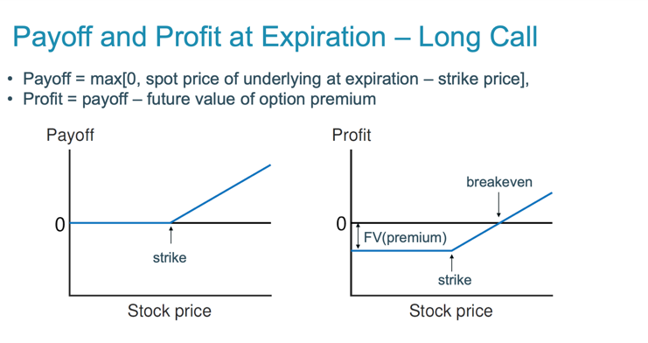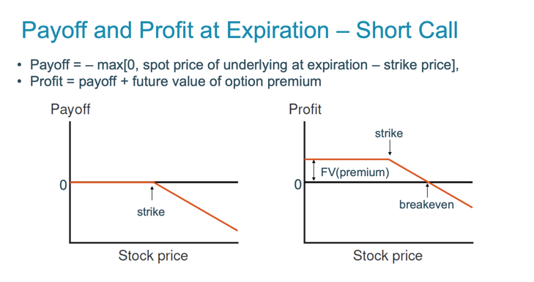

  - Put option
    - Gives its owner the right to sell an asset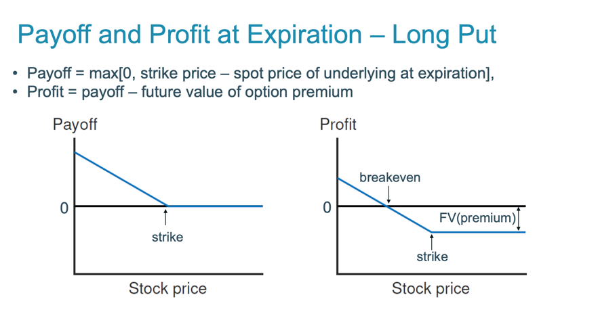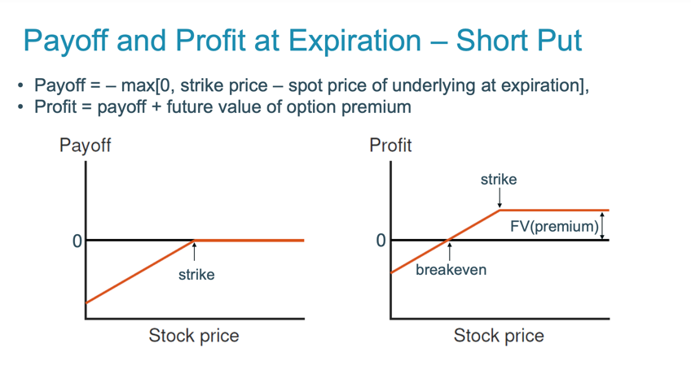
  - American option
    - Can be exercised any time before expiration date
  - European option
    - Can only be exercised on the expiration date
- Summary
  - Price of a stock is 100
    - It is a call option with exercise price 90?
      - Always exercise in the money option at expiration
    - It is a put option with exercise price 90?
      - Never exercise out of the money at expiration
    - It is a call option with exercise price 120?
      - Never exercise out of the money at expiration
    - It is a put option with exercise price 120?
      - Always exercise in the money option at expiration
- Options and Risk – Hedging vs Speculation
  - Derivative securities are often considered very “risky”
  - Speculating
    - Derivative is used to increase risk, so that large gains are achieved when market moves right away
  - Hedging
    - Derivative is used to offset risk of existing position, leading to lower net risk
- Portfolio insurance with options
  - Protective put
  - Fiduciary call

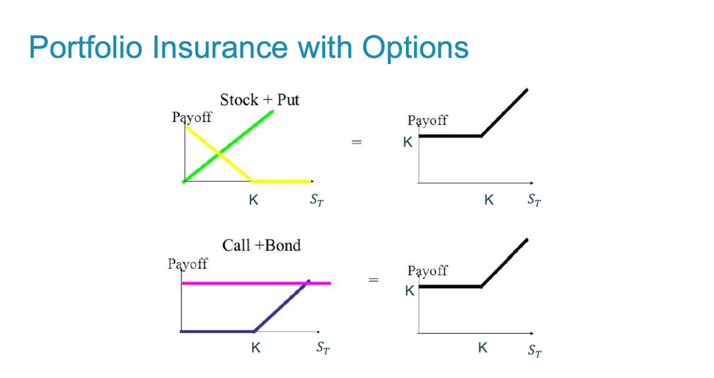
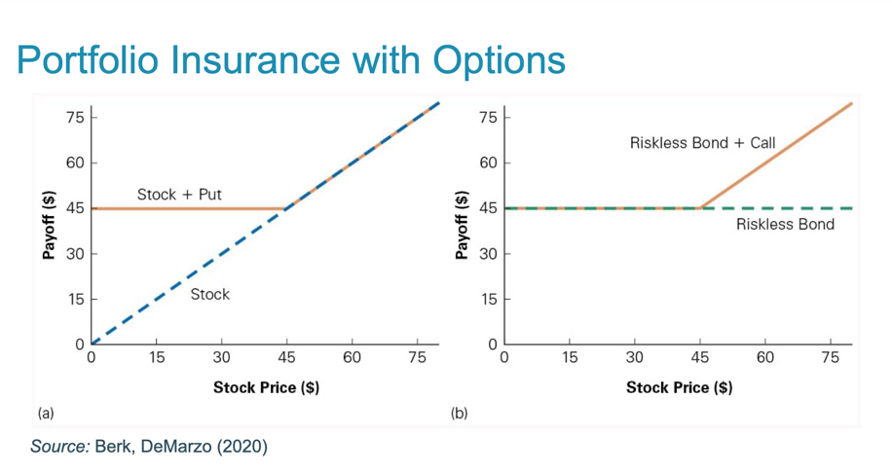

- Put-Call parity
  - Recall the two different ways to construct portfolio insurance
    - Purchase the stock and a put
    - Purchase a bond and a call
  - Because of both portfolios provide exactly the same payoff, the Law of one price requires that they must have the same price
  - Put-Call parity
    - Stock + put = call + bond
$$S_{0}+P\left(K,T\right)=C\left(K,T\right)+{PV}_{0,T}\left(K\right)+{PV}_{0,T}\left(div\right)$$
      - $S_{0}$ = the current stock price
      - $P\left(K,T\right)$ = price of a put with the strike price K and time to maturity T
      - $C\left(K,T\right)$ = price of a call with the strike price K and time to maturity T
      - ${PV}_{0,T}\left(div\right)$= the present value of the dividends payable over the life of the option
- Intrinsic value vs Time value
  - Intrinsic value = the value it would have if it expired immediately
    - The amount of which the option is in-the-money, or zero if the option is out-of-the-money
    - Intrinsic value of call = max(S-K, 0)
    - Intrinsic value of put = max(K-S, 0)
    - !!! An American option cannot be worth less than its intrinsic value
  - Time value = difference between the current option price and its intrinsic value
    - An American option cannot have a negative time value
    - Time value – Call (no dividends)
      - $C=S-K+dis\left(K\right)+P$
        - S-K = intrinsic value
        - $dis\left(K\right)+P$ = time value
      - !! Any call on a non-dividend-paying stock has a positive time value
    - Time value – Put (no dividends)
      - $P=K-S+C-dis\left(K\right)$
        - When put is sufficiently deep in the money, C < dis(K) implying a negative time value of the European put
    - Time value - dividend-paying stocks
      - $C=S-K+dis\left(K\right)+P-PV(div)$
        - If PV(div) is large enough, the time value of a European call can be negative
- Factors influencing option prices
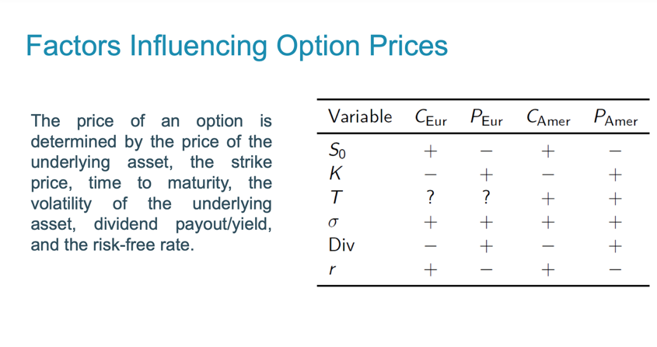

lecture 8
Valuing options: The single-period binomial model
- Binominal option pricing model
  - Model to determine option price given the characteristics of a stock or other underlying asset
  - Cox-Ross-Rubinstein model
  - Asset price in each period can move only up or down by a specified amount
  - Let S denote the current asset price, then the price can either increase to $S_{u}$ or decrease to $S_{d}$
- Replicating portfolios
  - Its payoff is the same as that of the call option, regardless of whether the stock goes up or down
  - The call option is thus equivalent to a portfolio of the underlying stock plus borrowing
- Why standard DCF doesn’t work?
  - DCF gives us the wrong option value
  - The option is riskier than the underlying stock
  - Option is a levered position in a stock
use option pricing methods: How to do this more generally?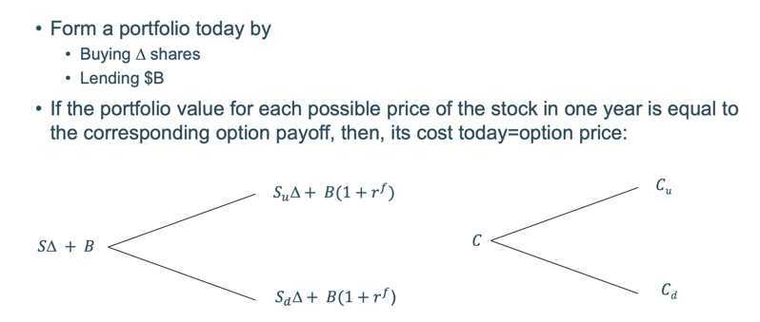
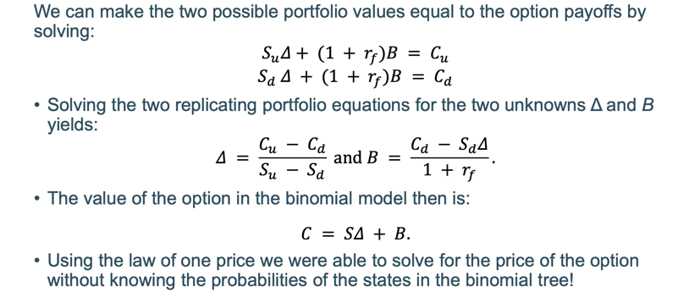
- Delta and hedging
  - Delta is the standard terminology used in options markets for the number of units of the underlying asset in the replicating portfolio
    - For a call option Delta between 0 and 1
    - For a put option Delta between -1 and 0
$$Option value=\left(asset price*delta\right)+lending$$
- Risk and return of an option
$$β_{Option}=\frac{S*∆}{s*∆+ B}*β_{S}$$
- Risk neutral valuation
  - All investors are risk-neutral
  - The price of any asset can be determined by calculating its expected payoff and discounting at the appropriate cost of capital
  - If all market participants are risk neutral, then all financial assets have the same cost of capital, the risk-free rate of interest
  - The values $p^{*}$ and 1-$p^{*}$ can be interpreted as the probabilities of the high and low state in a hypothetical risk-neutral world
    - $p^{*}$ represents how the actual probability has to be adjusted to keep the asset’s price the same in a risk-neutral world
  - Risk-neutral Probabilities: The probability of future states that are consistent with current prices of securities assuming all investors are risk neutral
- Summary
  - The risk-neutral probabilities can be used to price any derivative security
  - They transform future payoffs into certainty equivalents
    - The safe cashflow that has the same value to investors than the risky cash flow
      - Discount expected cash flows at a risk-adjusted discount rate
      - Find the certainty equivalent cash flow and discount at the risk-free rate
  - A common technique for pricing derivative assets is Monte Carlo simulation
    - Expected payoff of the derivative security is estimated by calculating its average payoff after simulating many random paths for the underlying
    - In the randomization, the risk-neutral probabilities are used and so the average payoff can be discounted at the risk-free rate to estimate the derivative security’s value.
Valuing options: The multi-period binomial model
- The value option in any multi-period binomial tree work backwards
  - At maturity the call is worth its intrinsic value
  - We have to change the replicate portfolio every period based on the change in the stock price
- Dynamic trading strategy
  - General idea: an option payoff can be replicated by dynamically trading in a portfolio of the underlying stock and a risk-free bond
  - In the continuous limit have to adjust positions continuously
  - Implication: risk of option changes every time the stock price moves!
    - Recall: $β_{option }= \frac{S*∆}{S*∆+B}*β_{s}$
    - There is no one fixed cost of capital for an option investment and standard DCF is a huge nightmare to compute
- Making the model more realistic
  - Single period binomial model unrealistically assumes that stock can take on only two values at the expiration date.
  - Two period model splits the total period in two subperiods to increase the number of possible stock prices to 3
  - Can continue this process to make the model even more realistic
    - Decide on an expiration date T
    - Divide total time interval T into n subperiods each of length h=T/n
    - With n subperiods get n+1 possible stock prices at T
  - Variance increases the further you look in the future
  - Stock returns are approximate ‘log-normal’

Valuing options: The black-scholes model
- Model to price European style options on a continuously traded stock
- Assumptions on stock return distribution
  - Continuously compounded returns on the stock are normally distributed and independent over time
  - The volatility of continuously compounded returns is known and constant
- Assumptions about the economic environment
  - There is no arbitrage opportunity
  - The risk-free rate is known and constant
  - There are no transaction costs or taxes
  - It is possible to short-sell costlessly and to borrow at the risk-free rate
- Model can be interpreted as the continuous time limit of a discrete option pricing model!
- Black-scholes price of a call (non-dividend-paying stock)
  - $C=S*N\left(d_{1}\right)-e^{-r*T}*K* N\left(d_{2}\right)$
    - $d_{1}=\frac{\ln\left(\frac{S}{K}\right)+\left(r+\frac{σ^{2}}{2}\right)*T}{σ*√T}$
    - $d_{2}=d_{1}- σ*√T$
- Black-scholes price of a put
  - $P=C-S-PV\left(K\right)=S*N\left(d_{1}\right)-e^{-r*T}*K* N\left(d_{2}\right)-S+e^{-r*T}*K$
  - $e^{-r*T}*K*\left(1-N\left(d_{2}\right)\right)-S*(1-N\left(d_{1}\right))$

- Recall
  - Option price in binomial model
    - $C=S*∆+B$
  - Black-scholes price
    - $C=S*N\left(d_{1}\right)-e^{-r*T}*K* N\left(d_{2}\right)$
- The replicating portfolio of a call option always consists of a long position in the stock and a short position in the bond
- The replicating portfolio is a leveraged position in the stock
  - A leveraged position in a stock is riskier than the stock itself, which implies that call options on a positive beta stock are more risky than the underlying stock
  - Therefore, calls have higher returns and higher betas
- How to estimate sigma?
  - 2 strategies
    - Use historical data
    - Back out the implied volatility: The volatility of an asset’s returns that is consistent with the quoted price of an option on the asset
- With dividends
  - Replace the stock price S by the stock price excluding the present value of any dividends paid prior to the expiration of the option
$$S^{X}=S-{PV}_{\left(0,T\right)}(div)$$

Applications: capital structure options
- Applying black-scholes: Equity as an option
  - Equity is a residual claim equity holders have a claim on cash flows left over after other financial claim-holders have been satisfied
  - The principle of limited liability, however, protects equity investors in publicly traded firms if the value of the firm is less than the value of the outstanding debt
    - Equity holders receive zero in bankruptcy
equity can be understood as a call option on the value of the company with strike equal to the face value of debt and maturity equal to the maturity of the debt outstanding
- The agency costs of debt
  - Recall asset substitution problem: with leverage, equity holders have an incentive to take excessive risk since the value of the equity call option increases with the firm’s volatility
- Debt as an option portfolio
  - Debt holders can be viewed as owners of the firm having sold a call option with a strike price equal to the required debt payment
    - If the value of the firm exceeds the required debt payment, the call will be exercised; debt holders will therefore receive the strike price and five up the firm
    - If the value of the firm does not exceed the required debt payment, the call will be worthless, the firm will declare bankruptcy, and the debt holders will be entitled to the firm’s assets.
  - Debt can also be viewed as a portfolio of riskless debt and a short position in a put option on the firm’s assets with a strike price equal to the required debt payment
    - Risky debt = riskfree debt – put option on firm assets

- Credit default swaps
  - Risky debt = riskfree debt – put option on firm assets
  - Riskfree debt = risky debt + put option on firm assets
    - In a credit default swap, the buyer pays a premium to the seller and receives a payment from the seller to make up for the loss if the bond defaults

- SUMMARY
  - How to value options in binomial and Black-scholes model?
    - Main techniques: replicating portfolio and risk neutral valuation
    - Application to value capital structure options

lecture 9

Real options: the right to make a particular business decision
- Key elements
  - Information will arrive in the future (uncertainty)
  - Decisions can be made after receiving this information (flexibility)
- Two steps
  - Identification
    - Are there real options imbedded in a given project?
    - What type of options?
    - Are they important?
  - Valuation
    - How do we value the (important) options?
    - How do we value different types of options?
    - Why can’t we just use NPV?
Valuation: From financial to real options
- Financial options: the right to buy or sell a traded asset
- Real options: the right to make a particular business decision such as a capital investment after new information has been learned
  - Differences
    - Real options are much more complex than financial options
    - Real options and assets on which they are written are often not traded in competitive markets
can we use the developed valuation techniques which are based on no-arbitrage arguments also for real options
- Application of option pricing models rather uncontroversial if underlying asset is traded
  - Can observe prices/volatility as inputs to option pricing models and create replicating portfolio
- What if underlying asset is not traded
  - Need to assume that shareholders have access to assets with the same risk characteristics as the capital investment being evaluated (twin security)
    - This is actually an assumption underlying also DCF project valuation
    - If we can value the project, then we can also value an option on the project
- Start with the static DCF analysis
  - Value the project as if there was no option involved
  - This benchmark constitute a lower bound for the project’s value
  - Evolution of value of passively managed project can serve as the underlying for option analysis
- Then the map the project into a simple option and value this using option valuation techniques
  - Requires to spot the relevant options in a project
  - Make a choice of valuation technique
  - Oftentimes involves making heroic assumptions
The options to defer and abandon
- The option to defer
  - If investment is now or never, use NPV rule
  - If investment need not be done immediately but can be deferred it is akint to a call option
  - Usually investment can occur at any time during prespecified period sometimes even without finite expiry date
- Main factors governing early exercise of a call option
  - The dividends forgone by not acquiring the asset today
    - Delaying investment usually implies lost cash flows
  - The interest saved by deferring the payment of the strike price
    - Defer investment costs
  - The value of the insurance that is lost by exercising the option
    - Acquire additional information on uncertain project value
main factors of the optimal timing of investment!
- Factors making deferral valuable
  - Cashflows from immediate investment small
  - Irreversible costs upon investment large
  - High uncertainty
- The option to abandon
  - If it sometimes is preferable to shut down current operations permanently and realize the resale value of capital equipment and other assets in second-hand markets
  - Abandon options are akin to put options: you have the option to get rid of something and receive a payment
  - Related: option to contract scale for example: slow rate of mineral extraction from a mine
- Valuing an abandonment option
  - Even though an initial investment has negative NPV, it might create an option that makes investment valuable
Summary
- Abandonment options can make otherwise unacceptable projects acceptable
- It is (es post) valuable to have
  - More cost flexibility, more variable less fixed costs
  - Fewer long-term contracts/obligations with employees, customers, suppliers, which might add to the cost of abandoning the project
- These actions will undoubtedly cost the firm some value (ex-ante), but increase the value of the abandonment options

Growth options
- An investment includes a growth option if it allows for a follow-on investment which can be made contingent on new information
- Often compound options, each stage: if successful, gives you an option to do the next stage
- Growth options can be very valuable for example, in industries with heavy R&D…
  - Investing in R&D generates option but not obligation to commercialize

Choosing between projects in the presence of real options
- Firms often have to decide between multiple projects
  - Choosing from independent projects
  - Choosing between mutually exclusive projects
  - Choosing optimal order of dependent projects
next we will discuss 2 and 3
    - How do the real options embedded in projects affect project choice?
    - How to optimally stage investments when the value of one project depends on the outcome of another?
- Investments with different life’s
  - Firms often have to choose between mutually exclusive projects
    - Standalone NPV of each machine
      - NPV ignores the difference in the projects’ life spans
    - The replacement option
      - To truly compare the two investment possibilities
        - The machine is not replaced
          - In this case, the NPV is correct
        - It is replaced at the same terms
          - NPV is incorrect, calculate the total NPV of investing
        - Technological advances allow it to be replaced at improved terms
          - NPV is incorrect, calculate the total NPV of investing
- Optimally staging investments
  - A project often consists of different development stages
    - Order of stages might be predetermined by the project’s nature
    - Order in which to complete project stages can be chosen
  - How to maximize value via optimal staging?
    - Start with the riskier and lengthier projects first as they tell more about overall project viability and allow to postpone follow-up investment costs!
  - In general:
    - Optimal order to stage mutually dependent projects by ranking each, from highest to lowest, according to
$$Failure cost index= \frac{1-PV(success)}{PV(investemnt)}$$
this index measures the value of uncertainty resolved per dollar invested
  - All else equal, start with the least expensive project!

Option exercise games and informational externalities
- Investment options and competition
  - Recall
    - In efficient financial markets any financial investment has a NPV of 0
    - Real investments can have positive and negative NPV
  - For a real option to have significant economic value, there has to be some restriction on competition in the contingency triggering investment
    - In a perfectly competitive market, no contingency, no matter how positive, will generate positive NPV
    - Real options are most valuable when you have exclusivity
      - How to create exclusivity?
        - Existing land or mineral rights
        - Patents restrict competitors form developing similar products
        - Licenses and copyrights…
    - They become less valuable as barriers to competition decrease
- Innovation race
  - First-mover advantage: firm investing first grabs entire market
  - Prisoners’ dilemma
  - Under non-exclusivity the threat of preemption by a competitor might erode the value of flexibility
- Information and strategic options
  - We have examined investment decisions for which either
    - All information comes from nature
    - Information comes from firm’s own action as in the R&D or staging examples
  - Now: learning from others
    - A war of attrition
      - It can take a long time for firms to invest
      - There is a second mover advantage due to a positive information externality that is not internalized by the investing firm
    - It is important whether information is acquired from actions of others or via direct signals about fundamentals

Lecture 10
Classification of Mergers and acquisitions and some stylized facts
- Merger
  - Combination of two or more independent companies into one economic entity
  - New company stock replaces the two companies’ stocks (consolidation)
  - Horizontal merger
    - Target and acquirer have similar line of business are in same industry
    - Number of firms in industry is reduced (market power)
    - May help realize economies of scale in production, research
  - Vertical merger
    - Target buys from or sells to acquirer (at different stages of production)
    - Vertical integration replaces market transaction with internal ones
  - Conglomerate merger
    - Target and acquirer operate in unrelated industries
    - Risk of earnings and cash flows can be reduced (diversification)
- Acquisition
  - Purchase of one company (target) by another one (acquirer)
  - The target normally ceases to exist.
- Link between merger activity and stock market (mis)valuation
- Industry clustering within M&A waves
  - Mergers play a critical role in industry restructuring as a response to industry shocks such as deregulation, changes in input costs, innovation…
  - Different payment methods over time
- Who profits from M&A?
  - Acquisition premium
    - Percentage difference between the acquisition price and the pre-merger price of a target firm
    - Acquirers pay average premium of 43% over target’s pre-merger
  - Stock price reaction upon announcement is different for acquirer and target.
Detour: Event studies
- How can we measure the market’s assessment of a takeover?
- Event study methods
  - To examine the impact of new information on stock prices
  - What is the information content in firm-specific news such as an earnings surprise?
  - What is the market’s assessment of a corporate decision such as a takeover?
  - We are interested in identifying the return that is associated with the event

    - The event-specific return is called abnormal return and
$${AR}_{t}= R_{t}- {E(R}_{t})$$
      - ${AR}_{t}$ = abnormal return
      - $R_{t}$ = realized return with announcement
      - ${E(R}_{t})$ = expected or normal return without announcement
How can we find out the expected return?
      - Market model
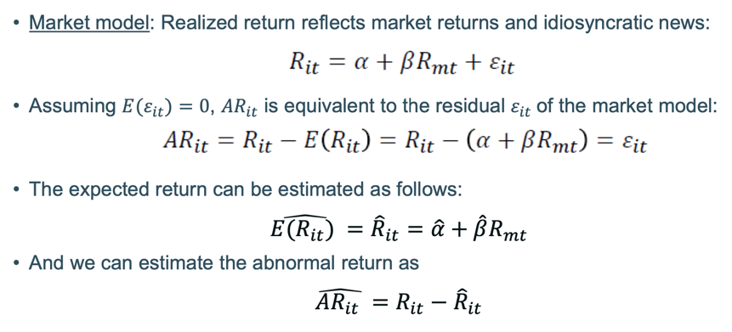
  - Step 1: Estimation window
    - Estimation window = period over which no event has occurred
    - Used to obtain parameter estimates to calculate normal/expected returns
    - Tradeoff: a longer period leads to an improved prediction model, but the 1-year old relationship between the stock and the market may no longer apply today
  - Step 2: Event window
    - Event window period surrounding event date
    - Should cover entire effect of the event but at same time be as short as possible
    - Tradeoff: the more certain you are about the event date, the smaller the event window can be and the more powerful your measurement of the significance of the event on the firm’s stock price
  - Step 3: Compute expected returns
    - Estimation window = t
    - Market model
      - Regress $R_{it}=α+β*R_{mt}+ε_{it}$
      - Compute expected returns over event window: $\hat{R_{it}}= \hat{α}+ \hat{β}*R_{m}$
  - Step 4a: Compute abnormal returns
      - $\hat{{AR}_{it}}= R_{it}- \hat{R_{it}}$
  - Step 4b: Compute abnormal returns
    - Cumulative abnormal returns (CAR)
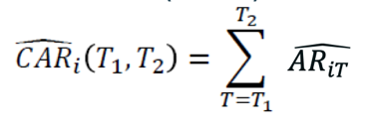
  - Step 5: Test for statistical significance
    - 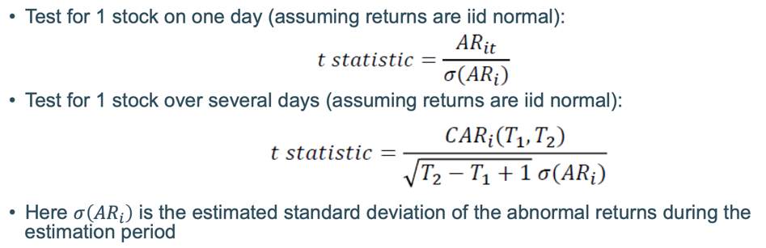

- Economic questions
- Why do acquirers pay a premium over the market value for a target company?
- Why does the target company’s price rise less than the premium offered by the acquirer upon the announcement?
- Why does the acquirer not consistently experience a price increase?

Motives for M&A’s
- Acquirer (A): initiates the acquisition, makes a bid for the target company
- Target (T): target shareholders either accept or reject the offer
An acquisition creates economic value if and only if the value of the combined firm exceeds their stand alone values
  - Economic value ${=V}_{T+A}-(V_{T}+V_{A})$
  - Net economic value = economic value – C
Acquirer creates shareholder value when net economic value is larger than premium
  - ${NPV}_{A}=V_{T+A}-V_{A}-\left(P_{T}+C\right)$$$=V_{T+A}-\left(V_{T}+V_{A}\right)-C-(P_{T}-V_{T})$$
Net economic value = NPV of A + NPV of T
- The acquirer usually receives the lowest share of the economic value created
- Target shareholders are usually paid a premium by the acquirer
- Transactions usually involve significant costs for lawyers, consultants and investment bankers
Motives for M&A’s
- Economies of scale
  - $\frac{{C'(q}_{i})}{q_{i}}< \frac{{C'(q}_{j})}{q_{j}} for q_{i}>q_{j}$
  - The savings a large company can enjoy from producing goods in high volume that are not available to a small company
  - Arises when fixed costs can be spread over a larger production volume or bargaining power vis-à-vis suppliers or customers improves
  - In particular for horizontal mergers
- Economies of scope
  - $C\left(q_{1}, O\right)+C\left(0,q_{2}\right)>C(q_{1},q_{2})$
  - Savings large companies can realize that come from combining the production and distribution of different products or product lines
  - Arises by sharing central services such as office management, accounting, financial control… avoiding duplication of general expenses
  - In particular for conglomerate mergers, also vertical mergers
- Cost synergies
  - Realization of economies of scale and scope also referred to as operating synergies are the most widely used rationale for M&A’s
- Vertical integration
  - Refers to the merger of 2 companies in the same industry that make products required at different stages of the production cycle
  - COORDINATION
  - More vertical integration is not always better trend towards outsourcing
    - Small more focused outside supplier may have lower costs
    - Large manufacturers might have more bargaining power against these small outside suppliers than within firm
- Complementary resources
  - If two firms have complementary resources, where one firm owns what the other needs, a merger might also make sense
    - Purchase talent in a functioning team by acquisition
    - Different functional strengths, one firm strong in marketing, other in research
- Acquire market power
  - Acquiring a rival in a horizontal merger reduces competition in the industry and thereby increase industry profits
    - Industry output/price gets closer to monopoly level
    - Merger towards monopoly profitable
    - Else remaining rivals are better off, but effect on merging firm is theoretically unclear
  - Most countries have antitrust laws that limit such activity
  - Reduction of competition might also be achievable via implicit agreements
- Valuation + growth
  - If target stock prices are sufficiently low, the acquisition of existing PPE (propertyplant and equipment) through M&A might constitute a bargain relative to internal growth
    - Firms with low Q-ratio are attractive low market to book value few growth opportunities
  - Misvaluation driven mergers
    - Overvalued firms might want to use their stock as currency
    - Relatively undervalued firms are interesting targets to secure overvaluation
- Correcting managerial failures
  - Badly managed firms will have lower valuations than well managed firms
  - Acquirers often argue that they can run the target firm more efficiently than existing management could
    - Undervalued firms become a takeover target
    - Assets are transferred towards better management
  - Threat of takeover has a disciplining effect
    - Either managers does a good job
    - Or a takeover will replace them
- Tax savings
  - A conglomerate may have a tax advantage over a single-product firm because losses in one division can offset profits in another division
  - When two firm combine their activities, their earnings and cash flows may become more stable and predictable as a result they can borrow a larger amount of debt, which can create a tax benefit for the combined firm
    - the WACC of the combined firm decreases
- Diversification
  - Result of diversification: Two firms combined have lower idiosyncratic risk
- EPS Growth (earnings per share)
  - When a firm with a high price/earnings ratio acquires a firm with lower P/E ratio, using its shares to pay for the acquisition, the earnings per share increases.
  - An acquisition just for the purpose of increasing EPS does not create any value!!

Managerial motives to merge
- Conflicts of interest:
  - Larger company = higher pay and reputation
  - While the transaction might not make economic sense, managers will still profit from the transaction
  - Managers act in their own interest (private benefits)
- Overconfidence
  - Hubris hypothesis
  - Managers pursue takeovers with low chances of creating value because they believe that they can make the difference
  - Managers believe they act in the best interest of shareholders
The takeover process
- Purchase of one company (target) by another one (acquirer)
  - The target normally ceases to exist
- Tender offer: formal offer to shareholders to buy their shares within a specific period at a specific price
  - Friendly: target’s management agrees of invites the tender offer
  - Hostile: target’s management is not involved or disagrees with the tender offer. Offer is directly taken to shareholders
- Acquisition of assets: target firm remains a shell company but assets are transferred to acquiring firm. Ultimately, target firm is liquidated
Steps of the takeover process
- Formulate an acquisition strategies
- Valuation of target, synergies, and control
  - The valuation of an acquisition target is not fundamentally different from the valuation of any firm, although the existence of control and synergy benefits add some complexity
  - Steps
    - Status quo valuation
    - Valuation of change in corporate control
      - $Value of control=value of firm if optimally run under new managament-value of firm with current management$
      - The value of control stems from the changes that can be made to the target’s existing management policies in order to increase firm value
    - Valuing synergies
      - Synergy benefits capture the value that can be created by combining the acquirer with the target
      - Steps
        - Value A and T independently by discounting the expected FCF’s to each firm at its own WACC
        - Calculate the value of A+T with no synergy by adding the values of each firm $V_{T}+V_{A}$
        - Integrate the effects of identified synergy benefits into the FCF’s and into the discount rate and value the combined firm A+T including the synergies $V_{T+A}$
        - The value of the synergy benefits is then determines as
$$V_{T+A}-(V_{T}+V_{A})$$

- Offer
  - Set price, expiry date and method of payment
    - Cash transaction
    - Stock-swap transaction
      - When is a stock-swap merger a positive-NPV investment for the acquiring shareholders?
Exchange ratio: $\frac{x}{N_{T}}<\frac{P_{T}}{P_{A}}*(1+\frac{S}{T})$
- Bidding process
  - Competing bids or by management via a management buyout
  - Takeover defenses to deter takeover or to increase offer price
- End of bidding
  - All offers on the table
  - Shareholders decide
- If more than 50% tender, acquirer takes over control
  - Exchange management
  - Propose merger
Takeover defenses
- For a merger to proceed both the target and the acquiring board of directors must approve the deal and put the question to a vote of the shareholders of the target
- For a hostile takeover to succeed, the acquirer must go around the target board/management and appeal directly to the target shareholders
  - Unsolicited: offer to buy target stock (tender offer)
  - Proxy flight: the acquirer attempts to convince the target’s shareholders to unseat the target’s board by using their proxy votes to support the acquirers’ candidates for election to the target’s board
- Poison pills
  - A rights offering that gives the target shareholders the right to buy shares in the target at a deeply discounted price
  - As target shareholders can purchase share at less than the market price, existing shareholder of the acquirer effectively subsidize their purchases
- Staggered board (classified board)
  - A board of directors whose three-year terms are staggered so that only one-third of the directors are up for election each year
- White knight
  - A target company’s defense against a hostile takeover attempt in which it looks for another, friendlier company to acquire it
- Golden parachute
  - An extremely lucrative severance package guaranteed to senior management in the event that the firm is taken over and managers are let go
- Recapitalization
  - A company changes its capital structure to make itself less attractive as a target
- Further takeover defenses
  - Require a supermajority of votes to approve a merger
  - Restrict the voting rights of very large shareholders
  - Require that a fair price be paid for the company, where the determination of what is fair is up to the board of directors or senior management
The free-rider problem
- Strategic elements in acquiring/giving up control as potential explanation
- Existing shareholders do not have to invest time and effort but still participate in all the gains from the takeover that the corporate raider generates
- Solutions
  - Toeholds
    - Acquire shares in the market anonymously before making an offer
    - However stakes of 5% of stock or more have to be disclosed
    - Due to a delay in the announcement, an acquire can buy about 10% of stock anonymously
  - Leveraged buyout (LBO)
    - Finance the purchase price by borrowing
    - After the transaction goes through, put the debt on the firm’s balance sheet
Conclusion
- Mergers can increase value if there are synergies or gains from charging control
  - It is mostly the target that benefits from the transaction
  - In many cases, just a transfer of wealth from acquiring to target shareholders
- In a perfect market with atomistic shareholders hostile bids would not succeed because of the free rider problem
  - Toeholds
  - Leveraged buyouts
- Market for corporate control: takeovers can create value indirectly via incentive effects

Lecture 11
Behavioral corporate finance
- Focuses on systematic deviations from standard model of rational decision making in these two sets of agents
- Rationality = unbiased beliefs/forecasts and expected utility maximization
- Two perspectives
  - Some investors are less than fully rational
  - Managers are less than fully rational
- Irrational investors approach
  - Mispricing
  - Limits to arbitrage mispricing can persist
  - Rational managers
    - Can identify mispricing
    - Try to exploit it
- Irrational managers approach
  - Non-standard managerial behavior that departs from the rational benchmark and the market’s response
  - Building elements
    - Biased managers
    - Rational investors
  - The irrational manager wrongly believes that he is maximizing firm value
How does managerial overconfidence affect corporate investment policies?
- Entrepreneurial startups
  - Starting a business often is risky and odds of success are low
- What is overconfidence?
  - A behavioral bias that causes people to overestimate the accuracy of their information as well as their ability relative to a reference group
  - Manifestations of overconfidence
    - Miscalibration
      - The excessive confidence about having accurate information
      - Reasons for miscalibration: Agents
        - Overestimate the precision of their forecasts
        - Underestimate the volatility of random processes
        - Underestimate the range of potential outcomes
    - Better than the average effect
      - Describes agents who believe that they are better than a reference group with respect to a particular ability or skill
      - Can translate into
        - Optimism
        - Illusion of control
      - Overestimate value of their investment projects and firm
  - Origins of overconfidence
    - Evolutionary biology
      - Confidence necessary if survival rests on undertaking dangerous tasks

    - Self-attribution bias
      - Tendency to ascribe success in some activity to own skill, while blaming failure on bad luck or the actions of others.
  - Managerial overconfidence
    - Selection effects: overconfident agents
      - Are more likely to apply for managerial positions, to take risks
      - Put more efforts as they overestimate their impact on share price
    - Job characteristics: psychological evidence suggest that overconfidence is high
      - When being in control
      - Given an illusion of knowledge
    - Corporate governance usually subject to frictions
    - Corporate decisions such as investment driven not only by firm-level but also by managerial characteristics
    - Distortions in investment behavior, affect the choice of financing
    - Value impact may depend on interaction with other managerial characteristics and agency problems
- CEO overconfidence and corporate investment – The Dark Side
  - Miscalibration
    - How to measure?
      - Optimism = point forecast – subjective mean
      - Miscalibration = confidence interval – subjective dispersion
    - Are CFO’s miscalibrated?
      - Over precise
      - Common bias among CFO’s
    - Does miscalibrations affect corporate planning and forecasting?
      - Regression of firm-specific crop
      - Forecasts and policies on individual CFO miscalibration show that greater CFO market miscalibration is associated with
        - Greater miscalibration in forecasting own-project returns
        - Higher leverage
        - Higher corporate investment
    - What is the effect of miscalibration on corporate investments and leverage?
      - Can affect firm value which has important implications for corporate governance
  - Motivation - overconfidence
    - CEO overconfidence based on the better-than-average effect or company specific optimism causes CEO’s to systematically overestimate the return to their investment projects and the value of their company
      - CEOs overinvest if they have sufficient internal funds and are not disciplined by the capital market or corporate governance mechanisms
      - They are reluctant to issue new equity and invest less if internal funds are insufficient
    - 1) Agency view – misalignment of managerial and shareholders objectives:
      - managers overinvest to reap private benefits
      - The overinvestment amount depends on the influx of cash flow (free-cash-flow problem)
    - 2) Asymmetric information between insiders and the capital market:
      - Managers restrict external financing to avoid diluting the shares
      - Increases in cash flow can reduce the underinvestment distortion
    - Overconfidence measure
      - Revealed beliefs measure of CEO overconfidence based on their personal portfolio decisions
        - High exposure to idiosyncratic risk of their firms
        - Risk-aversion and under diversification predict that CEOs should divest company stock-price risk
        - Overconfident CEOs believe that stock prices under their leadership will rise more than they objectively should expect
        - They postpone option exercise or even buy additional company stock
      - A CEO is overconfident if
        - Holder 67
          - At least twice during the sample period he did postpone exercise of vested options more than 67% in the money beyond year 5
        - Longholder
          - He ever holds an option until the last year of its duration
        - Net buyer
          - He was a net buyer of company equity in most of his first five years in office
      - Alternative interpretations
        - Inside (private) information
          - Positive information likely is transitory, overconfidence is persistent
        - Signaling positive prospects to market
          - Does not predict investment-cash flow sensitivity
          - Stock-based measure computed out of sample
        - Risk tolerance (lower risk aversion)
          - Less risk averse CEOs should borrow more and be less sensitive to cash flows
        - Tax reasons
        - Procrastination
          - CEOs trade on their personal portfolios
          - Inertia does not predict purchasing additional stocks
    - Hypothesis
      - 1) the investment of overconfident CEOS is more sensitive to cash flow than the investment of CEOs who are not overconfident
      - 2) The investment-cash flow sensitivity of overconfident CEOs is more pronounced in equity-depended firms
    - Summary
      - Overconfidence measured using CEOs personal portfolio decisions: overexposure to the idiosyncratic risk of their firms
      - There is a positive relation between CEO overconfidence and investment)cash flow sensitivity
      - The investment-cash flow sensitivity of overconfident CEOs is more pronounced in equity-dependent firms
      - CEOs with financial education exhibit lower investment-cash flow sensitivity

  - Overconfidence and M&A
    - Why are there so many acquisitions, when there is little evidence that tthey create value for the acquirer
    - Building elements
      - Rational investors and efficient markets
      - Overconfident managers of acquiring firm
        - Systematically overestimate acquirer-specific component in synergies
        - Excessive confidence in own valuation of the target
    - Overconfidence
      - More mergers
      - More acquisitions
    - Overconfident CEOs make value-destroying mergers
      - Overconfident CEOs are 65% more likely to make an acquisition
      - They do more mergers that are likely to destroy value
      - Overconfident CEOs do more mergers when they have access to internal financing
      - The market reaction is significantly more negative for mergers announced by overconfident CEOs
    - Conclusion
      - Overconfidence can cause managers to
        - Produce miscalibrated forecasts
        - Overestimate returns to investment projects
        - View external funds as overly costly
      - Biased views about their company can induce investment distortions
        - Conduct value-destroying mergers
        - Implement projects with excessive risk or negative NPV
        - Shun profitable positive NPV projects when internal funds are scarce
      - Governance implications
        - Immune to standard incentives such as stock-based compensation
        - Respond to capital structure
        - Need for more involvement of independent directors
- CEO overconfidence and corporate investment – the bright side
  - Puzzle: Why do firms employ overconfident managers and give them leeway to follow their biased beliefs in making major investment and financing decisions?
  - Overconfidence might balance other managerial characteristics not desired by shareholders such as individual risk aversion
  - Positive: undertake good but risky projects avoided by rational managers
  - Hypothesis: overconfident managers accept greater risk, invest more in innovative projects and achieve greater innovation
  - Effect on performance: ex ante unclear, but results indicate that overconfident managers are better innovators in innovative industries
  - SUMMARY
    - Overconfident CEOs are better innovators
    - Greater efficiency of innovation is achieved only in innovative industries

- Conclusion
  - Dark sides
    - Investment distortions relative to rational manager benchmark, more value destroying mergers
  - Bright side
    - May counteract distortions due to other managerial characteristics or agency problems , greater innovation

