Machine Learning January 2020
- Triviaal: Match these terms to the corresponding description.
- Match these terms to the corresponding description (Warning: not just the definition from the slides):
  - VC-Dimension
  - Curse of Dimensiality
  - Sample complexity
  - MDL Principle
  - Occam’s Razor (Lecture 7, slide 11)
  - Overfitting
- Draw a circle around the correct answer. A high VC-dimension:
  - indicates {high/low/has nothing to do with} expressiveness of a hypothesis space
  - makes it {more/less/equally} likely that a hypothesis exists that fits the data perfectly
  - causes the learner to require {more/fewer/equally many} examples to learn a correct hypothesis
- What choice determines the inductive bias of a SVM the most?
- Give a term for the set of all consistent Hypotheses?
- /
- Sketch the decision surface for these points if there was used (the drawing was given 4 times):
  - A decision three
  - 1NN
  - SVM (linear)
  - SVM (non-linear)
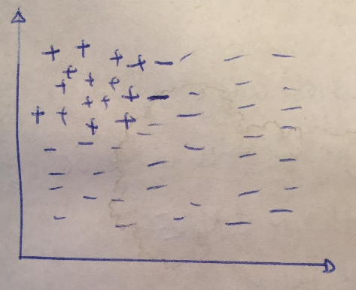
- Classic exercise on theta-subsumption. A hierarchy with boxes was already given, so you just had to fill in the numbers. (this made it easier to not make mistakes)
- Is it possible that a classifier that has an accuracy below default (always predicting the majority class) is on the convex hull. Make a drawing and argue.
- Classify an example using NB and 3NN (Warning: the likelihood for all outputs was 0 using NB)
- A cleaning robot needs to clean the floor of an office. There are 8 tiles. An * indicates a docking station where the robot can recharge its battery, and ‘x’ indicates an obstacle. The robot can move north, south, east, and west. It automatically cleans any tile it moves over, and automatically recharges when arriving at a docking station. The robot knows its current position and whether its battery is “high” or “low”. Starting with a fully charged battery, the battery status changes from high to low after 2 moves, and the robot runs out of power after 2 more moves.
Assume that the robot performs Q-Learning with a discount factor gamma = 0.5, and it gets a reward of 1 when arriving on a dirty tile. There are no other rewards. The robot is activated once a day, starting from Tile A, and all tiles are dirty at this point.
A* | B | X | C
D | E | F | G*
All Q-values are initialized at 0. They are updated in reverse order at the end of each day. This is the exploration the robot performs on day 1 and day 2.
Day 1: east- south -west – east
Day 2: south – east – east – east – west – west – north - south

Give the following q-values after two days.
 | North | South | East | West
Tile b, high battery
Tile e, low battery

