FSA SUMMARY & NOTES

Lectures 1 & 2 - Intro & Financial Statements

Financial Statements

Demand for financial information by:
- Shareholders
- Investment analysts
- Lenders and bondholders
- Employees
- Customers, suppliers and other partners (e.g., joint-ventures)
- Regulators and tax authorities

Supply of financial information for reasons of:
- Compliance with public market regulation
- Benefits of disclosure:
  - Lower cost of equity and debt
- Disclosing information also involves costs:
  - Preparation and dissemination
  - Competitive disadvantages

Income Statement: An income statement reports on operating activities. It lists amounts for sales (and revenues) less all expenses and costs over a period of time. Sales less expenses yield the “bottom-line” net income amount.

Equity Statement: The statement of stockholders’ equity reports on changes in the book value of equity and its components. Its two main components are:
- Contributed capital (from stock issuances)
- Earned capital (retained earnings or reserves built up from previous periods)

Cash Flow Statement: The statement of cash flows reports on cash flows for operating, investing, and financing activities over the FY.

Balance Sheet: Assets
- To be reported on a balance sheet, an asset must:
- be owned (or controlled) by the company
- possess expected future economic benefits
- Assets are listed in order of liquidity
  - Current assets comprise assets that can be converted or are expected to be converted to cash within a year.
  - Long-term assets cannot easily be, or are not expected to be, converted into cash within a year.

Current Assets:

- Cash and Cash Equivalents—currency, bank deposits, and investments with an original maturity of 90 days or less.
- Marketable securities—short-term investments that can be quickly sold to raise cash, typically with a maturity between 3 and 12 months.
- Accounts receivable, net—amounts due to the company from customers arising from the sale of products and services on credit;
- Inventories—goods purchased or produced for sale to customers, including raw materials and work-in-progress.
- Prepaid expenses—costs paid in advance for rent, insurance, advertising or other services.

Long term Assets:
- Property, plant and equipment (PPE), net—land, factory buildings, warehouses, office buildings, machinery, motor vehicles, office equipment and other items used in operating activities (“net” refers to subtraction of accumulated depreciation).
- Leased assets— all leased assets must be shown on the balance sheet.
- Intangible and other assets—assets without physical substance, such as patents, trademarks, franchise rights and other costs the company incurred that provide future benefits.
- Goodwill— the premium on top of the book value paid in acquisition activities.
- Long-term investments—investments (usually in equity and bonds) which are not intended to be sold within a year.

Asset Recognition:
- In general, assets are reported on the balance sheet under the principle of historical cost, also referred to as ‘amortized cost’.
- Historical cost accounting means you are recording the value of the asset at the historical cost price.
- Historical cost accounting is prevailing because it is:
  - Objective
  - Verifiable
  - Predictable
- There is an important alternative: Fair value accounting
- Only include items that can be reliably measured.
  - Considerable amount of “economic assets” may not be reflected on a balance sheet.
  - Examples include a strong management team, attractiveness for new employees, a well-designed supply chain, or superior technology.

Balance Sheet: Equity and Liabilities:
- Other side of the balance sheet = equity + liabilities
- Equity consists of:
  - Contributed Capital (cash raised from the issuance of shares with current and new shareholders)
  - Earned Capital (retained earnings or capital reserves built up from prior fiscal periods).
  - Retained Earnings is updated each period as follows:
  - 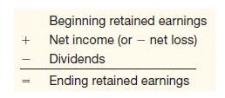
  - Which company has the highest book equity in the World?

Liabilities:
Long-term (or Non-current) Liabilities:
- Long-term debt—borrowings from creditors to be repaid more than one year from now, including bank loans, bonds, and other loans.
- Operating long-term liabilities—Obligations, such as accounts payable, pensions and provisions, that are expected to be settled a year or more from now.

Short-term (or Current) Liabilities:
- Accounts payable—amounts owed to suppliers for purchases on credit.
- Accrued liabilities—obligations for expenses that have been incurred but not yet paid; examples are wages payable, interest payable, tax payable.
- Unearned revenues—obligations created when the company accepts payment in advance for goods or services it will deliver in the future.
- Short-term debt—short-term debt to banks or other creditors.
- Current maturities of long-term debt—principal portion of long-term debt that is due to be paid within one year.

Net Working Capital – Operating Cycle

Net Working Capital = Current Assets – Current Liabilities

The Income Statement
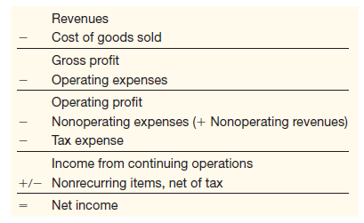

When are Revenues recognized?
- Net income does not necessarily correspond to a net cash flow. A firm could have “good income” but “poor cash flow” or vice versa (i.e., there are two dimensions to consider).
- Earnings often differ from cash flows as they go back to the fundamental economics of what defines what a company ‘earns’?
- Revenue Recognition Principle—revenues are recognized when they are earned, not – necessarily – when the cash inflow occurs
- Matching Principle—recognize expenses when the companies incurs them.

The Principles of Accrual Accounting
- The recognition of revenues when they are economically earned
  - even if they have not yet been received in cash or
  - even if they have already been received in cash
- The matching of expenses
  - when the revenues are recognized, in case there is an economic link with them
  - when the expenses are incurred, in absence of such a link.
  - the cash outflow of the cost is irrelevant for its recognition.

Equity Statement
- Statement of Equity is a reconciliation of the beginning and ending balances of stockholders’ equity accounts.
- Main equity categories are:
  - Contributed capital
  - Retained earnings or reserves
- Other equity categories may include:
  - Preference shares
  - Share premiums
  - Other comprehensive income
Terminology differences:
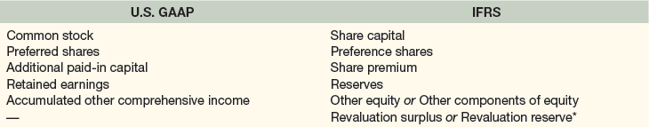

Comprehensive Income Statement
- Comprehensive income equals net income (bottom of the income statement) plus other comprehensive income.
- Other comprehensive income (OCI) contains changes (gains or losses) in the value of the equity which are not captured in net income.
- There are 4 main sources of OCI:
  - foreign currency translation adjustments
  - unrealized gains and losses on available-for-sale financial securities
  - unrealized gains and losses on hedging derivatives
  - unrealized gains/losses on postretirement benefit plans
- Put differently, comprehensive income consists of all of the revenues, gains, expenses, and losses that create a shock to the value of the equity of the firm.

Cash Flow Statement
- The cash flow statement reports on cash inflows and outflows during the fiscal period
- Cash flows are reported based on the three business activities of a company:
  - Cash flows from operating activities - Cash flows from the company’s transactions and events that relate to its operations.
  - Cash flows from investing activities - Cash flows from acquisitions and divestitures of investments and long-term assets.
  - Cash flows from financing activities - Cash flows from issuances of and payments toward borrowings and equity.

Cash Flow Statement indirect method:
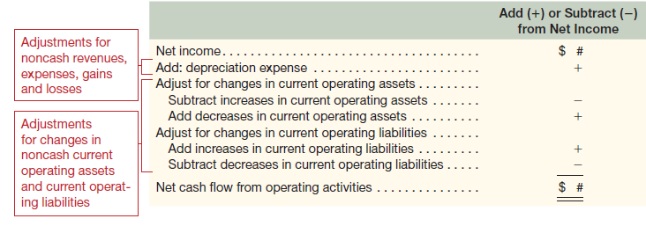

Working Capital Accounts
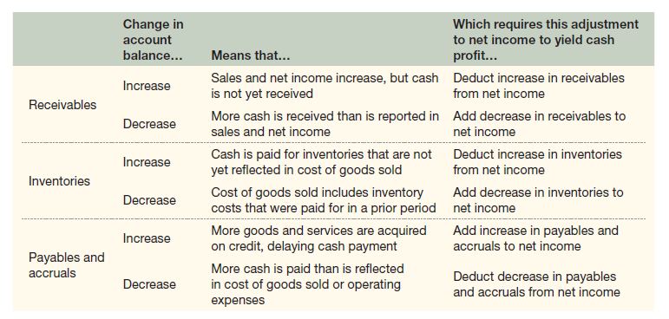

Relation of CF Statement to Income Statement and Balance Sheet
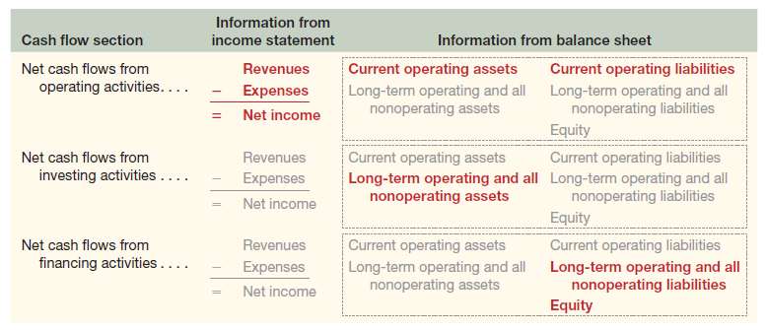

Lecture 3 - Profitability Analysis

Return on Equity (ROE) = Net Income / Average Equity

ROE = Operating Return + Non-operating Return

Return on Equity signifies how good the company is in generating returns on the investment it received from its shareholders. ROE measures the profits made for each dollar from shareholder’s equity.

Operating Return: RNOA

RNOA = Return on Net Operating Assets
RNOA = Net Operating Profit after Tax (NOPAT) / Average Net Operating Assets (NOA)

RNOA evaluates how much operating income a company derives relative to the operating assets it holds. ROE is a good gauge for investors on how well their funds are utilized to generate more profit.
RNOA evaluates how well a company and its management are deploying assets in economically valuable ways; a high ratio result indicates that management is squeezing more earnings out of each dollar invested in assets.

Every 100 euro invested; the company generates an operating return after tax of 8 euros.

NOA = Operating Assets – Operating Liabilities

Lecture 4 - Credit Risk Analysis – Solvency Ratios

Solvency (or credit risk) refers to the ability of the firm to meet its debt obligations. Credit risk is the risk creditors bear vis-à-vis their borrower reflecting the probability that the creditor will be able to fulfill the lending terms. A very much related concept is “bankruptcy risk” which is the probability a firm will expire or fail. Solvency is largely unrelated to a firm’s operations and usually focuses on the long run.

Static solvency ratios are based on only liability and equity items:
- Liabilities-to-equity ratio
- Book Leverage
- Market Leverage
Dynamic solvency ratios are based on a mix of balance sheet items and income statement or cash flow items:
- Times interests earned ratio
- (Net) Debt-to-EBIT(DA)

Liabilities-to-Equity = Total liabilities / Equity
Threshold: Should not be much larger than 2

Book Leverage = (LT Debt + ST Debt) / (Book value of Equity + LT Debt + ST Debt)

Market Leverage = (LT Debt + ST Debt) / (Market value of Equity + LT Debt + ST Debt)
Market value of equity = [# Shares outstanding x Price per share at FYE] (Market Cap)

Times Interests Earned (TIE) = Operating Profit (EBIT) / Interest Expense

TIE measures the number of times operating income (or EBIT) covers the interest expense. If less than 1 insolvency may be close-by.

Debt-to-EBIT(DA) = (Short-Term Debt + Long-Term Debt) / EBITDA
Less than 2 is considered to be safe; higher than 7 is considered to be indicative of solvency problems and very high credit risk. Some use 5 as the threshold for a red flag signal.

Net Debt = [Financial Liabilities] - [Cash and Cash equivalents]

Lecture 5 - Income Statement & Operating Income

Revenues:
- Revenue recognition criteria: realized or realizable and earned.
- Realized or realizable means that the goods have been shipped and title passes to the customer.
- Earned means that the seller has performed its duties under the terms of the sales agreement.
- Accruals involved:
  - Accounts receivable
  - Unearned revenues
- Under US GAAP, there is more industry-specific guidance on how to recognize revenues.
- What about long-term sales contracts?
What is the problem?
Percentage of completion revenue recognition

Example of the percentage of completion technique:
- Sales value of the LT contract of a building = 2,000,000
- Expected time to finish is 24 months, starting on Jan 1, 2020.
- Question: How much of the revenues will we recognize on Dec 31, 2020?
- What is irrelevant?
- What is relevant?
  - The extent to which the building is completed on Dec 31, 2020.
  - This proportion is estimated by comparing the total costs incurred over the total ESTIMATED costs to finish the building
  - Suppose costs incurred are 900,000 and we expect to finish the building by spending an additional 900,000 in 2021 percentage of completion = 50%.
  - In this case 50% of the 2,000,000 will be recognized in 2020.
- What if the true additional amount of expenses is not 900,000, but 1,000,000? we will not recognize any profits in 2021, because we under(over)-estimated the additional expenses (the percentage of completion).
Unearned Revenues:
- Deposits or advance payments are not recorded as revenue until the company performs the services owed or delivers the goods.
- Until then, the company’s balance sheet shows the advance payment as a liability (called unearned revenue or deferred revenue)

R&D Expenses
- General accounting rule: All R&D expenditures/investments are expensed as incurred.
- Why?
  - Capitalizing and depreciating/amortizing R&D costs is not advisable as the depreciation or amortization period is arbitrary.
  - Future economic benefits highly uncertain
- Exceptions:
  - When the generated assets have alternative future uses (in other R&D projects or otherwise).
    - For example: a general research facility housing multi-use lab equipment is capitalized and depreciated like any other depreciable asset. However, project-directed research buildings and equipment with no alternative uses must be expensed.
  - Software (in some specific cases)
- Recommendations for analysis:
  - Compare R&D/Sales for peer companies
  - Evaluate discussion of R&D effectiveness in the MD&A, financial press, and company communication.

R&D under IFRS
  - IFRS distinguishes between research and development
  - Development is required to be capitalized under specific conditions
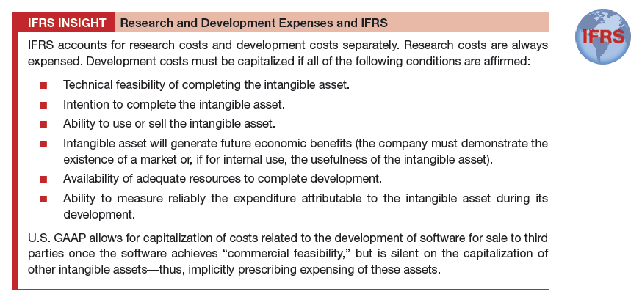

Restructuring Expenses
- Restructuring expenses are usually big and create a one-time drop in earnings.
- Accounting rules require a separate line in the IS or a footnote.
- Restructuring costs typically consists of three components:
  - Employee severance or relocation costs
  - Asset write-downs
  - Other (i.e., contract termination costs, legal expenses, etc.)
- Accounting principle is similar to a provision:
  - Another example of how earnings are inherently more forward-looking than cash flow measures are.
  - Usually, restructuring expenses decrease taxable income in financial reporting, but not in the tax reporting.

4. Selling, General and Administrative Expenses (SG&A): Pfizer vs Apple

5. Non-Controlling Interests

- Non-Controlling Interests or minority interests relate to shares held by other shareholders than the mother company’s shareholders (e.g., through acquisitions)
- Especially found in companies with (complex) group structures.

6. Earnings Per Share

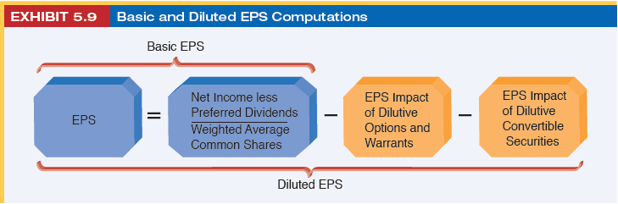

- What is dilution? What is the difference between basic EPS and diluted EPS?
- Why are firms required to disclose diluted EPS?

Lecture 6 - Current Assets & Liquidity Analysis

Inventory Turnover (IT) = Cost of Goods Sold / Average Inventory

Inventory turnover ratio is a measure that shows how many times a business has sold then replaced their inventory over a set time period. A company can then divide the days in the period by the inventory turnover formula to calculate the days it takes to sell the inventory on hand.

Average Inventory Days Outstanding (AIDO) = Inventory / Average daily COGS (COGS/365)

AIDO = 365 / IT

Gross Profit Margin (GPM) = (Sales – COGS) / Sales

Accounts Receivable Turnover (ART) = Sales / Accounts Receivable
ART measures the number of times one cashes in on its clients or receivables are collected from clients per year.

Accounts receivable turnover is the number of times per year that a business collects its average accounts receivable. Accounts receivable turnover is used to measure how efficiently companies collect on the credit that they provide their customers.

Average Collection Period (ACP) = Accounts Receivable / Av. daily Sales (= 365/ART)
ACP measures the average number of days of credit you receive from suppliers.

A higher ART (and equivalently, a lower ACP) indicates that receivables are being collected more quickly, and less working capital is spent on receivables.

Accounts Payable Turnover (APT) = Cost of Goods Sold / Accounts Payable
APT measures how many times suppliers are paid per year.

Average Payable Days Outstanding (APDO) = Accounts Payable / Daily Cost of Goods Sold
APDO measures the average number of days of credit you receive from suppliers. Other operating liabilities may also be included.

Current Ratio = Current Assets / Current Liabilities
Measure of the extent to which a firm has working capital. Threshold value 1.

Current Ratio is a metric used to measure a company's ability to pay its short-term liabilities due within a year. A higher ratio indicates a higher level of liquidity.

Quick Ratio (Acid Test Ratio) = [Current Assets – Inventories – Prepaid Expenses] / Current Liabilities

“Conservative” version of the current ratio: items which are unrelated to cash (e.g. prep. exp.) or for which there is more uncertainty that they will result into cash in the short run (e.g. inventories) are eliminated.

Current Ratio and working capital measure the amount of working capital the firm has available. But they are silent about what about a firm’s need for working capital.

Net Cash Position = Working Capital – Need for Working Capital
If NCP is positive no immediate liquidity problems
If NCP is negative need access to cash (usually the bank)

Net cash may also refer to the amount of cash remaining after a transaction has been completed and all associated charges and deductions have been subtracted.

Lecture 7 - Long-Term Assets

Accounting treatment of long-term assets involves (part of) the following practices and reporting items:
- Which assets are recognized?
- Depreciation, amortization or nothing?
- Type of recognition?
  - Fair Value Accounting
  - Historical Cost Accounting
- Sale of long-term assets
- Asset impairment

1. Property, Plant and Equipment (PPE)
- Property, Plant and Equipment (PPE) comprises tangible, operating assets that are expected to be kept in the company for longer than a year.
- Future expenses arising from these long-term assets and the degradation of their value is reflected in depreciation expense.
- The depreciation process typically involves:
  - Useful life – period of time over which the asset is expected to generate cash
  - Salvage value – Expected disposal amount for the asset at the end of its useful life
  - Depreciation rate – an estimate of how the asset will be consumed over its useful life
- Land is typically not depreciated.
- Typical deprecation methods are:
  - Straight-line method: depreciation expense is recognized evenly over the estimated useful life of the asset.
  - Accelerated methods: (e.g. Double-declining-balance method in which the double of the linear percentage is applied every year)

Depreciation Methods
- Consider this simple example: An asset (machine) with the following details:
(1) investment / purchase cost of EUR 100,000
(2) salvage value (rest value) of EUR 10,000
(3) useful life of 5 years
- Why are depreciation methods such as double-declining-balance sometimes preferred by managers?
Method: | Straight-Line |  | Double-Declining-Balance
year | Depreciation Expense | Book Value at End of Year | Depreciation Expense | Book Value at End of Year
1 | 18,000 | 82,000 | 40,000 | 60,000
2 | 18,000 | 64,000 | 24,000 | 36,000
3 | 18,000 | 46,000 | 14,400 | 21,600
4 | 18,000 | 28,000 | 8,640 | 12,960
5 | 18,000 | 10,000 | 2,960 | 10,000
 | 90,000 |  | 90,000

Where do we find the amounts of depreciation and amortization expense?
- Not in the income statement!
- In a footnote (e.g.: Diageo)
- In the cash flow statement:
OCF = NI + D/A - ∆WC

Sale of Long Term Assets:
- Suppose we sell one of our buildings with the following data:
  - Book value = 10 mio ( = Historical Cost – Accumulated Depreciation)
  - Sale Price = 15 mio (paid in cash by the buyer)
- How does the accounting occur for this transaction?
Journal entries: DEBET CREDIT
Cash 15
@ Property 10
Gain on Sale 5
- This gain is an operating income item other than revenues.
- IMPORTANT!!! Please note that we actually CASH IN this economic gain!!

Gain or Loss on Asset Sale = Proceeds from Sale – Net Book Value of Asset Sold

Impairments of long-term assets
- Impairment of tangible and intangible assets is determined by comparing the sum of the expected future (undiscounted) cash flows generated by the asset with its net book value.
- Separate standard in IFRS on Asset Impairment: IAS 36.
- Companies must recognize a loss if the asset is deemed to be impaired.
- Impairment analysis of long-term assets:

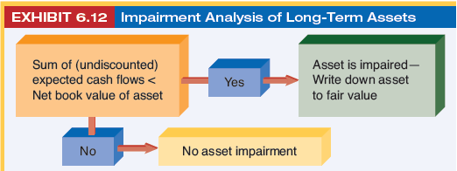

- Impairments can occur for all asset categories!

2.Intagible Assets
- Intangible assets include brands, trade names, franchises, licenses, copy rights etc.
- Separate standard for intangibles: IAS 38.
- Internally generated brands and other intangibles (such as quality of the production systems, employee satisfaction, governance) are not recognized on the balance sheet.
- Internally generated software and IT is an exception to this rule.
- Limited-life intangible assets, such as licenses and investments in IT infrastructure, are amortized in similar fashion to tangible assets.
- Brands and trade names are typically not amortized as they have an indefinite life. They are subject to an annual impairment test.
- Under IFRS, part of the development expenses are capitalized.

3.Good Will
- Intangible asset related to M&A activity– Some firms report on goodwill separately, others put it in Intangible Assets.
- The initial amount of goodwill is the premium on top of the book value of the net assets of the acquired target.
- Previously, goodwill used to be amortized, but…
- … IFRS and US GAAP nowadays no longer amortize goodwill but impose it to an annual impairment test instead.
- In the impairment test, the future benefits of the acquired assets need to be estimated.
- Goodwill impairment is another example of an accrual managers sometimes use to manipulate earnings (understating goodwill impairment increases earnings).
- Does “badwill” exist?

Microsoft purchases Nokia’s cell phone division, with these data:
- Sales Price of 5.4 bn Euro (paid in cash)
- Net book value on Nokia’s books for (merely) 2 bn Euro.
- How does the accounting in Nokia’s statements occur?
Journal entries: DEBET CREDIT
Cash 5.4
@ Assets (Held-for-Sale) 2
Gain on Sale 3.4
- How does the accounting in Microsoft’s statements occur?
Journal entries: DEBET CREDIT
Assets (in entire Balance Sheet) 2
Goodwill 3.4
@ Cash 5.4

4.Joint Ventures

Financial Interests in Other Entities
- Generally, we distinguish between 3 types of stakes a firm may have in related companies or entities:
  - When one owns 50% or more of the shares
  - When one owns less than 5% of another firm
  - When one owns between 5 and 50% of another firm (major shareholder – block holder)
- The second category is usually described as “other financial assets”.
- The latter category typically gives rise to items such as “Investments in associates and joint ventures” of “Investments accounted for using the equity method” in the balance sheet.

Fair Value Accounting
- Fair value accounting is the alternative valuation principle to historical cost.
- Under the Historical cost (or Amortized cost) model, assets are stated on the balance sheet at cost less accumulated depreciation and any impairment losses.
- Under the Fair value model, assets are stated at their fair value, defined in IFRS as the amount for which an asset can be exchanged between knowledgeable, willing parties in an at arm’s length transaction. Sometimes referred to as the “open market value”.
- Unlike historical cost, there is no depreciation is recorded.
- Fair value valuation is a market-based valuation process. Consequence: it includes assumptions about future growth and risk factors.
- The intention of the owner of the asset to hold on to it, or to fulfill the liability is irrelevant in the context of fair value measurements.
- For SOME assets, fair value is mandatory (e.g., financial instruments IFRS 7 and IFRS 9)

Advantages:
- Reflects current information
- Consistent measurement criteria
- Not subject to conservatism or value understatements
- More useful for equity analysis
Disadvantages:
- Less persistent and predictable
- Induces more (earnings) volatility
- Lack of conservatism not always beneficial (e.g. for creditors)

Fair Value or Historical Cost?

Suppose we own a building with the following data:
  - Book value = 10 mio ( = Historical Cost – Accumulated Depreciation)
  - Fair Value = [Sales Price – Transaction Costs] = 15 mio
Suppose we switch from historical cost to fair value accounting.
How does this change affect our financial statement?
Journal entries: DEBET CREDIT
Property 5
@ Gain on Property Value 5
This gain of 5 mio is a NON-CASH revenue!
But you will pay taxes on it!
So, switching from HC to FV increases tax liabilities and decreases FCFs.

Is fair value accounting allowed for long-term assets? YES

Are companies applying fair value accounting? NO

Why are firms reluctant to switch to fair value accounting?

  - Instigates volatility in your financial reports
  - Increases tax liabilities!
Some firms are voluntarily applying fair value accounting

5.Accounting for financial assets and financial instruments
- IFRS 9 for the recognition and measurement of financial instruments
- IFRS 9 replaced IAS 39 in 2018, bringing only minor changes
- IAS 39 was a contested standard, first introduced in 2005, when IFRS became the mandatory set of accounting standards to be use in the EU.
- IFRS 7 for the disclosure requirements on information regarding financial instruments.

Fair value accounting for financial assets
- Valuation fundamentals of fair value assets and liabilities occurs in three categories:
  - Level 1: Inputs are unadjusted, quoted market prices in active markets for identical assets and liabilities. Level 1 contains investments and trading securities for which a quoted market price is available (e.g. equity in a listed firm)
  - Level 2: Inputs are established using observable inputs, but for which no identical asset or liability is traded on a market. These inputs include quoted prices for similar assets in active markets. These inputs may also stem from quoted prices for identical or similar assets or liabilities in inactive markets (e.g. derivatives)
  - Level 3: Inputs are unobservable. Values are derived from estimations and assumptions (e.g. private equity investments using valuation multiples). Level 3 inputs are unobservable estimates and often involve managerial judgment and often involve a higher degree of subjectivity.
6.Leasing

- Leasing is an alternative investment policy to borrowing for the financing of long-term assets.
- Leasing provides flexibility and enables lessees to address the issue of obsolescence and residual value risk. Sometimes, leasing may be the only way to obtain the use of a physical asset that is not available for purchase.
- As of January 2019, the accounting standard for leasing has changed:
- Under the previous standard, IAS 17, there was a distinction between operating and finance leasing. Only finance leasing was recognized in the balance sheet. Operating lease was treated as rental expense.
- Under the new standard, IFRS 16, all leases are put on the balance sheet.
- The expense items are now both operating and nonoperating in nature.

Leasing Change: Impact per Industry

Leasing activity is ubiquitous but differs significantly across industries.
PwC study indicates that retailers are major users and expected to experience significant impacts.

Lecture 8 – Tax Accounting

Accounting for taxes
- All firms are required to provide a tax footnote (IAS12) – some provide several footnotes on taxes.
- A firm needs to account for the tax consequences of transactions and other events in the same way it accounts for the transactions or other events themselves.
- Tax information and tax accounting is highly important as it involves many stakeholders…
- Tax accounting is complex, yet important as tax footnotes may convey useful information on a firm’s economic activities, its future prospects, its tax aggressiveness, its likelihood of future tax litigation, type of management etc.
- … and tax policies are on the political agenda and tax payables are hotly debated in the media.

Actual vs Statutory Tax
- Actual tax rate = ETR = Effective tax rate
- Statutory tax rate = Theoretical tax rate = Tax rate that firm needs to pay according to national tax regulation

- Actual tax rate = ETR
- Statutory tax rate = Theoretical tax rate
- Differences between actual tax rate and statutory tax rate are attributable to:
  - Tax rates differ by country (and sometimes region)
  - Additional state or city taxes
  - Tax-Exempt Income (decreases the ETR)
  - Nondeductible Expenses (increase the ETR)
  - Changes in DTA and DTL affect ETRs, but not statutory tax
  - Current taxes related to previous period(s)
  - Exchange rate fluctuations
  - Changes in tax rates (within the fiscal period)
  - Taxes accounted for in OCI

Current vs Deferred Tax
- Current tax is the tax expense of the current fiscal period (and earlier periods).
- Deferred tax is either an asset (DTA) or a liability (DTL), and can be short-term or long-term.
- DTA and DTL are accruals that arise and disappear because of temporary differences between the consolidated financial statements (under IFRS) and the financial statements considered by the tax authorities.

Deferred Assets vs Liabilities
- Companies maintain two sets of accounting records:
  - one for preparing financial statements for external parties
  - another for reporting to tax authorities.
- These two sets are necessary because the country’s tax code is different from GAAP/IFRS.
- Deferred tax liabilities (assets) arise when tax expense amount for financial reporting is greater (lower) than what is paid (or payable) to tax authorities in this year.
- DTL is a tax liability postponed to the future
- DTA is a tax benefit to be consumed in the future

Deferred Tax Liabilities
- Financial Reporting (Accounting) Profit > Taxable Profit
- Sources of DTLs:
  - Accelerated depreciation
  - Prepaid expenses
  - Buyer write-ups of long-term assets
  - Capitalization of specific expenses
- For each of these 4 sources, please note/understand:
  - The technical accounting mechanism behind it.
  - DTL = [tax rate] X [the deferral amount of assets]
  - Accrual of DTL is temporary Financial reporting catches up with tax reporting over time.

Concluding Remarks on DTL
- DTLs chiefly arise because of more aggressive depreciation and amortization in tax reporting.
- Theoretically, growing firms could feasibly never have to pay DTLs
- Important in advanced analysis of M&A deals
- Major investing activities are visible in the DTL
- “Surprising” increases in deferred tax liabilities are a red flag signal as they may be the result of aggressive revenue recognition
  - Advice: Read and analyze the tax footnote carefully.

Deferred Tax Assets
- DTAs represent a claim of the firm against the government, as they may reduce the taxes to be paid on future profits.
- The reasons for creation and use of DTAs vary across countries and are normally defined in national legislations in the context of income taxes.
- DTAs are also referred to as government contingent liabilities
- Accounting profit < Taxable profit
- DTAs are related to past transactions and can be grouped in two principal categories:

1. Deductible temporary differences:
- Restructuring expenses
- Other provisions (e.g. pensions)
2. Carry forward of past losses

IFRS versus U.S. GAAP
- Several smaller differences
- One important one related to the valuation allowance
- Under US GAAP:
  - Companies are required to establish a deferred tax valuation allowance for deferred tax assets when the future realization of their benefits is uncertain.
  - The effect on financial statements is to reduce reported assets, increase tax expense, and reduce equity.
  - These effects are reversed if the allowance is reversed in the future when realization of these tax benefits becomes more likely.
- Under IFRS:
  - No valuation allowance
  - DTAs are only recognized when there is a “high” probability that the tax benefit will be realized.

Temporary vs Permanent Differences
- Most differences between financial reporting and tax returns are a matter of timing, and therefore temporary differences, giving rise to DTA or DTL.
- However, differences between financial and tax reporting caused by an item that does not reverse over time result in permanent differences.
- Permanent tax differences never give rise to deferred taxes.
- Two types of permanent tax differences:
  - Tax-exempt revenues (e.g. revenues from a good cause; government incentives for promoting diversity etc.)
  - Nondeductible expenses – Examples:
    - Fines and penalties for the company. Tax codes rarely ever allow a deduction in the event of a fine, but fines are often deducted from net income in the financial reporting.
    - Meals and entertainment.
    - Life insurance costs for executives.
- The tax footnote is required to show effects of permanent differences.

Review Examples and Exercise !!!

Lecture 9 – Valuation Basics

1. Accounting Adjustments

- Making accounting adjustments to financial statements before they are usable for valuation purposes is often necessary.
- Making these adjustments is often debatable and subjective.
- Many of the adjustments have to do with:
  - Making numbers comparable with each other
  - Rewriting the balance sheet and income statement
  - (3a.) Undoing accounting conservatism in BS and IS
  - (3b.) Transforming accounting earnings into economic earnings

- Making the numbers comparable with each other. Examples:
  - Gross profit for BMW vs Daimler
  - R&D treatment of BMW vs R&D treatment of Ford Motor Co.
- Rewrite balance sheet and income statement:
  - NOPAT versus NNE (NI = NOPAT – NNE or NOPAT = NI + NNE)
  - NOA versus EQ and NNO (NOA = EQ + NNO)
- Transforming accounting earnings into economic earnings or

To “undo” accounting conservatism in the balance sheet - Examples:
  - Reversing accelerated depreciation / undoing impairments
  - Capitalizing advertising expenses
  - Capitalizing R&D expenses
  - Undoing inventories under LIFO
  - Estimating and capitalizing internally generated brands book value closer to market value
- Suppose we spent the amount of 10,673 on R&D in 2015. R&D expenditure grows at a rate of 17% per year. In accounting earnings (ACC EARN), we fully expense the amount spent on R&D. to achieve economic earnings (ECON EARN), we capitalize the R&D expense and amortize it to zero over a period of 5 years.
- Questions:
  - What is the effect of this alternative treatment of R&D on economic earnings in 2015-2019?
  - How does the economic balance sheet look like in 2015-2019?
  - Why would analysts capitalize R&D expenses?

2. Forecasting Financial Statements: 4-step procedure:

- Forecast revenues.
- Forecast operating expenses. We assume a relation between revenue and each specific operating expense account. Probably the relation will be more one-on-one for COGS than for SG&A and R&D.
- Forecast operating and nonoperating assets, liabilities and equity. We assume a relation between revenue and balance sheet accruals such as inventories and receivables.
- Adjust short-term investments or short-term debt to balance the balance sheet. We use marketable securities and short-term debt to balance the balance sheet. We then recalculate net nonoperating expense (interest/dividend income or interest expense) to reflect any adjustments we make to nonoperating asset and liability account balances.

Forecasting Revenues

Forecasted Revenues = Actual Revenues x (1 + Revenue Growth Rate)

- Use historical growth rates
- Use analyst forecasts (see example AB Inbev)
- A few other things to consider when forecasting revenues:
  - Impact of Acquisitions - revenues from acquisitions are only included from the date of the acquisition. Historical revenues used for comparison do not include the acquired company.
  - Impact of Divestures - revenues and expenses of divested business are excluded form current and historical totals.
  - Existing vs. New store growth - new store growth can be more costly than organic growth.
  - Impact of unit sales and price disclosures - forecasts that are built from anticipated unit sales and current prices are generally more informative, and accurate, than those derived from historical euro/dollar sales.

Forecasting Other Items
- Cost of goods sold are impacted via increased inventory purchases in anticipation of increased demand, added manufacturing personnel, and greater depreciation from new manufacturing PPE.
- SG&A increase concurrently with, or in anticipation of, increased revenues, although not as much in line with revenues as COGS; these expenses include increased costs for buyers, higher advertising costs, payments to sales personnel, costs of after-sale customer support, logistics costs, IT costs and administrative costs. Potential for economies of scale.
- Cash and changes in cash is usually the result of “everything else” and used as the plug.
- Accounts receivable, Accounts Payable and Unearned Revenues increase directly with increases in revenues as more products and services are sold on credit.
- Inventories normally increase in anticipation of higher sales volume to ensure a sufficient stock of inventory available for sale.

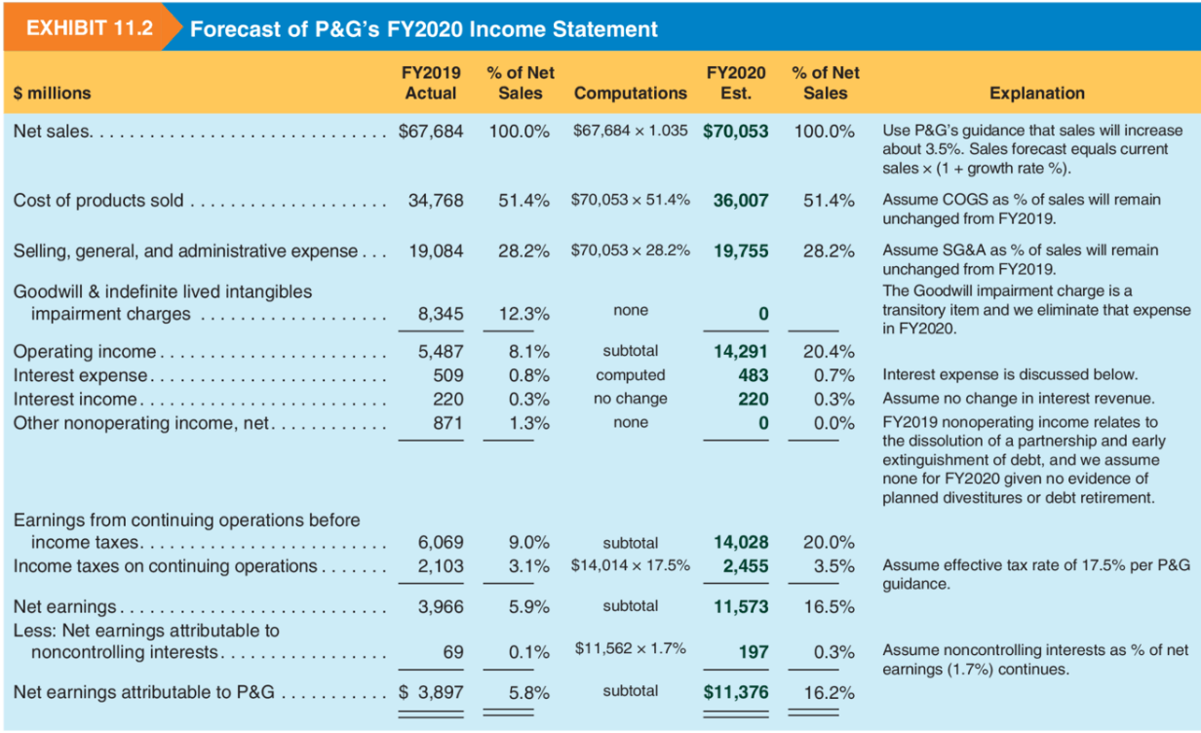

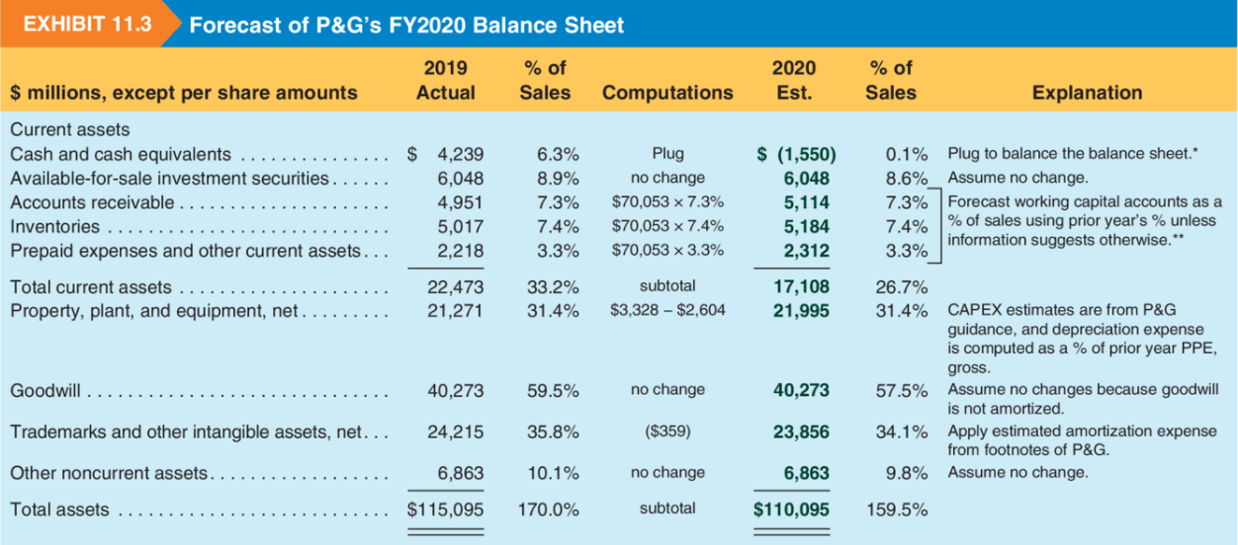

Forecasted Liabilities and Equity for P&G
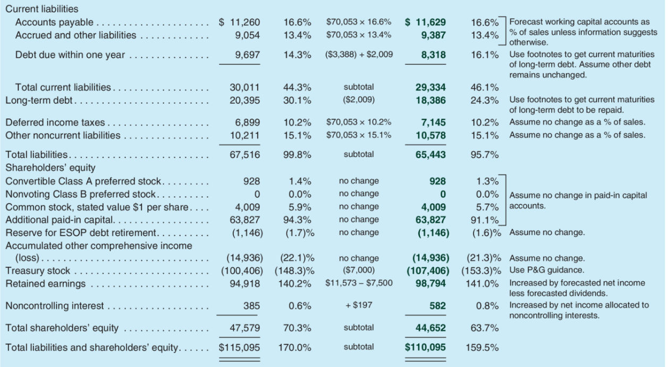

Analyst Forecasts
- Forecasts of financial numbers by professional analysts
- Forecasts usually per share and mostly focus on earnings
- Other numbers that are sometimes forecasted (primarily for big companies): sales, equity, OCF, FCF and long-term growth
- Application for sales forecasts of AB Inbev: See excel file “Lecture 9 – Materials” in the sheet “Sales forecasts ABI”
- Consider how the forecasts evolved in 2020 on the sales of AB Inbev.

Valuation Fundamentals

- Value of the firm = Sum of all future payoffs
- Value of the firm = Payoffs for shareholders (Dividends)
+ Payoffs for debtholders (Interests)
- Value of the firm = Value of Equity (Eq_{L}) + Value of Debt (D)
- Value of the firm = Value of the operations
- Value of the firm = Sum of all future Free Cash Flows
- Free Cash Flows = Dividends + Interests
- Value of the firm = V_{L} = Eq_{L} + D
- Future payoffs must be estimated: Dividends (Eq_{L})
Free Cash Flows (V_{L})

- Discount rate must be estimated: Cost of equity = E(R_{L})
Cost of operations = E(R_{U})

- MM1: Capital structure is irrelevant for the value of the firm
- MM2: Cost of the equity increases with increasing leverage

- E(R_{L}) = cost of equity = required return by investors before they invest in equity.
- If we have debt, E(R_{L}) is the result of both our operations (E(R_{U})), as well as how we finance our activities and at what price (R_{D}).
- E(R_{L}) = E(R_{U}) + [E(R_{U}) – R_{D}] x [D / Eq_{L}]
Required return of the operations = Required return without Debt = Spread X Leverage
- E (R_{U}) = E(R_{L}) x [Eq_{L} / (Eq_{L} + D)] + R_{D} x [D / (Eq_{L} + D)] = WACC
- “Market” version of our framework seen in Lecture 3.

Cost of Capital
- Cost of capital is the required rate of return. It reflects the risk involved with holding on to an individual stock.
- It reflects only undiversifiable risk (or market risk).
- We can also think about risk in terms of betas. CAPM has taught us:
  - Risk = Risk-free rate + individual firm risk premium
  - E(R_{i}) = R_{f} + [E(R_{m}) – R_{f}] x $β_{i}$
  - in which: $β_{i}= \frac{COV (Ri,Rm)}{{σ2(R}_{m})}$
  - Weighted sum of all betas equals 1.
- β_{U} = β_{L} x (Eq_{L}/(Eq_{L}+D)) + β_{D} x (D/(Eq_{L}+D))
- β_{U} = β_{L} / (1+ D/Eq_{L})

- Operational (firm) risk factors:
  - Firm size
  - Volatility in the business operations
  - Growth opportunities
  - Existing competition
  - Entry of new competitors
- Credit risk factors:
  - Leverage
  - Covenants
  - Credit quality
- Macroeconomic factors:
  - Macroeconomic volatility
  - Inflation risk
- Country-specific factors:
  - Quality of the securities regulation
  - Investor protection rights across countries
  - Political risk and political volatility
  - Risk of expropriation
  - Corruption, legal quality, impartiality of courts…
- Information (risk) factors:
  - Quality of the accounting numbers
  - Quality of the audit
  - Quality of the regulatory oversight
- Governance risk factors:
  - Risk of expropriation by the manager / weak boards
  - Risk of insider trading.

Analyst Earnings Forecast
- What about the numerator: FCF or dividends?
We need earnings forecasts
- One potential source is forecasts made by professional analysts.
- Main forecast is Earnings per share for the next 3 or 4 years.
- Application for sales forecasts of AB Inbev: See excel file “Lecture 9 – Materials” in the sheet “Earnings Forecasts ABI”
- Please note the following:
  - The information content in forecast accuracy
  - The information content of forecast dispersion
  - The impact of Covid 19 on the earnings forecasts

Lecture 10 – Cash Flow Based Valuation

Lecture 11 – Income Based Valuation

Lecture 12 – Market Based Valuation

